Have a safe and happy holiday from staff at Sowilo !!!
Sowilo Holiday Ideas
[October Holidays 2015]

The Royal Show
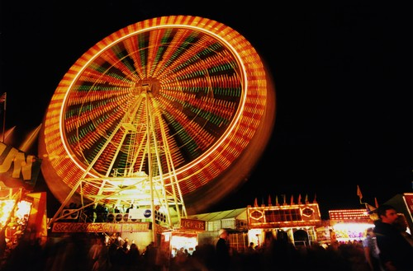
1 Graylands Rd, Claremont WA 6010
(08) 6263 3100

Click here for events
http://www.perthroyalshow.com.au/whats-on/calendar-of-events.aspx

General Information

Show Hours
Show hours are from 9am to 9pm every day. Sideshow Alley stays open late.

Pavilion Closing Times
The Art and Photography Gallery, Centenary Pavilion (District Displays and Floral Design), Shopping and Lifestyle Pavilion and City Farmers Animal Nursery close at 8pm. The Dairy Pavilion, IGA Fresh from WA Pavilion, Heritage Hall, Police Pavilion, Cookery Pavilion, Creative Crafts Pavilion and Creatures Great and Small Pavilion close at 7pm. The Cattle Lane Walk Presented by Harvey Beef, Farmtech Pavilion, Farm 2 Food Pavilion, Pigeons and Poultry Pavilion and the Sheep, Shearing and Wool Pavilion close at 6pm. The Dog Pavilion, Cat Pavilion, and the Rabbit and Cavy exhibits on the last three days in the Creatures Great and Small Pavilion close at 5pm.

No Smoking
The IGA Perth Royal Show is a smoke free event. No smoking is allowed on the Showground or immediately outside any gates. Areas have been set aside for smokers at Private Road (next to Sideshow Alley) and at the rear of the toilet block near the corner of Hardy and Morrison Avenue. Check at the information booths for directions.

Carers
The Show supports the use of the Carers WA Membership Card and Companion Card by offering free entry to carers upon presentation of a valid card. When with the care recipient, present it to gate staff for entry to the Showground.

First Aid
St John Ambulance First Aid Posts are situated throughout the Showground. Post 1 is situated at St John Ambulance building on Rose Avenue adjacent to the Police Station inside Gate No. 9 (Map Ref G5), Post 2 is at the Southern entrance to the Main Arena (Map Ref f2) and Post 3 is located at the Western Side of the Main Arena, near Gate 10 (Map Ref C6). St John Ambulance Event Health Service Members will also be patrolling around the Showground.
A variety of personal first aid supplies are available from all St John Ambulance Posts for a gold coin donation.
Parcel Minding
Parcel Minding is coordinated by Girl Guides inside Elders Entrance Gate 1 (Map Ref K3). The cost is $8.00 for a large bag, $10.00 for a trolley.

Lost Person/s
Should you and your child become separated at the IGA Perth Royal Show, please alert an information booth, Showground Police Station (Map Ref D6) or the RAS Office (Map Ref H3) to notify the Lost Person's Centre. All lost people will be cared for at the Lost Person Centre (Map Ref F4).

Parents' Facilities
Parents’ facilities are available at public toilets in Keane Avenue behind Kiddie Land (Map Ref J3), Shopping and Lifestyle Pavilion (South Precinct) in Viveash Avenue (Map Ref H1), Waylen Avenue (Map Ref F2), Richardson & Edgar Avenue (Map Ref D4), the Lost Person Centre (Map Ref F4) and the Mother's Room Marquee (Map Ref F4).

Pram/Stroller Hire
Strollers are available from inside Gate 1 (Map Ref K3). Cost is $15 per half day (minimum hire) and $5 per hour thereafter. A $30 refundable deposit is required.

Wheelchair Hire
Wheelchairs and electric gophers are available inside Gate 1 (Map Ref K3). Wheelchairs cost $20 per half day and $40 for a full day and require a refundable deposit of $50. Electric gophers cost $30 for a half day and $5 thereafter. A refundable deposit of $100 is required. Pre Show bookings are available by telephoning 0439 942 089 or during the Show 0424 721 161.

Gluten Free Options
There are a number of gluten free options available around the Showground. Click here to download the gluten free map.

ATMs
ATMs can be found in the following locations:
X17 (Map Refs A2 (X2), B3 (X2), C2, D6 (X2), F1 (X2), G5 (X4), H2, I4, I5, J2, J4

Acrod Parking
Acrod parking is available at Gate 1, opposite Gate 12 and Ashton Triangle.

Lost Property
For lost property please call the RAS Office on 6263 3100. Items are kept for approximately eight weeks after Show and if still remain unclaimed are then donated to charity.
Items of value are collected daily by the police during Show and held at Cottesloe Police Station - 9286 7777

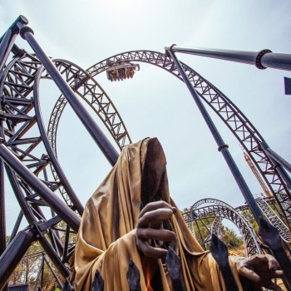
Adventure World

351 Progress Dr, Bibra Lake WA 6163
(08) 9417 9666

A good time to go to Adventure World is the week of the royal show as it is deserted and you don’t need to wait for unlimited rides
.

DAY TICKETS FOR THE 2015-16 SEASON ARE NOW AVAILABLE
Gift Vouchers are available to purchase to give a ticket as a present and are valid for 12 months from the date of purchaseOnline ticket prices include transaction fees
Infant/Toddler | 3years and under | FREE
Senior Day Pass | please show ID indicating 60+ years | $20.00
Concession Day Pass | Student, Health Care, Pension & Veteran's | $52.00
Child Day Pass | aged 4-13 years | $47.00
Adult Day Pass | aged 14+ years | $57.00
Family Day Pass | 1 Adult & 2 Children (OR 2 Adults & 1 Child) | $142.00
Family Day Pass | 2 Adults & 2 Children (OR 1 Adult & 3 Children) | $177.00
Family Day Pass | 2 Adults & 3 Children (OR 1 Adult & 4 Children) | $216.50
Family Day Pass | 2 Adults & 4 Children (OR 1 Adult & 5 Children) | $259.00

After 2pm discount

COME TO ADVENTURE WORLD FOR AN AFTERNOON IN THE SUN.

Join us for 3 hours from 2pm - 5pm from Thursday to Monday (closed Tues & Wed) for these great discounted prices only available at the Admissions Gate Adults 14+yrs
$36: Child 4-13yrs $31 Child >4yrs FREE

More offers

BUY NOW

Adventure world Event - What's On
29, 30, 31 October 2015
FRIGHT NIGHTS IS BACK
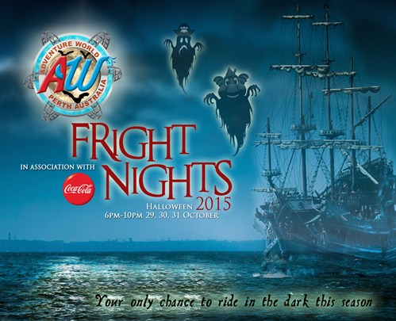
Fright Nights at Adventure World are back and bigger events than ever offering the only chance to ride Australia’s Best Roller Coaster ‘Abyss’ and
the new mega waterslide CODE NAMED ‘MI2’
in the dark this season!
Find your zone and enjoy everything the park has to
offer PLUS these eerie additions to Adventure World in the dark!
THRILL ZONE

For adult adventurers, immerse yourself in the 18+ foggy Graveyard Bar conveniently located in the middle of all your favourite themed thrill rides – Abyss, The Black Widow and The Rampage. Try to relax with a drink but it’ll be hard with creepy pop-up circus acts, roaming ghouls, pyrotechnics and DJ Tina Says on the decks. Grab a bite from a street food stall and don’t forget to come along in your freaky costume to enter the best dressed comp with $250 up for grabs for the best dressed each night! (See below for more info on Best Dressed)
TIKI TERROR

Find your favourite spot on the main lawn to set up your family night out but be prepared to be sacrificed to the tiki gods! Check out the monstrous films as we turn a shade sail into a giant movie screen. Grab some glo-gear from the Little Shop of Horrors or get your faces painted but be aware, creatures lurk at every corner and you might even be haunted by a creepy pop-up performance.

AGE 10+ BEST DRESSED COMPETITION - $250 PRIZE EACH NIGHT

Open to all Fright Night’s guests over 10 years, the best dressed competition this year will take place online! Simply come in your best freaky costume and take a photo that proves you are wearing your costume inside the event before you go and get wet & messy on all the Adventure World rides! Make it interesting – for example pose with a guardian, giant spider or one of the hideous roaming ghouls. To enter, upload your photo to Facebook or Instagram and use the hashtag #awfrightnights AND tag @adventureworldperth (Instagram only) by 10pm on the night you attend. $250 cash is up for grabs and the winner will be judged by a panel of staff on Monday morning.
Important: If you have a private profile on Facebook make sure you post the photo to our Facebook page as well as on your own wall. If you have a private Instagram account comment on our most recent photo with ‘private’ so we know to follow you and see your awesome costume!

EVENT ACCESS
Ticket includes access to the park from 2pm – 10pm, Fright Nights entertainment starts at 5pm
Entering the park prior to 5pm:
Guests are permitted to enter the park on a day ticket and stay on into the evening. On arrival Guests will be asked if they wish to attend the event and if so, they will be issued with both day and event wristbands to wear.
There are no discounted After 2pm tickets for sale on these days - all tickets sold after 2pm are for the Fright Nights events
In order to control the park capacity, Season Pass members require a $17 ticket to attend the events (see event discount info in your membership terms and conditions). These are available online before the event or on arrival at the admissions gate. Members will also be asked on arrival if you wish to stay on for the event, and if so, requested to present or purchase your discounted event ticket.
Event guests who do not have an event wristband will not be permitted on rides during the events.

3# Host a Grand Final Barbecue
Invite your friends to watch the grand final, serve snacks or have a Barbie.

Kelmscott Show - October 2015

The Smoke Free WA Kelmscott Show is presented by the Kelmscott Agricultural Society on the 16th and 17th of October 2015. The Show is located at the Rushton Park Showgrounds, corner of River Road and Orlando Street in Kelmscott.

Gates Open
Friday 16th October: 4pm to 9pm
Saturday 17th October: 9am to 6pm

Admissions Information
$38 | Family Ticket (2 adults & 2 children)
$15 | Adults
$8 * | Seniors & Companion Card Holders (accompanying carer FREE)
$8 | Children 5-14
FREE | Children under 5
* Applicable Senior or Companion Card to be produced at the gate
Exhibitors are required to pay admission. Pass outs are available at each gate for exhibitors.

There are NO ANIMAL EXHIBITS on Friday night
SmokeFree WA Fireworks Spectacular on Friday night only
Section opening times
Main Exhibition Hall  Friday 5.00pm to 9.00pm  Saturday 9.00am to 6.00pm | Flower Pavilion  Friday 5.00pm to 9.00pm  Saturday 9.00am to 6.00pm
Schools Pavilion  Friday 5.00pm to 9.00pm.  Saturday 9.00am to 6.00pm. | Pigeon & Poultry Pavilion  Saturday 10.30am to 4.45pm.

Friday – Entertainment
Main Stage - Top Oval
5:30pm - 6:30pm | GoGos  Live Band
7:30pm - 8:30pm | Two-Cent Professionals  Live 12-piece Band

Around the Grounds
4:00pm - 8:00pm | Pop Magic  Magic and Mystery!
5:00pm - 8:00pm | Stilt Walker  Healthway Publicity
Lower Oval
6:00pm - 8:30pm | Freestyle Motocross  Extreme Entertainment Three demonstrations - 6pm, 7pm, 8pm. Not to be missed. Heart-stopping aerial entertainment
8:30pm - 9:00pm | SmokeFree WA Fireworks Spectacular  Sky-works Extravaganza!
Top Oval
6:00pm - 8:00pm | Log Chop Demonstration  Sweaty and Athletic!  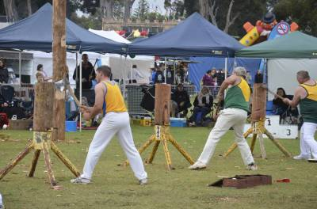
Saturday
Main Stage - Top Oval
10:00am - 9:00am | Classic Sounds Orchestra  Meet the Instruments
10:45am - 11:00am | Hopperoos  Dynamic School Group
11:00am - 11:30am | Energetic Kids  Kids and Dance
11:30am - 12:00pm | Jus' Dance  Dynamic Dance
12:00pm - 12:30pm | Pioneer Village School Choir and Dance Troupe  Vibrant School Song & Dance
1:00pm - 2:30pm | Junior Idol Finals Competition  Local Talent at its Best!
2:45pm - 3:00pm | Classic Sounds Music School Performance Troupe  Talented Youth
3:00pm - 4:30pm | Senior Idol Finals Competition  Amazing Showcase of Talent
5:00pm - 5:15pm | Performance Class Demonstration  Young local performers
5:15pm - 6:00pm | LaunchPad  Modelling Demonstration

Old Pool Site
9:00am - 5:00pm | Minecraft  Exhibition and Competition!
9:00am - 4:00pm | Out of the Box  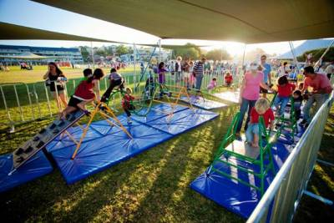  Extreme Activity Out of the Box is thrilled to be invited to this years 2015 SmokeFree WA Kelmscott Show! Catch a Chook, Penguin Fish Fling, the Big Striker, Tin Can Toss are just a couple of the totally fun, FREE kids activities that the whole family can enjoy.  Learn how to throw a lasso to hook the buffalo horns or really test your coordination on Ring a Bottle. The little ones aren’t forgotten with a great "Toddler Only Zone" that has an obstacle course and miniature Hook a Duck Game. See you there!
10:00am - 3:00pm | Scitech  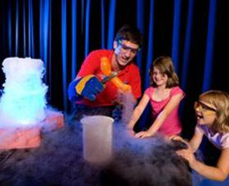  Interactive display ALL AGES Immersive yourself in free interactive exhibits suitable for all ages demonstrating the fascinating principles of science and technology. There are also two 30-minute science shows under the gazebo that you won’t want to miss: “Where is Air?” at 11am and “Flight” at 2pm!
River Market Area
9:00am - 5:00pm | Old Macdonald's Farm  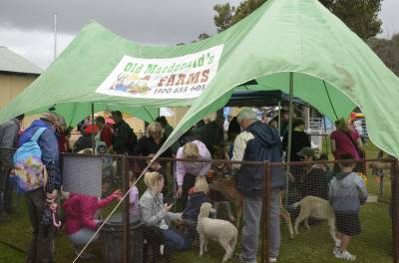  Old Macdonald’s Farm provides a never to be Forgotten Nostalgic and Fun Interactive animal experience, with bottle feeding, hand feeding and brushing our adorable Farm friends, all brought in show condition for your enjoyment wherever you may live.  Old Macdonald’s Farm bring a variety of baby farm animals which can include lambs, kids, piglets, calf, guinea pigs, * rabbits , ducklings, baby chicks and don't forget the Alpacas! Our baby farm animals love all the attention!!
Exhibition Main Hall
10:00am - 10:45am | Roleystone Singers  Community Singers
11:00am - 11:45am | Good Shepherd Primary School  Beautiful School Performers
12:00pm - 12:45pm | Classic Sounds Fiddle Group  Live Fiddle Music
Around the Grounds
10:00am - 2:00pm | Sparky the Dragon & Princess Sophie  Cheeky Mascots!
10:00am - 1:00pm | Stilt Walker  Spreading the Healthway Message
11:00am - 4:00pm | Pop Magic  Strolling Magic & Balloons
12:00pm - 4:00pm | Linda Bickley  Cheeky Street Entertainment
Lower Oval
9:00am - 5:00pm | Brownes Milking Station  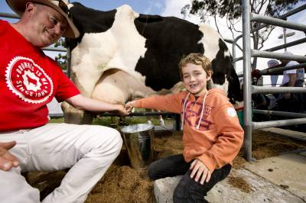  Farmer Damian will be providing live cattle milking demonstrations at 10:15am, 12:15pm, 2:15pm and 4:15pm as well as providing informative commentary on the farm to food relationship from a dairy farmers perspective.  Come down and see cattle being milked up close, just like on a real dairy farm!!
9:00am - 5:00pm | Darling Range Wildlife Shelter  Darling Range Wildlife Shelter (Incorporated) [DRWS] is a totally volunteer and not-for-profit organisation whose purpose is to rehabilitate native wildlife and promote the value of biodiversity.  DRWS volunteers rescue, provide care and rehabilitate Australian native wildlife in need including threatened, endangered and migratory species. Our aim is to work towards their release back into their natural environment. Each year we record around 1000 wildlife admissions.  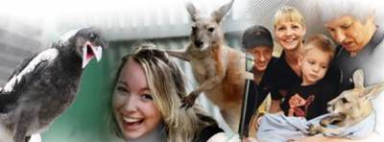
9:00am - 5:00pm | 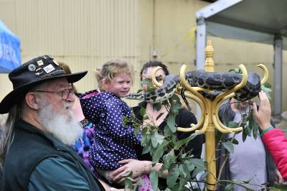  Reptile Display  This display provides a wonderful opportunity for show patrons to safely observe reptiles, to see what they look like, how they behave and to learn about their habits and habitats.  It also provides a fantastic opportunity to identify and learn about venomous and non-venomous snakes, that residents may encounter in the bush or possibly around their homes or backyards.
9:00am - 5:00pm | Sheep Shearing  Sheep shearing will be occurring regularly across the day. Our shearer, Jamie will also be providing information about the shearing profession and the wool farming process.  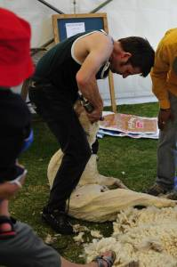
9:00am - 5:00pm | 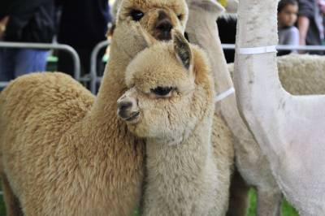  Alpaca Display  Angela will be once again providing this wonderful display of everyone's favourite animal, the Alpaca!!  Angela will be able to answer all your questions up close and personnel relating to the Alpaca wool farming industry.
9:00am - 5:00pm | Raptor Display  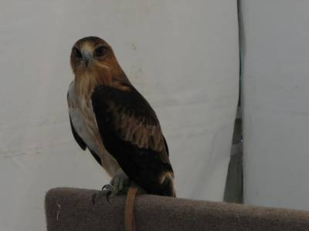  Renae & Gina Downer are dedicated volunteer members of The Society for the Preservation of Raptors. (Inc.) The Society for the Preservation of Raptors (Inc.) is a registered not-for-profit organization based in Western Australia. Their volunteers work toward and support the conservation of Australia's raptors (birds of prey and owls) through wildlife rehabilitation and community education. Visit our website located at http://www.raptor.org.au/ where you will find information about the Society, information on our raptor rehabilitation facilities, the education services we provide and how you can become involved in helping our wildlife

Top Oval
11:00am - 4:00pm | Sydney or the Bush  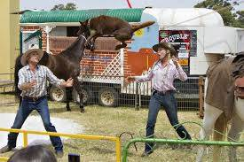  Live Outback Entertainment Stunning live entertainment on top oval opposite the log chop at 11am, 1pm, & 3pm.  In a light hearted Aussie colloquial style the hosts: Sydney & Kim engage the audience in a nostalgic trip back in time- a time when all Australians rode on the sheep’s back, began to shape this nation and call themselves Australians.  Our cast consisting of a stock horse, a donkey, sheep and a super entertaining working Red Kelpie Dog brings a dynamic experience of hilarious whip cracking antics through to real life blade sheep shearing and poetry.  The performance includes all the favourites: actual sheep shearing, amazing horsemanship & tricks, whip cracking, many traditions, rendition of Waltzing Matilda and stories, all performed in an arena as part of the large set. Familiar poetry from Banjo & Henry captures the essence of colonial Australia. The famous kelpie dog demonstrates all the aspects of working sheepdogs and enthralls the audience with his human like talents.
11:30am - 4:30pm | 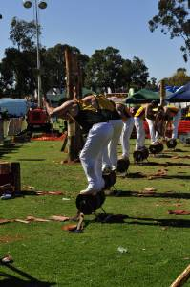  State Log Chop Event  Full 'o Muscle

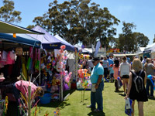
Attractions
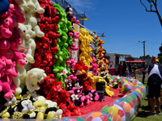
The SmokeFree WA Kelmscott Show hosts a day full of excitement for the entire family. Here is just a selection of the many attractions at this years show
Sideshow Alley
Come and enjoy the ever popular sideshow rides and games on the main oval. All of the usual favourites will be there for both the big and small kids. This year there will be additional rides for the young kids outside of sideshow alley.

Trade & General Stalls
There will be a wide variety of food, variety and trade stalls available this year.
Flower Pavilion
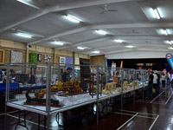
Competitive displays in general flowers, formal decorative art, informal decorative art, pot plants and children’s section Competitive displays in Vegetables, Fruit & Nutes; Dairy Products, James, Honey, Preserves, Pickles, Amateur Wine, Home Brew; Cooking; Knitting & Crochet; Needlework; Crafts; Manual Arts; China Painting, Pottery & Ceremaics; Painting & Drawing; Amateur Photography. There will also be demonstrations and performances on the main stage.

Main Exhibition Hall
Kelmscott Idol
The search is on for the Kelmscott Idol at the 2015 SmokeFree WA Kelmscott Show. Sponsored by the Roleystone-Karragullen Cummunity Bendigo Bank, there is great prize money up for grabs as well as an opportunity to showcase local talent.
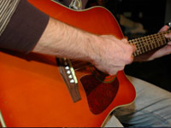
Auditions will take place 12th and 13th September and Finalists will perform on Saturday 17th October at the Show.
Children’s Farmyard Nursery
Competitive display in the Children’s Farmyard Nursery includes the following classes: Female and Progeny – Guinea Pigs – Mice – Car or Kitten – Puppy or dog – Bird in cage – Fish – Crazy crab – Any other pet small or large. The actual entries or pets will depend on what is entered. Judging commences at 11am.
Horses in Action
Come and watch the competitors compete in Hacking in an Official Ring or an Unofficial Ring on the lower oval. The event is conducted in conjunction with the Wallangarra Pony Club (Inc) proudly sponsored by Horseland Maddington. Please note that there is an alternative wet weather venue which may be used depending on the ground condition of the arena all enquires to the KAS Office
telephone. The encouragement ring will commence approximately 1pm after the official hacking
Animal Displays (Saturday only)
9am to 5pm – Raptor Display (Birds of Prey) by Renae & Gina Downer from the Society for the Preservation of Raptors
9am to 5pm – Reptile Display (Snakes, Lizards etc) by Marc Lane
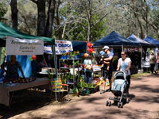
9:30am to 5:00 pm – Sheep Shearing Demonstrations by Jamie Campbell
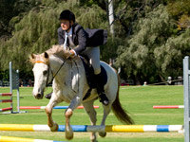
9am to 5pm – Alpaca Display by Angela Bartels
9am to 5pm – The Old MacDonalds Farmyard Nursery
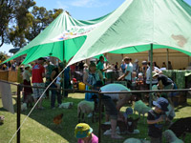
9am to 5pm – Pat a Lamb at the sheep section
River Area
Take a stroll along the banks of the Canning River on Saturday and view and purchase items from the various Arts and Crafts stalls. You will also find a number of children’s rides for the little ones. Camel and Pony rides are also located here for the kids.

City Of Gosnells – holiday programs
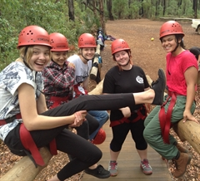

Girls Only Holiday Program

DESCRIPTION

The Girl’s Only Program is a school holiday program especially designed for females aged 12-17 years.
This program offers the opportunity to develop their social skills, to make new friends and participate in a variety of fun activities including horse riding, art activities, theatre excursions and life skills workshop.
Due to the popularity of the program, we are running two groups.
This enables us to offer the program to more participants, therefore registration is essential and a $10 fee per participant applies. We will contact you by phone to confirm your registration once processed.
For further inquiries please call Youth Development Officer on 9397 3133 or email.
CONTACT DETAILS
Address:
21 Discovery Drive, Thornlie WA 6108
Telephone:
9397 3133
Fees:
$10 per participant; registration is required.
Suitable:
Teenagers, Children

City of Gosnells - LALA Holiday Art Program

LALA ( Langford Lanterns) is a community project for young people aged 12 - 17 years living or going to school within the City of Gosnells. Help create a huge Phoenix lantern and many smaller lanterns for the Multicultural food fair held in November. Come along and work with a professional artist and youth workers while learning about creating an exciting art piece.
LALA will run for 8 days over the school holidays and is a free program, therefore registration is essential. To view the flyer and registration form, use the related links below.
For further inquiries please contact Youth Development Officer on 9397 3133 or email dditchburn@gosnells.wa.gov.au

RESISTRATION
http://www.gosnells.wa.gov.au/files/sharedassets/public/pdfs/youth_services/school_holiday_programs/lala_holiday_art/lala_registration_form_-_oct_2015.pdf

FLYER http://www.gosnells.wa.gov.au/files/sharedassets/public/pdfs/youth_services/school_holiday_programs/lala_holiday_art/lala_flyer.pdf

City of Gosnells - Youth Leadership Camp

Each October school holidays Youth Services, in partnership with the City's Youth Advisory Council, run a Youth Leadership Camp.
Applications generally open in August and are invited from young people in Years 8 to 10 at high school who are living or attend school within the City.
Applicants need to complete an application form that will be available from the open date. Provide as much detail as possible. If more space is needed attach your answers on a separate piece of paper.
You will be judged on your answers, not your spelling, punctuation or the neatness of your writing.
Applications must be received by mail, email or by person at the City's Civice Centre by the closing date and time.
Applications will be assessed by a panel from Youth Services staff and members of Gosnells Youth Advisory Council.
There is a cost for participants which will be advised when submissions open.
Daily activities may include adventure activities such as abseiling or caving, bush walks (weather permitting), kayaking, teambuilding games and other outdoor fun activities!
For further information call the Youth Development Officer on 9397 3132.

SHOPPING CENTRES

ACTIVITIES FREE UNLESS OTHERWISE INDICATED

WEEK 1

Tuesday 29th
Ocean Keys Clarkson Winter Wonderland - synthetic ice rink (5yrs+), centre snowman hunt and penguin meet and greet 11-2pm
Lakeside Joondalup Pixels Interactive Zone - 11-2pm in The Great Space
Innaloo Megacentre Oz Kids Kartz - race around the inflatable race track in your very own go kart. 11-2pm
Garden City Booragoon Play Doh Craft Village - imagine and sculpt your own Play Doh masterpiece. Meet Purple Doh Doh & Red Doh Doh. 10-4pm
Southlands Fire Man Sam - Live Shows 11, 12 & 2pm
Stockland Bull Creek Critters Up Close - critter presentations 11-12noon & 1-2pm
Armadale Shopping City Care Bears - Live Stage Show 11, 12 & 2pm. Meet & Greet 1pm
Wednesday 30th
Ocean Keys Clarkson Winter Wonderland - synthetic ice rink (5yrs+), centre snowman hunt and penguin meet and greet 11-2pm
Lakeside Joondalup Pixels Interactive Zone - 11-2pm in The Great Space
Karrinyup Shopping Centre In The Night Garden - kids can design and decorate their own sock puppet. 9.30-12.30pm
Innaloo Megacentre Oz Kids Kartz - race around the inflatable race track in your very own go kart. 11-2pm
Westfield Innaloo Tiny Tots Tennis - 10-2pm
Westfield Carousel Star Wars Immersive Zone - 11-2pm
Garden City Booragoon Play Doh Craft Village - imagine and sculpt your own Play Doh masterpiece. Meet Purple Doh Doh & Red Doh Doh. 10-4pm
Southlands Fire Man Sam - Live Shows 11, 12 & 2pm
Armadale Shopping City Care Bears - Live Stage Show 11, 12 & 2pm. Meet & Greet 1pm
OCTOBER
Thursday 1st
Ocean Keys Clarkson Winter Wonderland - synthetic ice rink (5yrs+), centre snowman hunt and penguin meet and greet 11-2pm
Lakeside Joondalup Pixels Interactive Zone - 11-2pm in The Great Space
Karrinyup Shopping Centre In The Night Garden - kids can design and decorate their own sock puppet. 9.30-12.30pm
Westfield Innaloo Tiny Tots Tennis - 10-2pm
Westfield Carousel Star Wars Immersive Zone - 11-2pm
Garden City Booragoon Play Doh Craft Village - imagine and sculpt your own Play Doh masterpiece. Meet Purple Doh Doh & Red Doh Doh. 10-4pm
Stockland Bull Creek Critters Up Close - critter presentations 11-12noon & 1-2pm
Southlands Fire Man Sam - Live Shows 11, 12 & 2pm
Armadale Shopping City Care Bears - Live Stage Show 11, 12 & 2pm. Meet & Greet 1pm

Friday 2nd
Ocean Keys Clarkson Winter Wonderland - synthetic ice rink (5yrs+), centre snowman hunt and penguin meet and greet 11-2pm
Lakeside Joondalup Pixels Interactive Zone - 11-2pm in The Great Space
Karrinyup Shopping Centre In The Night Garden - kids can design and decorate their own sock puppet. 9.30-12.30pm
Innaloo Megacentre Oz Kids Kartz - race around the inflatable race track in your very own go kart. 11-2pm
Westfield Innaloo Tiny Tots Tennis - 10-2pm
Westfield Carousel Star Wars Immersive Zone - 11-2pm
Garden City Booragoon Play Doh Craft Village - imagine and sculpt your own Play Doh masterpiece. Meet Purple Doh Doh & Red Doh Doh. 10-4pm
Stockland Bull Creek Critters Up Close - critter presentations 11-12noon & 1-2pm
Southlands Fire Man Sam - Live Shows 11, 12 & 2pm
Armadale Shopping City Care Bears - Live Stage Show 11, 12 & 2pm. Meet & Greet 1pm

Saturday 3rd
Ocean Keys Clarkson Winter Wonderland - synthetic ice rink (5yrs+), centre snowman hunt and penguin meet and greet 11-2pm
Karrinyup Shopping Centre In The Night Garden - kids can design and decorate their own sock puppet. 9.30-12.30pm
Innaloo Megacentre Oz Kids Kartz - race around the inflatable race track in your very own go kart. 11-2pm
Westfield Carousel Star Wars Immersive Zone - 11-2pm

Garden City Booragoon Play Doh Craft Village - imagine and sculpt your own Play Doh masterpiece. Meet Purple Doh Doh & Red Doh Doh. 10-4pm
Southlands Fire Man Sam - Live Shows 11, 12 & 2pm
Armadale Shopping City Care Bears - Live Stage Show 11, 12 & 2pm. Meet & Greet 1pm

WEEK 2

Sunday 4th
Karrinyup Shopping Centre In The Night Garden - kids can design and decorate their very own bird house 9.30-12.30pm
Innaloo Megacentre Oz Kids Kartz - race around the inflatable race track in your very own go kart. 11-2pm
Westfield Carousel Star Wars Immersive Zone - 11-2pm
Garden City Booragoon Play Doh Craft Village - imagine and sculpt your own Play Doh masterpiece. Meet Purple Doh Doh & Red Doh Doh. 11-4pm

Monday 5th
Ocean Keys Clarkson Winter Wonderland - synthetic ice rink (5yrs+), centre snowman hunt and penguin meet and greet 11-2pm
Karrinyup Shopping Centre In The Night Garden - kids can design and decorate their very own bird house Time TBC, Live Stage Show 9.30 & 11.30am & Meet and Greet 10.30am
Innaloo Megacentre Oz Kids Kartz - race around the inflatable race track in your very own go kart. 11-2pm
Westfield Innaloo Interactive Dinosaur Zone - 10-2pm
Garden City Booragoon Play Doh Craft Village - imagine and sculpt your own Play Doh masterpiece. Meet Purple Doh Doh & Red Doh Doh. 10-4pm
Bull Creek Stockland Despicable Me Craft - 11-2pm
Armadale Shopping City Ben & Holly - Live Stage Show 11, 12 & 2pm. Meet & Greet 1pm
Tuesday 6th
Karrinyup Shopping Centre In The Night Garden - kids can design and decorate their very own bird house Time TBC, Live Stage Show 9.30 & 11.30am & Meet and Greet 10.30am
Innaloo Megacentre Oz Kids Kartz - race around the inflatable race track in your very own go kart. 11-2pm
Westfield Innaloo Interactive Dinosaur Zone - 10-2pm
Garden City Booragoon Play Doh Craft Village - imagine and sculpt your own Play Doh masterpiece. Meet Purple Doh Doh & Red Doh Doh. 10-4pm
Bull Creek Stockland Despicable Me Craft - 11-2pm
Armadale Shopping City Ben & Holly - Live Stage Show 11, 12 & 2pm. Meet & Greet 1pm

Wednesday 7th

Westfield Whitfords Star Wars Immersive Zone - Centre Court 11-2pm
Karrinyup Shopping Centre In The Night Garden - kids can design and decorate their very own bird house Time TBC, Live Stage Show 9.30 & 11.30am & Meet and Greet 10.30am
Innaloo Megacentre Oz Kids Kartz - race around the inflatable race track in your very own go kart. 11-2pm
Westfield Innaloo Interactive Dinosaur Zone - 10-2pm
Garden City Booragoon Play Doh Craft Village - imagine and sculpt your own Play Doh masterpiece. Meet Purple Doh Doh & Red Doh Doh. 10-4pm
Bull Creek Stockland Despicable Me Craft - 11-2pm
Armadale Shopping City Ben & Holly - Live Stage Show 11, 12 & 2pm. Meet & Greet 1pm

Thursday 8th
Ocean Keys Clarkson Winter Wonderland - synthetic ice rink (5yrs+), centre snowman hunt and penguin meet and greet 11-2pm
Westfield Whitfords Star Wars Immersive Zone - Centre Court 11-2pm
Karrinyup Shopping Centre In The Night Garden - kids can design and decorate their very own bird house Time TBC, Live Stage Show 9.30 & 11.30am & Meet and Greet 10.30am
Innaloo Megacentre Oz Kids Kartz - race around the inflatable race track in your very own go kart. 11-2pm
Westfield Innaloo Interactive Dinosaur Zone - 10-2pm
Bull Creek Stockland Despicable Me Craft - 11-2pm
Armadale Shopping City Ben & Holly - Live Stage Show 11, 12 & 2pm. Meet & Greet 1pm

Friday 9th
Ocean Keys Clarkson Winter Wonderland - synthetic ice rink (5yrs+), centre snowman hunt and penguin meet and greet 11-2pm
Westfield Whitfords Star Wars Immersive Zone - Centre Court 11-2pm
Innaloo Megacentre Oz Kids Kartz - race around the inflatable race track in your very own go kart. 11-2pm
Karrinyup Shopping Centre In The Night Garden - kids can design and decorate their very own bird house Time
TBC, Live Stage Show 9.30 & 11.30am & Meet and Greet 10.30am
Westfield Innaloo Interactive Dinosaur Zone - 10-2pm
Armadale Shopping City Ben & Holly - Live Stage Show 11, 12 & 2pm. Meet & Greet 1pm

Saturday 10th
Ocean Keys Clarkson Winter Wonderland - synthetic ice rink (5yrs+), centre snowman hunt and penguin meet and greet 11-2pm
Westfield Whitfords Star Wars Immersive Zone - Centre Court 11-2pm

Sunday 11st
Westfield Whitfords Star Wars Immersive Zone - Centre Court 11-2pm

Perth Zombie Walk 2015

Saturday 10th October | 10am-6pm | Russell Square, Northbridge
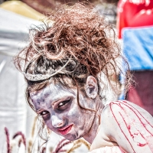

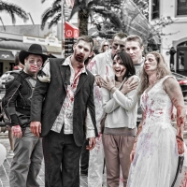
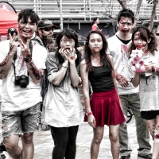

Perth Zombie Walk is a fun & eccentric annual community event that raises funds for the Brain Foundation, a nationally registered charity dedicated to funding world-class research in Australia into neurological disorders, brain disease and brain injuries.
Take a look around our site to learn more about the walk, how you can help, and register to Join the Horde!

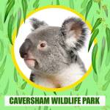
Woodward Rd, Caversham WA 6055
Admission Prices

Adult | $26.00
Child (3 – 14 years) | $11.50
Student | $18.50
Aged Pension | $18.50

Admission Price includes
all shows, talks, animal feedand photo opportunities

Western Australian in-date Aged Pension Card or Western Australia in-date Student Card must be presented to receive concession rate
PLEASE NOTE PRICE INCREASE EFFECTIVE 1ST OCTOBER 2015
Adult $27.00
Child $12.00
Student $19.00
Aged Pension $19.00
GIFT VOUCHERS AVAILABLE – available at reception or please call 08 9248 1984

Welcome To Caversham Wildlife Park
Come and spend the day at one of Perth’s most exciting tourist attractions, showcasing the largest private collection of native wildlife in Western Australia.
Hand-feed the kangaroos, join in the interactive farm show, touch a possum or lizard, meet a wombat, catch a keeper talk or two and have photos taken with koalas! Caversham Wildlife Park; a great Australian meet & greet experience for the whole family, in one fantastic day!
All of our shows, talks, photo opportunities and animal food are included in the entry fee! With no extra money needed around the park, you can make the most of your experience at Caversham Wildlife Park.
Caversham Wildlife Park is very proudly owned and operated by a Western Australian family. We don’t receive any Government assistance; the park is solely funded by visiting patrons! Thank you for your support and assistance!

Farm Show
Daily Shows: 10.00am, 1.00pm, 3.00pm

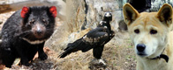
Keeper Talks
Weekends, Public Holidays
and School Holidays
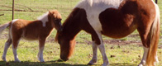

Molly's Farm
Daily: 9.30am to 4.30pm

Meet The Koalas

Daily Morning Session: 10.00am to
1.00pm Daily Afternoon
Session: 2.30pm to 4.30pm
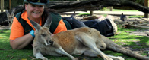

Feed The Kangaroos

Daily:9.00am - 5.30pm

Meet Wombat & Friends

Daily: 11.00am, 2.00pm, 3.45pm

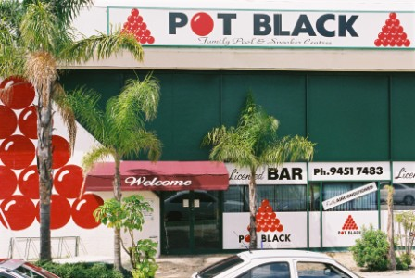

5 Mallard Way, Cannington
Phone: 9451 7483
Opening Times:
10am - late, 7 days a week
Facilities:
Pool & Snooker Tables
9 ball table
Hot and Cold Snacks
Video Games
Soccer Table
Airconditioned
Pot Black - Cannington
Features & Discounted Rates
10% Discount to uni and tafe students, pensioners & approved social groups
7 days per week. Excluded Friday & Saturday nights between 7.30pm and close.
Morning Specials: Play on any table for only $11 per person for 3 hours between 10am and 1pm on any day. Members pay only $9.
Afternoon Specials: Play on any table for only $12 per person for 3 hours between 1pm and 6pm on any day. Members pay only $10.
Special Seniors Mornings: For only $10 each, seniors play for 3 hours between
9am and 12noon on Tuesdays. Members pay only $8.
Memberships: You don’t have to be a member to play at Pot Black, but members qualify for special benefits. For example, Pot Black members receive substantial discounts of up to 35% on table hire charges, up to 15% discount on purchases of accessories and up to 10% discount on the bar.
For more information, please click through to our Memberships page.
Special Rates for Group Bookings: Phone us for more information on
9451 7483.
Pool & Snooker Leagues: Pot Black Cannington regularly conducts pool and snooker leagues for both social players and serious players.
Phone us for more information on 9451 7483 or click through to the Competitons page.
Rates to Hire Tables
Players are not charged individually. If the hire rate is $15 per hour and there are four people in your group on the one table, the real cost is only $3.75 each per hour.
Premium Snooker
Weekdays: $16 per hour Weekends: $17 per hour
Standard Snooker
All Times: $15 per hour
Pool
All Times: $15 per hour
American Pool
All Times: $15 per hour
Includes all equipment and GST.You pay only for the time you use.
Prices subject to change without notice.

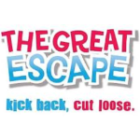
Visit us at

22 Southside Drive, Hillarys
Boat Harbour, WA 6025

Call us on 9448 0800
General Entry $34.90 per person
INCLUDES ALL DRY RIDES AND ATTRACTIONS ONLY*
Or ALL DAY Waterslides $24.90 per person INCLUDES ALL 4 X WATERSLIDES ONLY*
Or ALL DAY Kiddeez Zone $12.90 per person
INCLUDES UNLIMITED RIDES ON THE ADVENTURE PLAYGROUND, MINI JUNGLE MOUNTAIN, CHAIR-O-PLANE & BOUNCY CASTLE ONLY*

Just looking to come along for a great day? Here's all the information you will need:
No Booking Required. Come on down and join the fun!
We are open every day between 10am to 5pm.
A few things you may need to know.
Glassware, sharp knives and implements may not be brought into our fun park.
Alcohol may not be brought in or consumed.
No smoking is allowed in the fun park or entire harbour.
Eyewear is not permitted on any of our waterslides.
For safety reasons, if you are unable to comply with correct riding procedures for any attraction, you will not be permitted to ride. This may include guests that have restricted movement due to a plaster cast. Consult the lifeguard/attendant at each attraction for further information.

2015/16 Pricing starts on the 11th of September 2015
High Ropes $14.90 per person PER SESSION
Rockwall $4.90 per person PER SESSION
6D Cinema $4.90 per person PER SESSION
Trampolines $7.90 per person PER SESSION
Chair-o-plane $3.90 per person PER SESSION
Kiddeez $9.90 per person ALL DAY
Mini Golf
Adult $12.90 per person PER 18 HOLES
Child "Under 12" $9.90 per person PER 18 HOLES

important information
*Age/Height Restrictions apply - please refer to our individual attractions for further information about age/height requirements
Food and beverages from outside the park may NOT be brought into or consumed inside the park.
For more information, please view our park conditions

City of Roleystone Activities

There's the Discovery Trails for the avid explorer from 10am to 11:30am daily.
There will be an opportunity to get arty and creative later in the afternoon with clay modelling and plenty of crafts on offer.
For $3 per child, the school holiday activities begin at 10am and wrap up at 2pm so there's heaps to do with parents/carers costing only $4 to join in the fun too.
Don't forget there is lots to see and do at Araluen and if you're peckish why not pack some food as both electric and wood-fired BBQ's (between April and November) are available for whipping up some snaggers or juicy steaks.
Otherwise visit the Chalet Healy Tearoom for lunch or morning and afternoon teas from 10am to 4pm and maybe afterwards take a ride on the Araluen Train.

While you have made the trek up to Roleystone, why not pop into the Roleystone Theatre for some theatrical entertainment for the kids.
Storytime in the Hills is on Monday 1st, Wednesday 3rd and Friday 5th of October at 11:00am and 2:00pm.
There will be two short plays performed that have been written for children aged three years and up.
Adults and children under three are free and are invited to come along and enjoy the entertainment as well as.
Children's tickets are $10 and that includes a drink and a snack during intermission.
Call this number 9397 5730 to reserve your seats. Ticket sales are open now.

Halcyon Stables Spring Holidays Camp
If your kids love horse riding then book them into the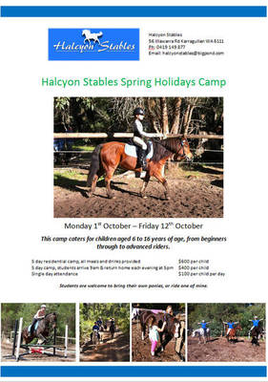 School Holidays Camp at Halcyon Stables. Located in Karragullen
The camp is $100 for one day, $500 for 5 days from 9am to 5pm and $600 for a residential stay with meals provided.
The camp runs in the first week of the October school holidays from Monday 1st for children aged from 6 to 16 years of age.
Anyone can attend no matter what skill level. If your child is a seasoned rider or a beginner all are welcome and if you don't have your own horse or pony there are some happy to be "borrowed".

According to the facebook page the camp includes: "two rides per child, one lesson and one trail ride plus games, theory lessons and hands on learning about horses and their care."
For more information ring 0419 149 877 or halcyonstables@bigpond.com.
Roleystone Parks and Reserves:
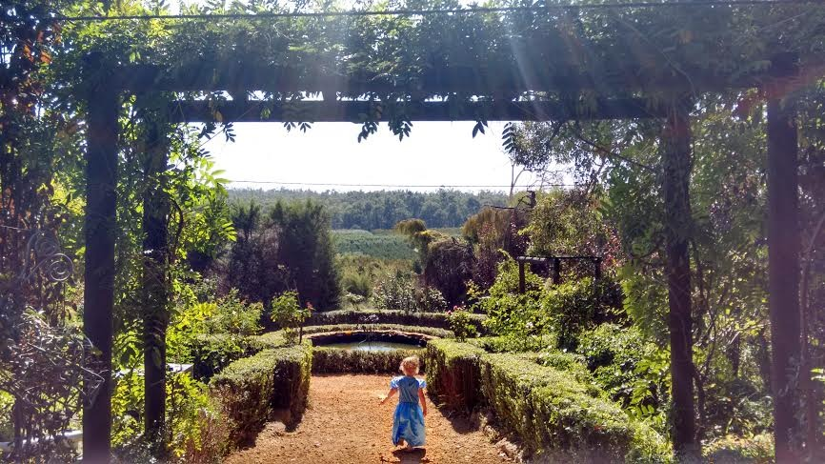
The drive itself along Brookton Highway, through picturesque Roleystone, is breathtaking and at times can feel more like a scene from a movie with its maple

Of course there is always free fun to be had with a visit to either Borrello Park or Churchman Brook Dam. Take a picnic or a BBQ and let the kids enjoy the playground and the natural spectacular this area puts on in Spring!
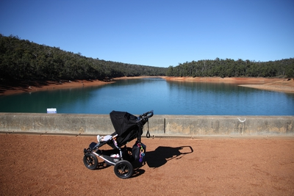

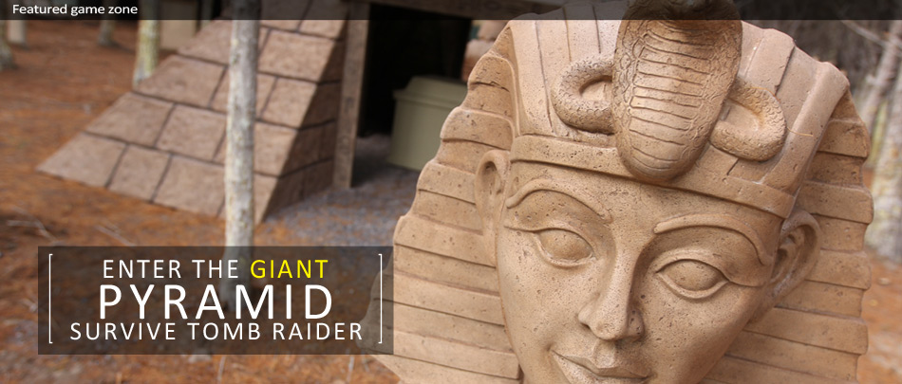

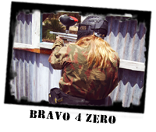
# Paintball
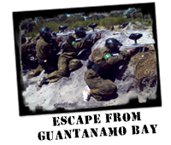
With the focus on quality game scenarios, safety and a professional service, Delta Force Perth
Muchea has not only revolutionised the sport of paintball in Perth, it has also welcomed many new players to this amazing sport and encouraged new participants to try this adrenalin packed adventure activity.
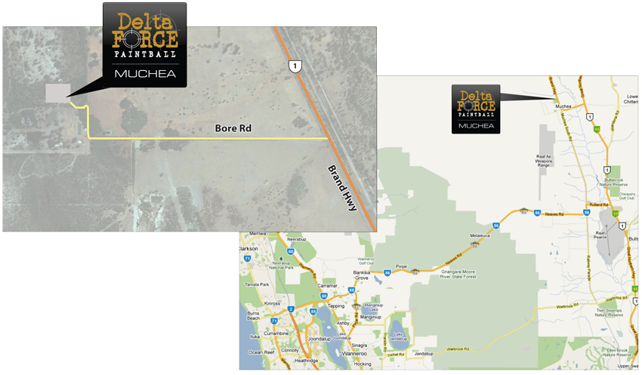
Safety is paramount and as such, Delta Force has spent a sizeable budget ensuring it has the very best in safety equipment available for its patrons. Its full head helmets that protect the entire head are a must, especially for the younger players. The specifically-designed body armour is issued to all players free of charge and helps to protect the upper torso. Neck protection is provided by the integrated padded-collar in the camouflage overalls. Further protection such as armoured paintball gloves and cricket boxes are also available to purchase.
So get your mates, family, bucks party, corporate function or work colleagues together and experience the new revolution of paintball games!
Rates:
$14.95 - Entrance and equipment for a FULL DAY of paintball action!
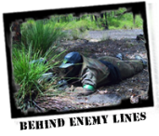
Includes:
12-14 action-packed games
A large selection of movie-set quality paintball game zones
Full head protection incorporating an anti-mist goggle system
Full body protection - body armour - free for all players
Full neck protection - combat suit with high padded collar
Custom designed special-forces combat suit
Latest USA-spec rapid-fire semi-automatic machineguns
Hip-mounted 400-shot capacity ammo magazine (to safely carry your paintballs)
Tuition and supervision by friendly Delta Force marshalling staff
Unlimited propellant
End of day debrief and TOP GUN awards
Comprehensive $20 million public liability insurance
Safe, friendly and professional service

Paintballs:
$250 for 2000 paintballs ($12.50 per 100 paintballs)
$145 for 1000 paintballs ($13 per 100 paintballs)
$85 for 500 paintballs ($14 per 100 paintballs)
$22 for 100 paintballs
Additional:
Additional paintballs, gloves, snacks and drinks are available for purchase.
Downloads:
Parent Information Document
Registration Form Muchea
Game Zones:
- Behind Enemy Lines
- Escape from Guantanamo Bay
- Jungle Attack
- Speedball
- Tomb Raider

Location

Baldivis

BY CAR
From Perth CBD:
Take the ramp to Great Eastern Hwy and continue for 11.5 kms. Turn left at Meadow St. At the roundabout, take the 2nd exit onto West Swan Rd and continue for 15kms. Turn left at Great Northern Hwy and continue for 20kms. Turn left to stay on Great Northern Hwy
Turn left at Brand Hwy. Continue along the Brand Hwy for 3kms past Muchea and take the first left after the Ti West Processing plant, on to Bore Rd. Watch for signs to the paintball centre. Follow signs to the car park.
Arrival Time:
As per confirmation.
Minimum age:
12 years
Map:
MUCHEA.pdf
Telephone:
For directions please call 1300 850 744

Circus WA Workshops

Sponsored School Holiday Programs & Even
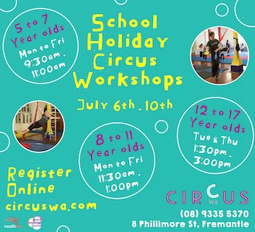
Have you ever wanted to run away with the circus? Fancy learning how to juggle, walk a tight rope, or swing on a trapeze??
Then come on down to Circus WA for our School Holiday Workshops!
These school holidays, kids and teens from 5-17 years old can come and try out the circus for themselves. With activities like diablo, unicycling, acrobatic tumbling, trapeze, and hula hoop, there’s plenty of fun to be had, and new things to learn!
Each workshop will run for 1.5 hours, and will be led by our talented trainers, who are all Circus performers themselves. The trainers will guide the students through various apparatus, and help them to develop their strength and coordination as well as skills they never knew they had!

SPRING SCHOOL HOLIDAY PROGRAM

ENROL NOW!
PLEASE NOTE: All scheduled workshops for 5 – 7 and 8-11 year olds are now FULL.
**JUST IN** An EXTRA school holiday workshop for 8-11 year olds has been scheduled for Friday 2 October 2.00pm-3.30pm. GET IN QUICKLY TO SECURE YOUR SPOT
TUES 29TH SEPT | WED 30TH SEPT | THU 1ST OCT | FRI 2ND OCT | MON 5TH OCT
9:30am – 11:00am **CLASS FULL** | 9:30am – 11:00am **CLASS FULL** | 9:30am – 11:00am **CLASS FULL** | 9:30am – 11:00am **CLASS FULL** | 9:30am – 11:00am **CLASS FULL**
5 to 7 year olds | 5 to 7 year olds | 5 to 7 year olds | 5 to 7 year olds | 5 to 7 year olds

TUES 29TH SEPT | WED 30TH SEPT | THU 1ST OCT | FRI 2ND OCT | MON 5TH OCT
11:30am – 1:00pm **CLASS FULL** | 11:30am – 1:00pm **CLASS FULL** | 11:30am – 1:00pm **CLASS FULL** | 11:30am – 1:00pm **CLASS FULL** | 11:30am – 1:00pm **CLASS FULL**
8 to 11 year olds | 8 to 11 year olds | 8 to 11 year olds | 8 to 11 year olds | 8 to 11 year olds

TUES 29TH SEP | WED 30 SEP | THURS 1 OCT | FRI 2 OCT | MON 5 OCT
2:00pm – 3:30pm |  | 2:00pm – 3:30pm | 2:00pm – 3:30pm
12 to 17 year olds |  | 12 to 17 year olds | **8 - 11 YEARS OLD** Extra Class
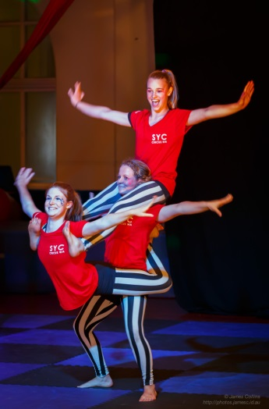
**CircusWA reserves the right to cancel or amend any classes due to insufficient enrolments. Should your workshop be cancelled you will be offered an alternate workshop, or a gift voucher to be used for future workshops. **
Each workshop is $29.00.
You can enrol in just one, or you can enrol in as many as you like
Payment is required at the time of registration to secure your place.
Once you have registered you will see a confirmation screen with our bank account details.
Please transfer the funds to our account. Once we have received your payment we will send you a confirmation email.

WA Circus School
BSB: 082-356
Account Number: 945 991 368
Bank: NAB

(Please use child’s full name or surname as a reference)
If bank transfer is not possible, you can pay via credit card over the phone on (08) 9335 5370.
If payment is not received within 3 business days of registration, we cannot guarantee that a place will be reserved in the class. We thank you for your understanding
- Willetton - Call 9332 2250 or Book Us Now
Telephone | (08) 9332 2250
Opening Hours | 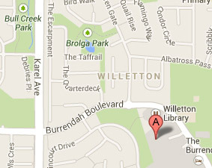  Mon - Thu 2:00pm - 9:00pm  Fri 12:00pm - 11:00pm  Sat 10:00am - 11:00pm  Sun 10:00am - 9:00pm  School & Public Holidays  10:00am - 9:00pm  Open at 10:00am on School & Public Holidays. Can be open at other times by arrangement.
Email | willetton@lazerblaze.com.au  (Bookings can't be made via this email)
Fax | (08) 9312 2540
Store Address | Lazer Blaze Willetton  Shop 73 (Level 1) Southlands Shopping Centre  Burrendah Blvde (corner of Pine Tree Gully)  Willetton WA 6155
Pricing
We offer rates for individual games, lockouts and groups. We also have special packages, perfect for parties and get-togethers.
Number of Games | Standard Game Prices | Member Prices
1 | $12.00 | $11.00
2 | $20.00 | $18.00
3 | $27.00 | $25.00
4 | $33.00 | $31.00
Extra Games | $6.00 | $6.00
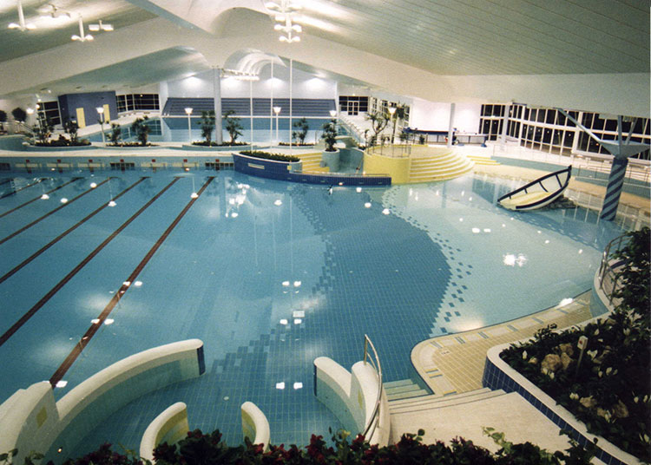

Bayswater Waves

At Bayswater Waves you’ll discover many wet and wild attractions, including WA’s only wave pool, six heated swimming pools, a twisting water slide, giant inflatables, swim-in movie nights and a whirlpool.
Or perhaps our lazy river, spa, sauna and steam room are more your pace?
Bayswater Waves offers more than 200 swimming lessons a week for people of all ages and abilities through the Bayswater Waves Swim School. All our pools are perfectly climate-controlled with state-of-the-art filtration systems.
Our double-storey Bayswater Waves Health Club boasts the latest resistance equipment and computerised exercise machines. Within the health club is our Spin Studio with 21 spin bikes and a circuit room that offers 15 different weight resistance machines. We also offer more than 60 group fitness classes per week, including aquarobics, aerobics, yoga, fitball and over-50s classes.
At Bayswater Waves, we offer a wide range of fee structures to cater for everyone – casual single visits, 10 visit vouchers, family passes and memberships.
Take your time to study the huge range of facilities and services available at Bayswater Waves. And don’t forget – we are always available to answer any questions you may have, to help make your stay more enjoyable. Be sure to give us a call on 9276 6538.
Perth’s Premier Indoor Aquatic Playground
Cnr Broun Avenue & Priestley Street, Embleton WA 6062
Tel: (08) 9276 6538 Fax: (08) 9276 9190
Email: waves@bayswater.wa.gov.au
Erth’s Dinosaur Zoo
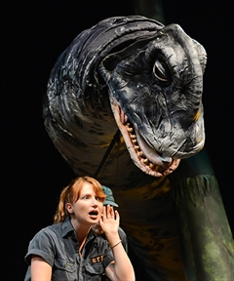
EVENT DETAILS

Cost:
$21.50 Standard; $17.50 Child (16 and under)
Who should attend:
This event is open to everyone, however children must be accompanied by parents and guardians.
How to get there:
You can reach this venue using public transport. To plan your journey, please visit Transperth.
Don Russell Performing Arts Centre
Murdoch Rd Thornlie
Western Australia
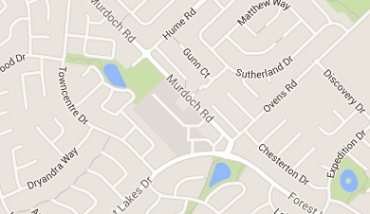
Don Russell Performing Arts Centre
Murdoch Rd, Thornlie
Western Australia

CONTACT DETAILS
Telephone:
9493 4577. Box Office Hours, Monday to Friday 9am - 5pm. Cash and Credit Card payments available.
Email Address: drpac@gosnells.wa.gov.au
Get the best out of your neighbourhood and discover more local events with nabo.com.au
Related Links
Program Brochure - New Season shows Buy Tickets here

# Thornlie bike & skate ramp
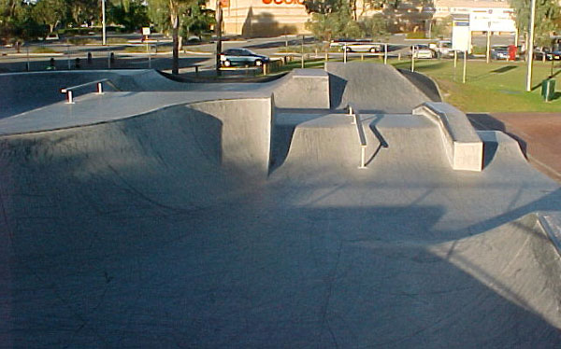
– Located behind Thornlie shopping centre
Remember to wear your helmet and protective gear.

# HAVE A MOVIE DAY AT HOME
Some Video Ezy stores have $2 Tuesdays for new releases, or get a pile of old classic family movies they are usually around $1 each if you hire a few at a time - grab some popcorn from the supermarket and you have the movies at home.

GET ON A NATURE PROGRAM AT THE COCKBURN WETLANDS CENTRE
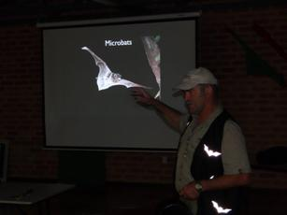
The Cockburn Wetlands Centre have fantastic nature programs every school holidays - night stalks, star gazing, reptile & wildlife interaction, nature craft and more!
Programs all under $5 per person,

Cockburn Wetlands Education Centre
Environmental Organisation
Address: Bibra Lake WA
Phone:(08) 9417 8460

Get the bikes
Take a friend and helmet and bike through one of your cycle trails in your local area.
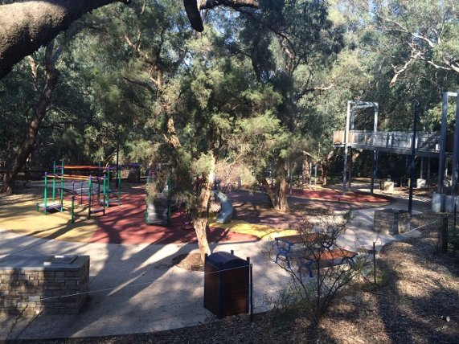

Activities at Bunnings *FREE*
Kids D.I.Y. Workshops
Let your kids make their own fun this weekend. Bring them along to our free Kids D.I.Y. Workshops
at Bunnings where they’ll make fun, creative projects like toolboxes, toy trucks, planter boxes and painting projects. With a different theme every week from garden and woodworking to paint, mosaics and recycled wall art, these workshops are free for children over the age of 5. An adult must accompany all children.
Workshops run every Saturday and Sunday, contact your nearest store for information on what’s on this weekend. Please note that as numbers are limited, bookings are recommended.

What's on: D.I.Y. Workshops and Activities

10:30am - 11:30am
Maddington Bunning's Garden Club
Are you a Green Thumb? or would like to be? Then come along to Maddington Bunnings monthly Garden Club. It's a free information session where you can get tips and tricks from our experts and you have a chance to ask some questions. This month we will be talking everything about tomato's. To book over the phone please contact 9238 8200
Make a booking

Wednesday 30th September

10:00am - 11:00am

School Holiday Program- Grandparents and Kids Workshop
Kids D.I.Y. Workshop Come into Bunnings Maddington with the grandkids for a fun activity decorating a pot and planting some seedlings. light refreshments will be provided. for queries or to book over the phone
please contact 9238 8200
Make a booking

Thursday 1st October

10:00am - 11:00am

School Holiday Program- Tissue Paper & Canvas Artwork

Kids D.I.Y. Workshop School Holiday Program

Make a booking

Friday 2nd October

10:00am - 11:00am

School Holiday Program- Popsicle Stick Fridge Magnets

Kids D.I.Y. Workshop School Holiday Program

Make a booking

10:00am - 11:00am

School Holiday Program- Jelly Fish In a Bottle
Kids D.I.Y. Workshop School Holiday Program
Make a booking

10:00am - 11:00am

School Holiday Program- Candle Printing
Kids D.I.Y. Workshop School Holiday Program
Make a booking

10:00am - 11:00am

School Holiday Program- String Art
Kids D.I.Y. Workshop School Holiday Program
Make a booking

10:00am - 11:00am

School Holiday Program- Make Your Own Woodwork Creation
Kids D.I.Y. Workshop School Holiday Program
Make a booking

Call your local store to find out what's on during the school holiday.

#Ellenbrook Water Playground *FREE*
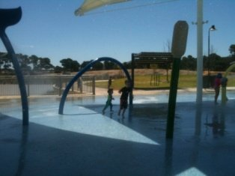
This wonderful free water playground is lots of fun for when the weather heats up. Lots of grassed area and free bbq's so bring lunch along and run around in the water sprays and cannons for hours on end! There is also a bmx track next door so bring the bikes along for some added fun.

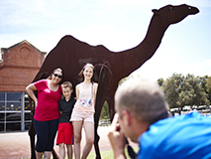
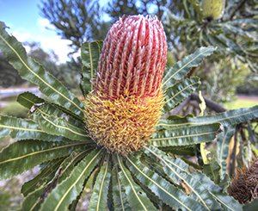
  - Environment & Conservation
    - Caversham Wildlife Park
    - The Children’s Forest
    - Woodland Reserve
  - Transport Heritage
    - Heritage Tram Rides
    - Motor Museum of WA
    - Vintage Train Rides
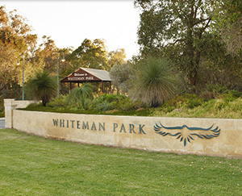
    - Whiteman Explorer
    - Revolutions Transport Museum
  - Village/Shops
    - Handcraft Centre
    - Pottery Centre
    - Print Shop
    - The Lolly Stop
  - Park Facilities
    - Dog Park
    - Village Café
    - Bush Walking Trails
    - Barbeques
    - Chariots of Hire
    - Picnic Shelters
    - Playgrounds
    - Orienteering
    - Sports Facilities
    - Walk / Cycle Paths
    - Mini Water Playground
- Visitor Info
With hectares of open space, great playground facilities and lots of fun attractions it's not surprising that so many families choose Whiteman Park for children's birthday parties. Why not book one of picnic shelters, or Bennett Brook Railway’s party carriage?
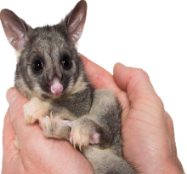

Whiteman Park is a fun place to visit, with so much for you to see, do and discover!
You can feed kangaroos at Caversham Wildlife Park, visit the Boy of the Bush in the Children’s Forest, jump in the driver’s seat of a bus at Revolutions Transport Museum and have fun with all the different activities on offer each school holidays. With so much variety, you’ll need to ask mum and dad to come back over and over again! In this section of the website, you can find out about the many birds and animals in the Park (Fact Sheets), find things to do in the Children’s Forest and download some fun for home.

Whiteman Park: Entry off Lord Street or Beechboro Road, Whiteman, Western Australia

Art Gallery of Western Australia

School Holiday Activities
2015
Treasure Ships Opening Weekend
10am-4pm | Saturday 10 & Sunday 11 october
Activities are FREE, exhibition entry costs apply
Join in the free family fun with AGWA and Awesome Festival for the opening weekend of Treasure Ships.
Kids can get creative in our map-making and painting with spices art workshops. On Saturday, be entertained by Glenn B. Swift, Storyteller Extraordinaire. And on Sunday, experience the magic of an Indonesian Wayang Kulit (shadow puppet) performance and hands-on workshop.
Treasure Ships features the spectacular and exotic art produced for global markets in the age of spices. The exhibition, displaying art dating from the sixteenth to early nineteenth centuries, uses extraordinary works of art to tell the story of spice markets and shipwrecks.
Interactive Drawing Space
The State Art Collection display Your Collection 1920 – 1960 features a drawing table for both children and adults. Participants can draw a colourful still life using the objects in the exhibition as inspiration. You can then take your work home or display it within the space for everyone to admire
While there, don’t forget to pick up a free city playground pass from AGWA
City Playground Pass for your ticket to school holiday adventures in the City. See inside for details and don’t forget to keep this guide to help you explore everything on offer.
A helpful reminder, works of art are like Emus, they don’t like to be touched, and children under ten must be accompanied by an adult at all times when visiting the Gallery. We look forward to your visit!

Situated in the Perth Cultural Centre, the Art Gallery of WA is conveniently located within easy walking distance from the Perth train station, and is accessible from most Perth-bound bus routes.

Walking
Entry from the City is best taken via the Perth Train Station and Roe Street pedestrian overpass, or from Barrack Street via the James Street Mall.
Rail
AGWA is easily accessed by the pedestrian over-pass from the Perth Train Station. On alighting from your train follow signs for 'Eastern Concourse'. Take the lift or the escalators to the top; proceed through the barriers and turn left. You will cross the bridge immediately before arriving at the Gallery to your right.
Bus and Taxi
Transperth's Blue CAT buses provide the closest pick-up and drop-off points for the Art Gallery at the Museum Stop on Beaufort St.
Taxi and special group buses are temporarily permitted to drive into the Cultural Centre to within 30m of the Main Gallery entrance for set-down and pick-up purposes only. Please inform your driver to enter James St via Beaufort St. Longer-term parking is strictly prohibited.
City of Perth Parking (CPP) provides convenient open and covered car parking facilities around the city – including three in close proximity to the Art Gallery – just look for the distinctive City of Perth Parking signs.
Download the CPP Parking App

- Opening Hours
Day: Wednesday - Monday
Time: 10am - 5pm
Closed Tuesdays, Good Friday, Anzac Day and Christmas Day.

- Entry Fees
While the Gallery is free to visit, we do ask all visitors to make a voluntary donation as you enter.

Perth Cultural Centre
Perth, Western Australia
Geo code for GPS: -31.950414,115.860604

AQWA Aquarium of Western Australia
Hillary's Boat Harbour, 91 Southside Dr, Hillarys WA 6025
(08) 9447 7500

AQWA showcases the marine life and unique regions of Western Australia’s magnificent 12,000 km coastline. Activities include: Visiting all marine life exhibits which includes sharks, ...
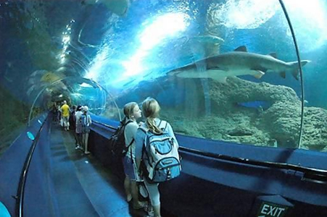

Admission prices
Adult | $30.00
Concession  (Valid concession card must be shown: Pensioner, student, healthcare card) | $22.00
Child  (ages 4 to 15 years) | $18.00
Child  (under 4 years if accompanied by a family member) | Free
Family  (2 adults and 2 children) | $79.00
Cost
low prices for Tuesday

Bowling from
$14.90
per adult

$12.90
concession

AMF Cannington

Contact Details

Address
Manning Rd and Burton St
St Cannington WA 6107
Phone: 1300 368 067
Email: amf_cannington@amfbowling.com.au

Operating Hours
Monday - Friday: 10am - Late
Saturday - Sunday: 9am - Late
School Holidays: 9am - Late

Service & Facilities:
- 24 bowling lanes
- Birthday Parties
- Corporate and Group Functions
- Café seating for 48 people
- Fully licensed bar
- Glow in the dark bowling Friday and Saturday nights
- Amusement machines and pool table

#Explore Kings Park
Synergy Parkland *FREE*
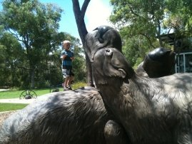
See dinosaurs and find fossils, and play on the island playground (not recommended for children under 4 as the playground is located in the middle of the water) - but an awesome adventure playground for older children.

# Climb DNA Tower Kings Park *FREE*

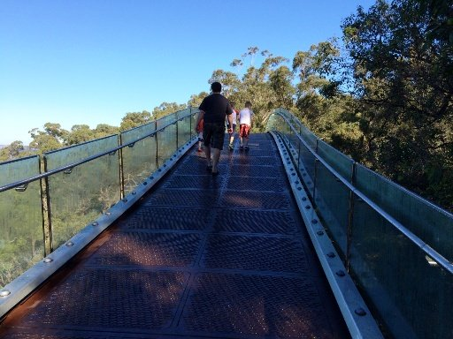
Climb to the top of DNA Tower - either drive or take the 30-40min round walk from Synergy Parkland While you are there see if you can find the hidden Geocache!

# 14 Walk the treetops at Kings Park along the Lotterywest Federation Walkway*FREE*

Get a beautiful view of the city an enjoy this short walk along the treetops in Kings Park
Bring a picnic lunch or buy lunch or a coffee at Sticky Beaks Cafe located within the play area.

Variety Place (Ernst Wittwer Playground)- King’s Park

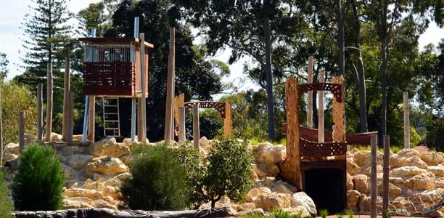

This park has had a re-do in August 2014 with new play structures added and picnic areas. It has been designed as a recreational area suitable for people of all ages and abilities supported by Variety WA and hence the new name, Variety Place.
The area is mostly constructed with natural materials, with bark chips to provide a soft fall.

Activities include:
- Fort
- Climbing nets
- Climbing logs and rocks
- Tunnels
- Bridges with hiding areas underneath
- Metal maze
- Stepping stones with balancing planks.
- Jarrah logs, some of which have carvings of various insects on them.
- Saw Avenue amphitheatre (kid’s shows held here during summer events season)
Click on the images to enlarge:
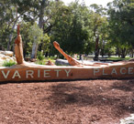 | 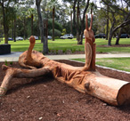 | 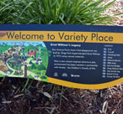 | 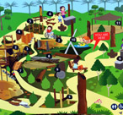
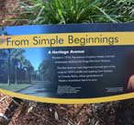 | 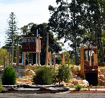 | 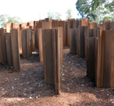 | 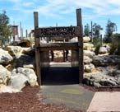
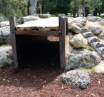 | 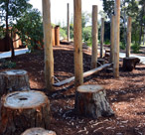 | 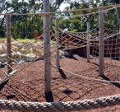 | 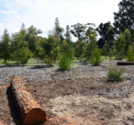
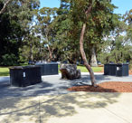 | 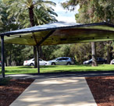 | 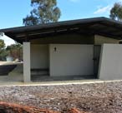

Age: All ages
Duration: You can fill a morning or afternoon here.
\Accessibility
Parking in lots on May Drive, Kulbardi car park and parallel parking allowed on Saw Avenue (on the side of the playground – not permitted on the other side of Saw Avenue). Disabled and pram access is best from Kulbardi car park as this has a path directly to the park, other parking locations do not.

Facilities:
- Variety Pavilion can be booked – holds 40-50 people and has power outlets
- Water fountains (several scattered at various locations around the play space).
- Picnic tables (many are shaded or placed in areas with tree cover). Many have wood carvings benches cut into interesting shapes.
- Free electric bbq area.
- Disabled/male/female toilets.

Cost: Free

Opening hours: Daily all year round.

Website
http://www.bgpa.wa.gov.au/kings-park/visit/maps-and-transport/saw-avenue

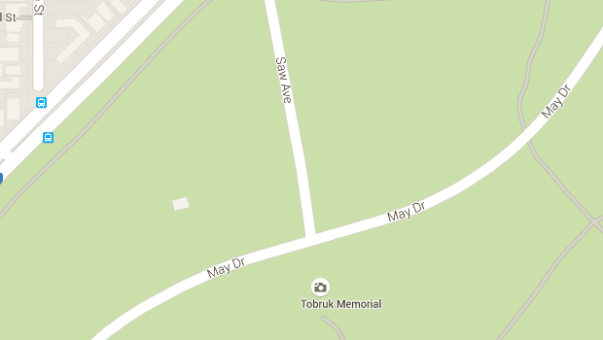
Contact details: Saw Avenue, King’s Park, Subiaco, WA 6005.
bookings@bgpa.wa.gov.au
Bookings: 9480 3624
Fax: (08) 9322 5064
Park Management officer 0418 923 973
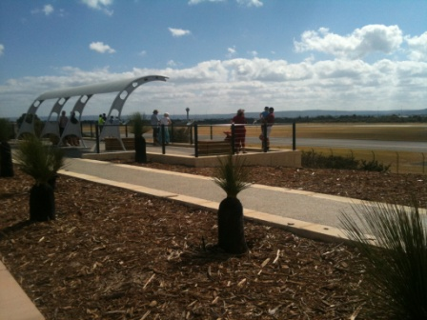

# Watch the planes take off from the Perth Airport Viewing Platform *FREE*

Take a packed lunch and spend a couple of hours watching planes take off and land or spot a bandicoot on the walking trail

RIDE THE TRAIN TO MANDURAH OR FREMANTLE
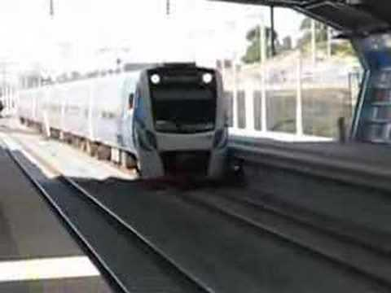
Make sure you choose a Family Rider ticket and the family
Can ride all day for only $11.60 (7 people, max 2 standard fares)
Make sure you choose a Family Rider ticket and the family can ride all day for only $12.20 (7 people, max 2 standard fares)
Get your Perth train activity sheets here

VISIT THE PERTH MUSEUM
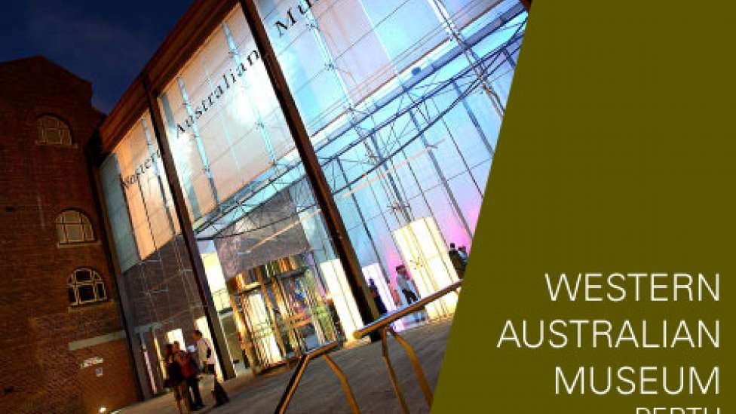
Entry is free (suggest donation $5), and there are some great school holiday activities on (you may need to pay a small fee to participate in the activities)

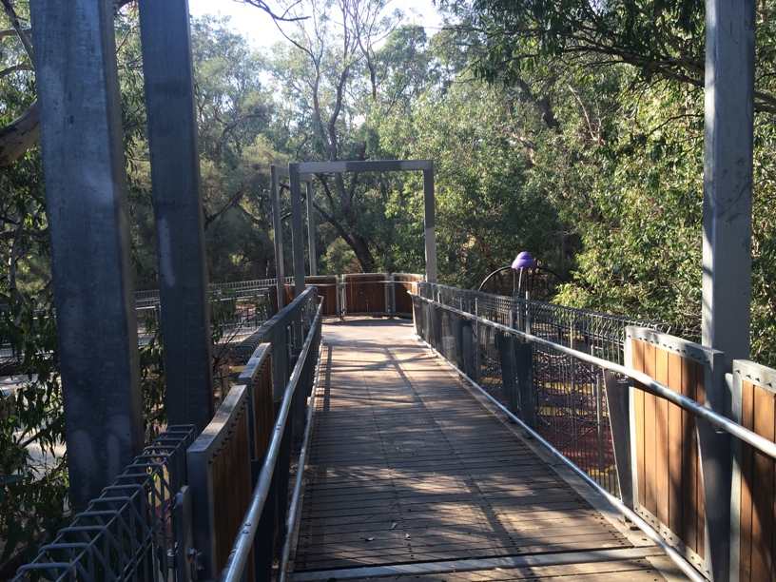

THE TREETOP WALK AT PIONEER PARK - GOSNELLS

Check out the activities at your local library and local Council
There are usually lots of great school holiday activities at your local library, but get in quick you usually have to book. Or just take a visit to check out some new books - most library’s usually have fun, educational kids areas. See our Your Local Library page for some local library’s that hold school holiday activities.
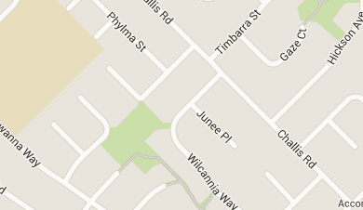
Games Morning

Love playing games?
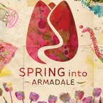
Visit the library for some old fashioned fun and play a variety of board games including giant Snakes and Ladders, and Connect Four. Places are li... more
Spring into Armadale Festival
Spring into Armadale will present a unique series of events which includes arts, culture, food, wine and nature experiences in the Armadale and hills region. The Festival will showcase more than 150 events that will be occurring in the region from August to October including the Araluen Botanic Park Tulip Spring Festival.
The major, inaugural events include the So Unexpected Artisan Exhibition and Artists Village - an exclusive opportunity to see internationally recognised artists, couture designers and musicians in one place.
Bring your families and friends, to enjoy the scenic Minnawarra Park and Sanctuary Lake and to enjoy the markets, music, food, dancing, crafts and sports that happening in the City of Armadale. There is lots for everyone from kids to seniors.

Cost:
This is a free event.

Who should attend:
This event is open to the general public.
How to get there:
Please visit Transperth as your guide to public transport timetables, fares and accessible transport.

Want more from your suburb?
nabo.com.au is the social network for your suburb.
Get the best out of your neighbourhood and discover more local events with nabo.com.au

Minnawarra Park
Armadale Rd and Orchard Ave , WA Armadale (WA)
Western Australia

8 Sep to 31 Oct
Tuesday, 29 Sep 2015
Wednesday, 30 Sep 2015
Thursday, 1 Oct 2015

Perth

Minnawarra Park
Armadale Rd and Orchard Ave , WA, Armadale (WA)
Western Australia

Armadale (WA) community · kids · library
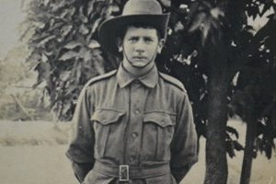
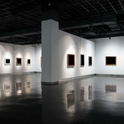

On the Home Front: Life in the City of Armadale During World War I
History House Museum
Discover life in the City of Armadale During World War I in the History House Museum.
ANZAC Exhibition – “On the Home Front: Life in the City of Armadale During World War I”.
On the Home Front: Life in the City of Armadale During World War I
24 April 2015 - 11 November 2015,
Tuesday, Thursday and Friday: 10am - 4pm & Saturday and Sunday: 1pm - 4pm
History House Museum, 11 Jull St, Armadale WA 6112
Cost:
Free
Who should attend:
This is open to everyone.
How to get there:
For all public transport options to this venue, please visit Transperth .
History House Museum
Jull Street Armadale, WA 6112
Email: cbell@armadale.wa.gov.au
Cost: Free
Event Contact: Phone (08) 9394 5670

City of Armadale
7 Orchard Avenue
Armadale
Western Australia 6112

T: 08 9394 5000
F: 08 9394 5184
info@armadale.wa.gov.au

Armadale (WA) art · entertainment · exhibition · free
You Can't Laugh At That!

Peter Rowsthorn, renowned comedian and actor, will be your guide as he takes you on a tour of History House Museum and gives you his take on the history of the City of Armadale.
Come along and listen to him share stories relating to some of his favourite objects on display. Refreshments will be provided.
PLEASE NOTE: The performance on Thursday 29th October will be filmed by Barking Wolf.
Cost:
This is a free event.
Who should attend:
This event is open to the general public.
How to get there:
If you wish to use public transport to get to this venue, please visit Transperth.

Lego Games - Seville Grove Library
Come and create amazing things at our game themed Lego sessions. There will be games and challenges. Places are limited and bookings are essential... more

Tai Chi For Health And Tranquillity

Knowledge Centre - Gosnells
The ancient Taoists were renowned for their study of the arts of health and longevity. Tai Chi brings this tradition to the modern world.
The Taoist Tai Chi Society of WA will demonstrate how Tai Chi can bring health and wellbeing into your life in a friendly atmosphere.
Cost:
This is a free event, refreshments will be provided and bookings are essential.
Who should attend:
This event is mostly suited for adults.
How to get there:
You can reach this venue using public transport. To plan your journey, please visit Transperth.
Get the best out of your neighbourhood and discover more local events with nabo.com.au
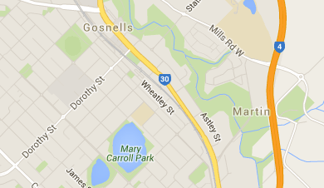
Knowledge Centre
2232 Albany Highway, Gosnells WA 6110 Gosnells
Western Australia
Saturday, 3 October
10:00AM until 11:00AM
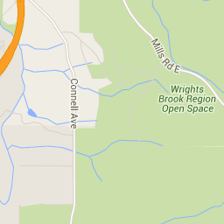
Knowledge Centre
2232 Albany Highway, Gosnells WA 6110, Gosnells
Western Australia

Success community library · school holidays

Beat the boredom with some board games. Join us on Monday mornings for a free session with other like-minded players. We have a range of board and card games available including Scrabble, Backgammon, Chess, Uno and Fluxx.
This event occurs every Monday
a free event.
Who should attend:
This event is mostly suited for kids ages 5+.
How to get there:
If you wish to use public transport to get to this venue, please visit Transperth.
Get the best out of your neighbourhood and discover more local events with
nabo.com.auSuccess Public Library
816 Beeliar Drv , WA Success
Western Australia Friday, 2 October 10:00AM until 11:00AM

Spectacular Science - Science of Fun at Success Public Library
Unleash your inner mad scientist and get involved in some cool experiments.
Science of Fun - October School Holidays @ Cockburn Libraries
All events are free, but bookings are essential | Parents must be in attendance during these events.
Cost: This is a free event.
Who should attend: This event is mostly suited for kids.
How to get there: For all public transport options to this venue, please visit Transperth.
Get the best out of your neighbourhood and discover more local events with nabo.com.au
Success Public Library
816 Beeliar Drv , WA Success
Western Australia
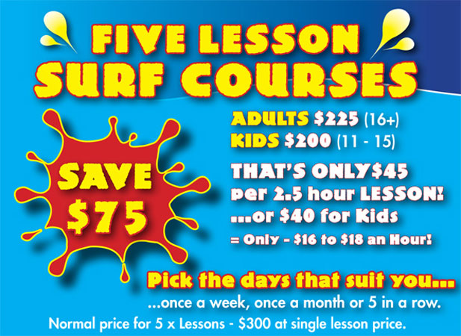
We have been teaching our Surf Lessons and Surf

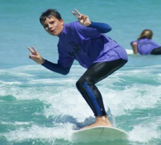
Courses in Perth for over 25 years!
Surfing Lessons Perth employ locals who have many years experience surfing and teaching on our Perth beaches.
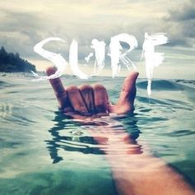
Surfing Lessons Perth are passionate about providing quality teaching and surf instruction to people who want to learn how to surf, no matter their age, fitness level or ability.
Surfing Lessons Perth – SLP
Find us parked on the grass in front of Manning Street
Click Here for directions
Online Bookings Essential
Sorry we dont take bookings at the beach…
Scarborough Beach Surf School – Phone: 08 94475637
The Esplanade, Scarborough, Perth WA ABN: 73 776 977 878
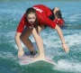
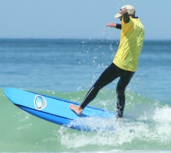
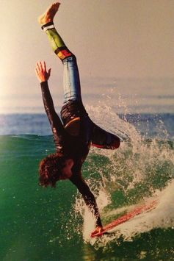
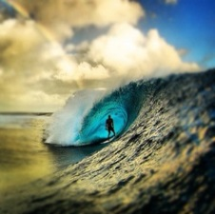
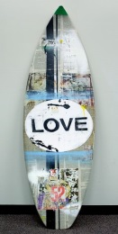
School Holiday Movies at Hoyts REVIEW - What's On
(3D) Everest
Mature themes
EVEREST is the dramatic true story of a team of climbers who found hope, strength and triumph in the wake of tragedy.
Intern, The
Infrequent coarse language and mature themes
70-year-old widower Ben Whittaker has discovered that retirement isn't all it's cracked up to be. Seizing an opportunity to get back in the game, he becomes a senior intern at an online fashion site,
founded and run by Jules Ostin.

Katti Batti
Katti Batti is a modern day romance that traces young architect Madhav Kabra’s (Imran Khan) love for the free-spirited Payal(Kangana Ranaut). They make for a perfect couple until a sudden turn of events creates an unanswered distance between them. What follows is a series a events that tests the fate of their relationship.
The Martian
Survival themes and coarse language
During a manned mission to Mars, Astronaut Mark Watney (Matt Damon) is presumed dead after a fierce storm and left behind by his crew. But Watney has survived and finds himself stranded and alone on the hostile planet. With only meager supplies, Watney must draw upon his ingenuity, wit and spirit to subsist and find a way to signal to Earth that he is alive.
Maze Runner: The Scorch Trials
Violence, science fiction themes and sustained threat
In this next chapter of the epic 'Maze Runner' saga, Thomas (Dylan O'Brien) and his fellow Gladers face their greatest challenge yet: searching for clues about the mysterious and powerful organization known as WCKD.
Oddball
General
The story of Allan 'Swampy' Marsh and his Maremma dog Oddball. Swampy convinced local authorities to allow Oddball to protect a colony of Little Penguins on Middle Island from wild cats and dogs. Oddball succeeds in his campaign and becomes a front runner for Maremma dogs being used to protect other endangered Australian wildlife.
(3D) Pan
Mild themes and violence, some scary scenes
The story of an orphan who is spirited away to the magical Neverland. There, he finds both fun and dangers, and ultimately discovers his destiny -- to become the hero who will be forever known as Peter Pan.
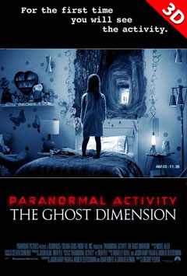
(3D) Paranormal Activity: The Ghost Dimension
Still reeling from the death of their young daughter, Ryan and Emily move their remaining daughter and their Uncle Mike from New York City to Palo Alto, California, where Ryan has a new job designing video games. As the family settles into their new home, they soon realize that something isn't quiet right, and that someone or something intends to use their grief for sinister purposes.

Pixels

Mild themes, violence, coarse language and sexual references
In Pixels, when intergalactic aliens misinterpret video-feeds of classic arcade games as a declaration of war against them, they attack the Earth, using the games as models for their various assaults.

- Straight Outta Compton Strong coarse language
Starring O’Shea Jackson Jr., Corey Hawkins and Jason Mitchell as Ice Cube, Dr. Dre and Eazy-E, Straight Outta Compton is directed by F. Gary Gray (Friday, Set It Off, The Italian Job). The drama is produced by original N.W.A. members Ice Cube and Dr. Dre, who are joined by fellow producers Matt Alvarez and Tomica Woods-Wright. Will Packer serves as executive producer of the film alongside Gray.
Two by Two
Very mild themes and animated violence
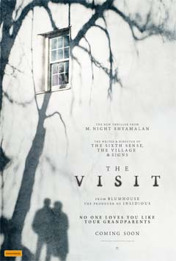
HOYTS Jnr presents… Two by Two on the BIG SCREEN! A flood is coming, and the animals are lining up for the ark, two by two. A couple of creatures that miss the craft set sail, and are faced with the daunting task of staying afloat.
The Visit
Mature themes, violence and coarse language
Shyamalan returns to his roots with the terrifying story of a brother and sister who are sent to their grandparents’ remote Pennsylvania farm for a weeklong trip. Once the children discover that the elderly couple is involved in something deeply disturbing, they see their chances of getting back home are growing smaller every day.

Categories:

School Holiday Movies at Hoyts
To book visit www.hoyts.com.au

More Ideas of Things to do

At Home: Inside
- Think up a new drink – add lemons apple strawberries and ice in a blender etc.
- Find an old tshirt or pair of shoes and reinvent them and jazz them up.
- Make a secret handshake
- Come up with a new board game
- Reinvent your room
- Invent a new look for yourself
- Build a new story line by line – for first person starts the story with one sentence then the next person and you can build a crazy story together.
- Record a day in photos. Think of interesting ways to shoot things in everyday life.
- Talk in rap a whole afternoon
- Cook dinner for your family
- Act like a spy for a day.
- Make a list of favourite movies of all time.
- Start a band
- Write a letter to the prime minister – you can make a difference!!’
- Bake cupcakes.
- Make a cubby house.
- Invite friends over to play.
- Make homemade pizza.
- Dance to music.
- Make an inside obstacle course with cushions, pillows, boxes, chairs and blankets.
- Ice biscuits.
- Play dress ups and do a play.
- Make a themed play space:
- Write a school holiday diary
- Reorganise your room
- Make fruit Kebabs.
- Write a letter to someone.
- Learn a magic trick.
- wake someone up pretending its easter

At Home: Outside
- Eat outside.
- Make your own Olympics
- Swap names with a friend to confuse people
- Backyard cricket or football
- Have a water bomb war.
- have a paper plane contest
- Do general gardening or plant a vegetable or herb garden.
- Make an outside obstacle course. Click here for ideas.
- Play Backyard games.
- Make a treasure hunt.
- Plant flowers seeds.
- Create an outdoor play garden.
- Make a flower head wreath.
- Have a picnic lunch
- Make a time capsule to your future self. Add photos and notes to yourself etc. put it in a box with a note saying do not open til 2020.
- Film a music video clip or make a movie.
- Make tie-dyed t-shirts
- Make a cd of your favourite songs
- Write a song
- Compile a cook book
- Make your own icy poles
- Create a quiz and test your family and friends

At Home: Arty and Crafty
- Make fairy wings.
- Create a family artwork on a large canvas.
- Collect flowers and press them inside book between baking paper.
- Sketch or paint.
- Face painting.
- Make a musical tree. See here for details.
- Be crafty at home: knit, paper craft, play dough, cooking or painting.
- Make up a travel drawing box.
- Paint toe nails. (Boys like this too!)
- Make boats out of milk bottle lids, a straw (for the mast), paper (for the sail) and blue-tack to stick the sail on to the boat.
- Make a leaf collage picture.
- Glue cut out pictures from a magazine or junk mail to a piece of paper.
- Make a photo book: take photos of your favourite things and collate them into a book.
- Make sock puppets by gluing wool on the top of an old sock and using a permanent marker to draw eyes, nose and a mouth.
- Do a self-portrait. Stick a large piece of butchers to the wall (or lay on the floor) and trace around your body.
- Make a long paper-clip chain.

Out and About
- Visit a museum
- Go Geocaching.
- Go window shopping and have a special morning tea.
- Go see a movie.
- Eat a big ice-cream.
- Visit a library.
- Fly a kite.
- Have a picnic outside.
- Go fruit picking.

Plan a day trip
- animal farm
- new town
- historical village
- market
- environmental centre
- hiking
- bush walking
- drive up a mountain
- visit the beach
- the country
- theme park
- Visit someone lonely.
- Collect shells on the beach.
- Go ten tin bowling.
- Visit a planetarium.
- Feed ducks at a pond.
- Go fishing.
- Look for organized school holiday opportunities at art schools, museums, shopping centres, national parks, libraries and councils.
- Go swimming. (If Winter, look for a heated pool).
- Parents - Visit and share something of your own childhood this may be a home you lived in as a child.
- Look for free activities at a shopping centre.
- Go for a walk.
- Visit Dad or Mum at work.
Adventurous
- Go Bike-riding
- Catch a train.
- Go Ice-skating or roller-skating.
- Catch a bus.
- Go on a bush walk or hike.
- Go on a nature hunt.
- Make a cubbyhouse from items from a second hand shop.
- Catch a ferry.
- Allow your kids to learn a new skill. Look for workshops in horse-riding, pottery, art, rock climbing and drama.
- Have a quest. This may be photographing butterflies for a day, hunting for cool letterboxes, looking for street signs for the names of the people in your family or tasting 3 different types of cookies and cream ice-cream.

At Night
- Look at the stars.
- Walk on the beach at dusk
- Go on a nature walk down your street with a torch.
- Have a movie night. You can make your own popcorn cups by making a cone shape with a piece of paper and taping it together.
- Toast marshmallows in the oven before threading them on to sticks
- Eat at a family restaurant.

When It’s Raining (also see At Home: Inside)
- Collect rain in a bucket.
- Play inside games like hide and seek
- Photograph the raindrops on the window and include them in a photo book.
- Go for a drive in the car.
- Visit a friend’s house (or invite a friend over

Quiet Time
- Play board/card games like Monopoly, Dictionary, Pictionary, Snap, Taboo, , Scategories..
- Watch a DVD at home.
- Stay in your PJs all day.

Experiments

Make your own slime

1 cup of cornflour
¼ cup of water
- drops of food colouring
- snap lock plastic bag

What to do:
- pour cornflour into the bag and slowly add water mixed with food colouring carefully press the air out of the bag and close it.
- Knead the bag unto the mixture is smooth, then go outside and slime away

Make a coke and mentos rocket

Crab a bottle of coke and go outside pop a Mentos into it. Put the lid back on and give it a shake.
Carefully open the lid, stand back and watch!

Wear raincoats - trust us, you need it.

Make a volcano

Things you need:
- tablespoons of baking soda make sure its not baking powder
- 1 cup of vinegar

- Put baking soda into a large bowl or ice-cream container in the kitchen sink
- Pour in the vinegar and watch as the volcano erupt
- For extra effect you can make a realistic looking volcano around your container out of papier-Mache and paint.

