April holidays 2018

These Holidays @ Hoyts

Head to Perth Zoo these school holidays and let your kids discover weird and wonderful facts about some of their favourite animals.
In-quiz-itive cubs can try their luck at the interactive quiz trail. See if you can find all

WHAT'S HAPPENING
Perth Zoo is widely known as a unique events and functions destination and can offer a host of amazing experiences. Thousands of visitors come to the Zoo not only to see the animals, but to be entertained by the many and varied events held in the Zoo’s spectacular setting.

Top Free Things To Do With Kids In The CBD
Outdoor Activities (98) Perth CBD (68) Indoor Activities (68) Parks and Playgrounds (67) Free (24
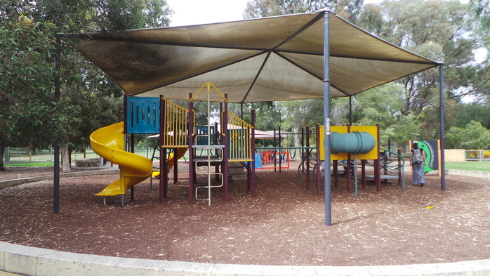
Do you love the city, but find that it’s just too expensive to visit when you have kids? Did you know there are a bunch of free activities that you can do with the kids in Perth? From a visit to the gorgeous Kings Park, to free museums and water playgrounds, Perth actually has some really cool, totally free places to visit. Here’s where they are.
Kings Park, Perth
Address: Fraser Avenue, Kings Park.
Kings Park is full of free activities for Perth families. There's the Synergy Playground, which is accessible via Saw Avenue or Poole Avenue. It is most suitable for kids aged six and over and features an elevated walkway, island fort, large-scale replicas of extinct Australian mega fauna and an interactive water misting forest. Adventure seeking kids can climb the DNA tower (with their parents) and enjoy the views of the park. There's also the Ivey Watson playground, which is conveniently located next to Sticky Beaks Cafe. You can take a wander around the botanical gardens or simply enjoy a picnic on the grass while the kids run around. The Naturescape Playground is currently closed, but there are plenty of other things to see and do in Kings Park.
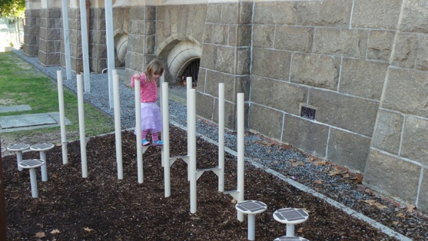
Cultural Centre Playspace
Address: James Street Mall, Perth (outside the WA Museum.)
This small play space is located just outside the Perth Museum and is an area for children to enjoy the musical, sensory and balancing elements on offer. For more information, you can read the Perth Mums Group review here.

Perth Family Photography Sessions
Do you need an updated family photo?

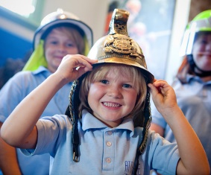
DFES Education and Heritage Centre
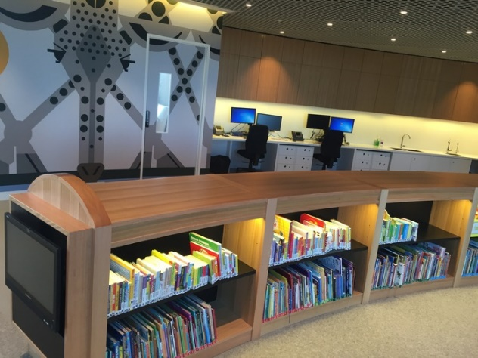
Address: Corner Murray and Irwin Streets, Perth.
This fascinating look into the history of Perth’s fire and emergency services is completely free to enter. You can learn all about the history of the building and view old fire trucks while the kids can even dress up as a fire fighter! For further information, read on here.
Perth Libraries
Address: The State Library of WA – 25 Francis Street, Perth and Perth Library – 573 Hay Street, Perth.
Perth City has two libraries - the State Library of WA, which is located in the Cultural Centre, and the newer Perth Library. Both venues run some fantastic free activities for kids, including story time and rhyme time at both libraries, while at the Perth Library, you can take kids aged two to seven along to a special nature storytime on the third Saturday of each month. Both venues also have great school holiday programs, so keep an eye on the websites for more information.
Water playgrounds at Elizabeth Quay and Forrest Place
Address: Elizabeth Quay – The Esplanade, Perth and Forrest Place, Murray Street Mall, Perth.
Perth is home to the Water Labyrinth, which operates daily during the day, along with the water playground at Elizabeth Quay, which runs every day except Tuesday, when it is closed for cleaning. Both are free to enter, meaning your kids can run in and out of the sprinklers and water jets until their skin turns wrinkly, and mum or dad start to get a bit cranky and want to go home.
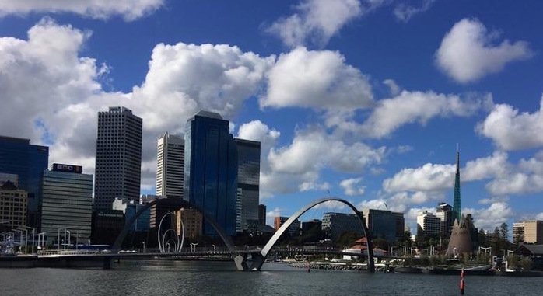

Hyde Park, North Perth
Address: William and Vincent Streets, North Perth.
A little out of the CBD, you'll find the gorgeous, leafy Hyde Park. This beautiful, shaded part of Perth has so many perks for kids and families, including a couple of playgrounds, a water playground, picnic areas, free barbecues and is close to the cultural hubs of Highgate and Mount Lawley.

50 Free Things To Do in Perth's Family Fun Hot Spots This School Holidays
School holidays are always tough on the bank account, but there are so many free family friendly things to do in Perth to fill in the days and get the kids out of the house. All these events, parks and activities are free (or entry by donation). Don't forget to pack something to eat, drink and snack on to save you more and make a picnic part of the adventure. Enjoy!
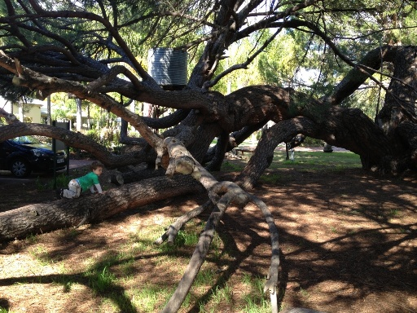
Climbing Tree in the Swan Valley
1. Climb the awesome tree between Mash Brewery and Oasis Super Golf on West Swan Road.
2. Take a break from the wineries and enjoy a play at the huge St Leonards Estate Playground. Lots of fun for kids of all ages with rock climbing wall, fireman's pole, rope challenges, cubby houses connected by elevated ramps and more.
3. Sample free chocolates at Margaret River Chocolate Factory
4. Enjoy a picnic and explore Whiteman Park. Entry to the park is free and lots of the attractions are free too including the huge playground, and Children's Forest.
5. While you are at Whiteman Park pay a visit to the Revolutions Museum. They have fun activities included in your donation entry in the school holidays.
6. If it's between October and the end of the April holidays bring your bathers and keep cool in the Mini Water Playground at Whiteman Park.
7. Take on a family challenge and complete the Great Valley Rally. This is a great way to explore the Swan Valley and discover something new.
8. Get another chocolate fix at Whistlers Chocolate. Enjoy your free chocolate samples, check out the massive chocolate zoo display and let the kids run around in the huge backyard with sandpit, blackboard and nature based play.
9. Let the sampling continue at House of Honey. Taste honey and honey lollies, and try some of the honey body products too.
10. Another great playground to stretch the legs in between winery visits is Livvi's Place Playground Whiteman Edge. This massive playground is fully fenced, features adventure play and has been designed for all abilities and with features especially for those with those with autism spectrum disorders, physical, visual, hearing and mobility impairments.

Perth City
11. Dress up like a fire fighter and enjoy the interactive educational displays to learn more about emergency preparedness and response at the DFES Education and Heritage Centre, open Tues - Thurs (please note: The DFES Education and Heritage Centre is closed over Dec - Jan. Opens 6th February 2018)

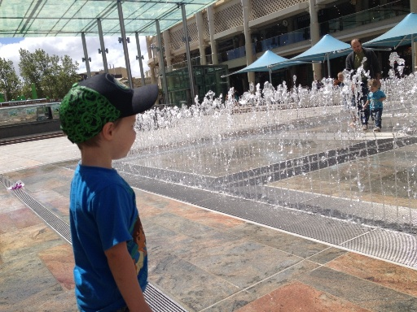
Water Labyrinth in Forrest Place
12. Whenever you head into the city take some spare clothes, the kids won't be able to resist the Water Labyrinth in Forrest Place.
13. Catch a family flick in the Free Flicks for Kids series Saturday afternoons at the Northbridge Piazza(September to May). Find the Free Flicks for Kids movie schedule here.
14. Jump on a free Perth City CAT Bus and enjoy a ride around the city
15. Endulge in some free chocolate samples from the Margaret River Chocolate Factory on Murray Street
16. Splash at the free water playground, play and explore at Hyde Park North Perth. Have a close look in the lake and see if you can spot and oblong turtle or two. (Water Playground runs Nov - late March).
17. Climb to the top of the fort and look out over Elizabeth Quay at the Island Playground. Spare clothes recommended, as this playground includes water play.
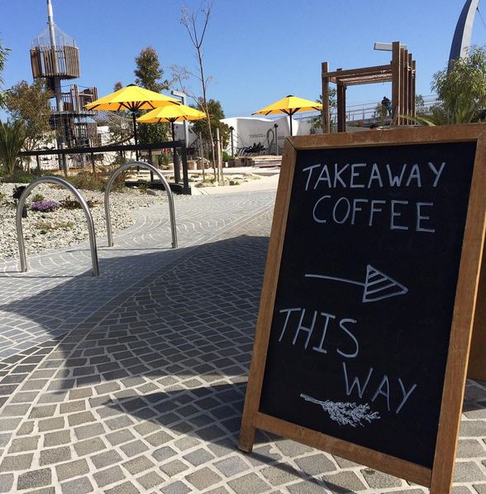
Island Playground Elizabeth Quay
18. Head up to The Story Place a the WA State Library in the Perth Cultural Centre to read a book, or join in Rhyme or Story Time. Check out the pop up WA Museum Discovery Zone during the school holidays.
19. Ivey Watson Playground in Kings Park is a little kids play paradise. It's mostly fenced with lots of grassed area for picnicking (or Sticky Beaks Cafe is within the park if you want to treat yourself to a coffee and something to eat or grab an icecream for the kids).
20. For the bigger kids Synergy Parkland Kings Park is a super fun place to play, with prehistoric creatures throughout the park to learn about and climb on, Lycopod Island Playground and the Arthur Fairfall Playground, the kids will love exploring and playing for hours here.
21. Walk through the treetops along the Lotterywest Federation Walkway Kings Park.
22. Climb to the top of DNA Tower Kings Park and check out the amazing coastal and city views.
23. If it's adventure play you are after, head to Variety Place in Kings Park. Kids can climb through tunnels and up to the top of the fort or head to Rio Tinto Naturescape and check out the Stage 2 upgrade play features.

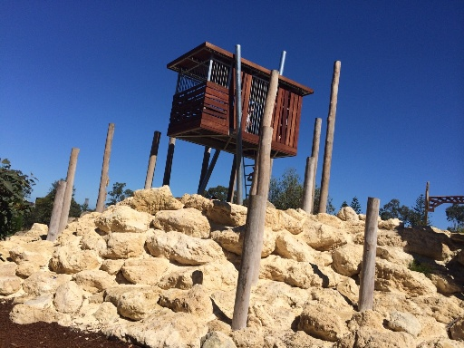
Variety Place Kings Park

Fremantle
24. Explore the shipwreck exhibits, dress up like a pirate, hold a cannon ball and more at the Shipwreck Galleries Fremantle. Entry is by donation.

Shipwreck Galleries Fremantle
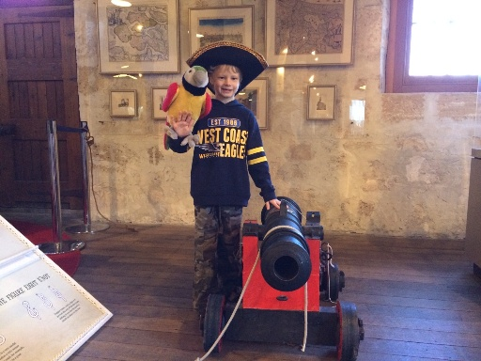
25. Climb to the top of the climbing frame and play at the beautiful Esplanade Park alongside the Fremantle Fishing Boat Harbour.
26. Pack your skateboard or scooter and head to the Esplanade Youth Plaza and ride at one Perth's coolest skate parks. You can also play ping pong, swing on the funky monkey bars and take on the rock climbing wall in the hang out zone. Entry is free
27. Catch the free Fremantle CAT and explore Fremantle by bus
28. The Fremantle Roundhouse is Fremantle's oldest public building. It's been used as a jail and as accommodation for the Water Police. Now you can enter by donation and learn all about it's history. The cannon is fired at 1pm daily and you may even be able to trigger the shot.
29. Bathers Beach is a beautiful spot for a swim on a hot day and is also a nice walk through the Kidigo Art Precinct where you can often find works of art around the art house. You can walk up to The Fremantle Roundhouse along the Bathers Beach Foreshore walk path.
30. Take advantage of Fremantle free bike hire at The Fremantle Visitors Centre in Kings Square and E Bikes R Us at the E Shed on Victoria Quay and explore Fremantle on two wheels.

Hills / Eastern Perth
31. Picnic at the Construction Camp Hub Picnic Area looking up at the beautiful Mundaring Weir. Walk off your picnic lunch with a walk across the Spillway Bridge to check out the Old Pump Station and wander back across the top of the weir (please note access to the weir walkway is closed for maintenance until 23rd December 2017).
32. Play the day away at the Hills best playground and park, Sculpture Park.

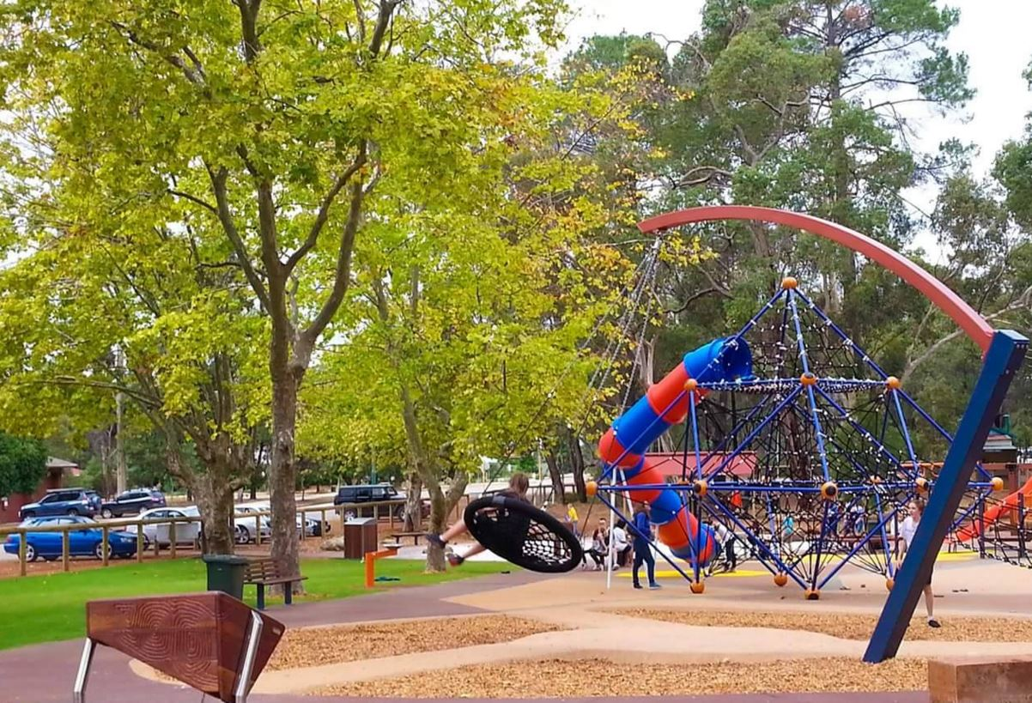
Scultpure Park Mundaring
33. Enjoy a nature walk and check out the views from Lesmurdie Falls and the city or enjoy a bush walk at Ellis Brook Valley Martin
34. Wander through the dinosaurs and other creatures and characters in the gardens at The Bird and Fish Place Wattle Grove.
35. Play like a pirate and explore like an adventurer at Woodbridge Riverside Park. It's fully fenced and features a big wooden pirate ship, tunnels, flying fox and lots of nature based and adventure play.
36. Pack lunch or a snack and sit back and watch the planes take off and land at the Perth Airport Viewing Platform.
37. Pack your kayaks or canoes and head to Lake Leschenaultia Mundaring. Enjoy a day out of swimming, play at the playground and take in a nature and wildflower walk. Entry to Lake Leschenaultia is free, and a small fee can be paid to camp here also.
38. Keep the kids cool at Rainbow Waters Ellenbrook Water Playground. This runs during the warmer months of the year and features zero depth water play with cannons, sprays and tipping buckets.
39. Climb a volcano, ride the flying fox and dodge the water spouts in the jungle at the big, fully fenced Faulkner "Volcano" Park Belmont.
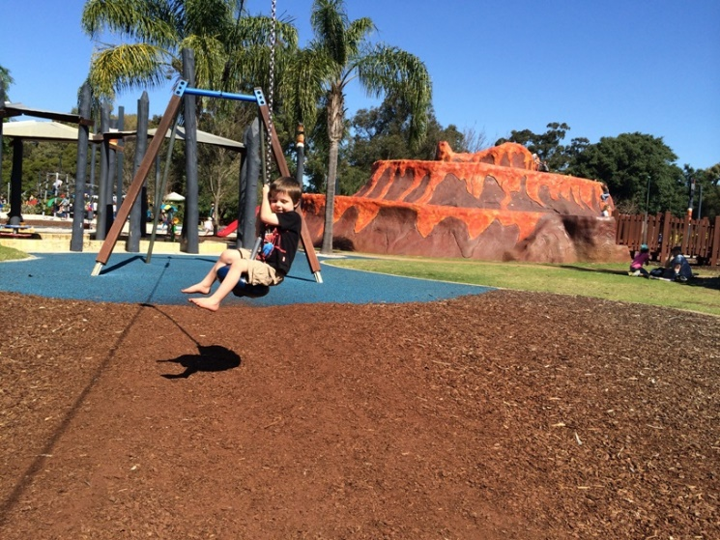
Faulkner "Volcano" Park
South of the River
40. Give the kids an outdoor "tech" fix at the huge Robot Park Piara Waters.
41. Watch the planes and helicopters take off and land from the picnic area at Jandakot Aiport.
42. Do it all at the amazing Kwinana Adventure Park with water playground that runs all year round, trampolines, flying fox, tree walk and more.
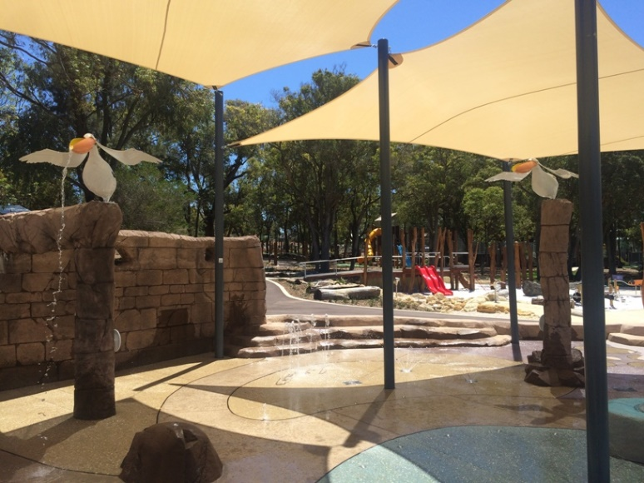

Kwinana Adventure Park
43. Climb to the top of the 7m tall jungle climb, bounce on the trampolines, ride at the skate park or on the bmx track at Wellard Adventure Playground.

North of the River
44. Swim out to the pontoon and slide into the calm waters of the Hillarys Boat Harbour all year round.
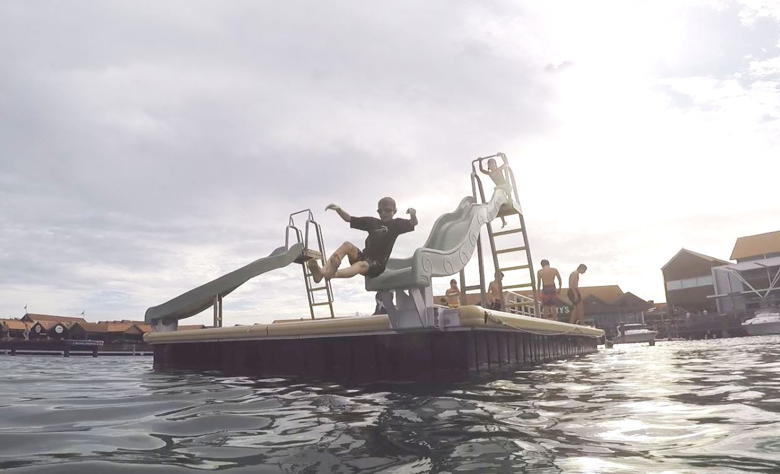
Hillarys Boat Harbour Pontoon
45. Climb to new heights at Eden Beach Foreshore Playground. The kids will be challenged by the 3 storey climb and slide down and long ropes challenge play equipment.
46. Head a little further north to Yanchep and climb and slide down the steps and slide built into the side of the cliff at Campground Playground.
47. Play at the two level Jungle Gym in the Karrinyup Shoppping Centre Food Court daily from 12-5pm.

Mandurah
48. Play and swim at Dolphin Quay. Swim out to the pontoon and slide into the calm waters, wander over the bridge to look out over Dolphin Quay and play at Keith Holmes Reserve.
49. Climb to the top of the 8m tall windmill, ride the giant pig slide and explore this huge farm theme adventure playground at Adventurescape Austin Lake, South Yunderup.
50. Explore the huge Quarry Adventure Park Meadow Spring. This is not just a park but a day of adventure at this park built within an old quarry with big climb up the cliff face and slide down.
Find events, playgrounds, cafes, attractions, deals and more nearest you and get a map to take you there while you are on the go with the Kids Around Perth App today!

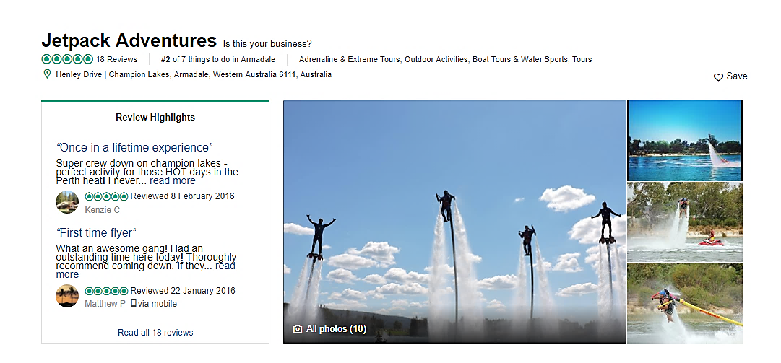
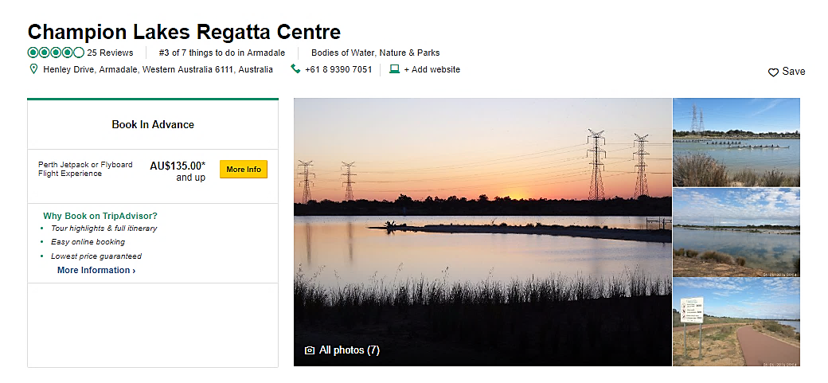
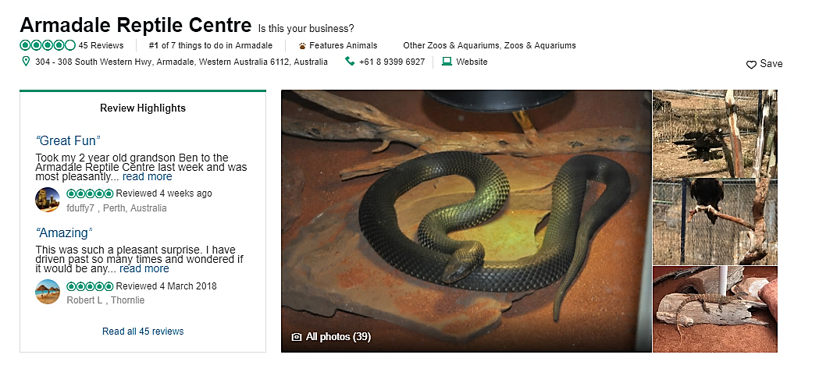
LOCAL AREA
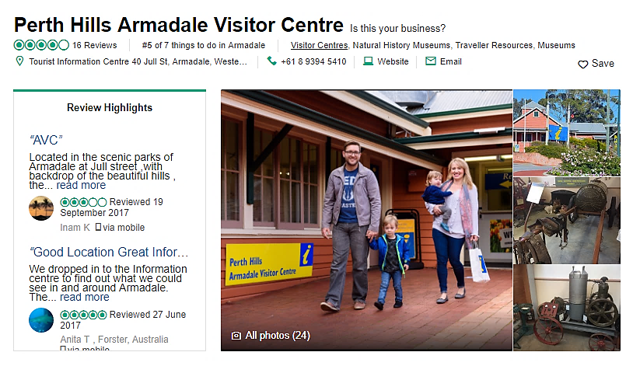
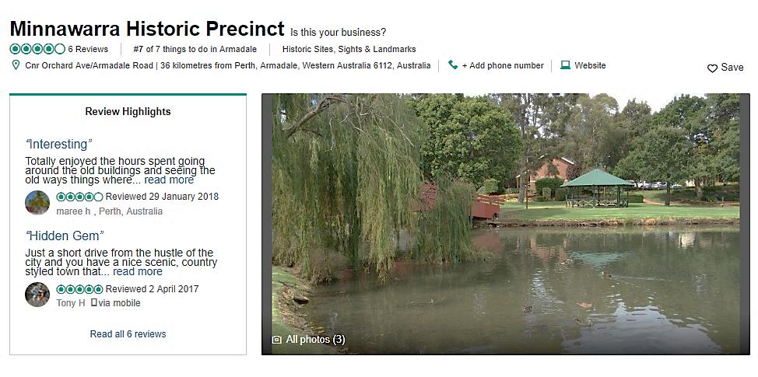
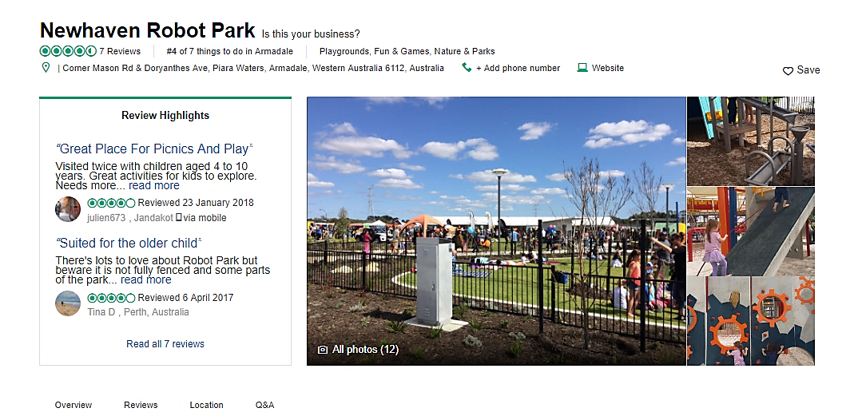
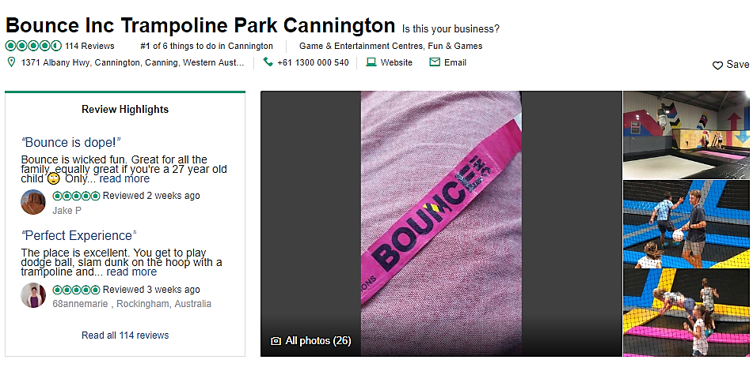
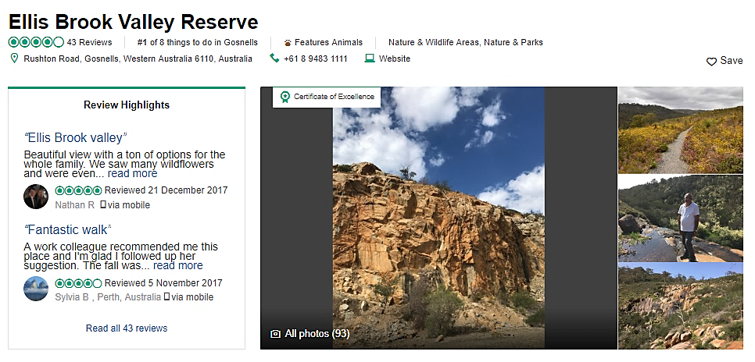
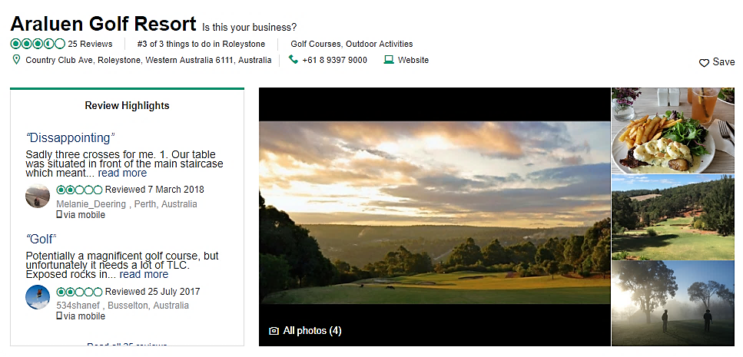
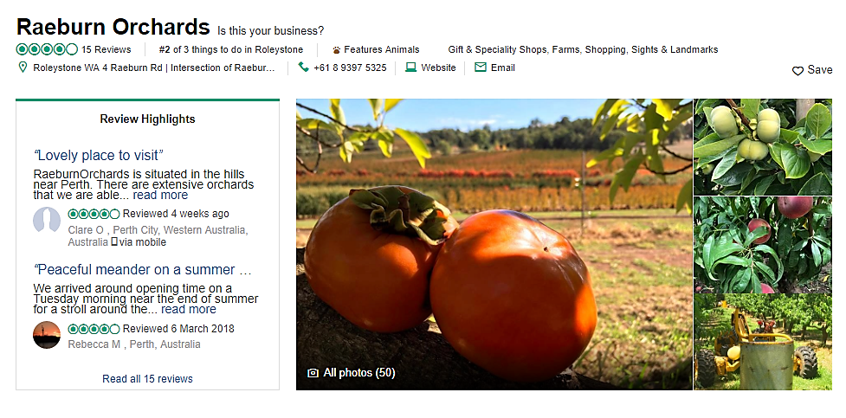
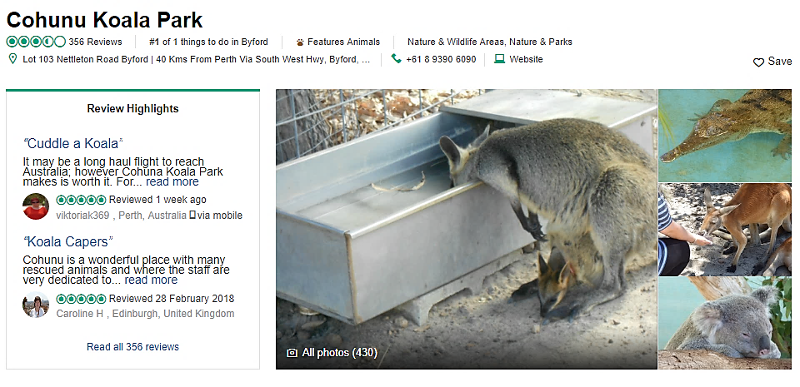
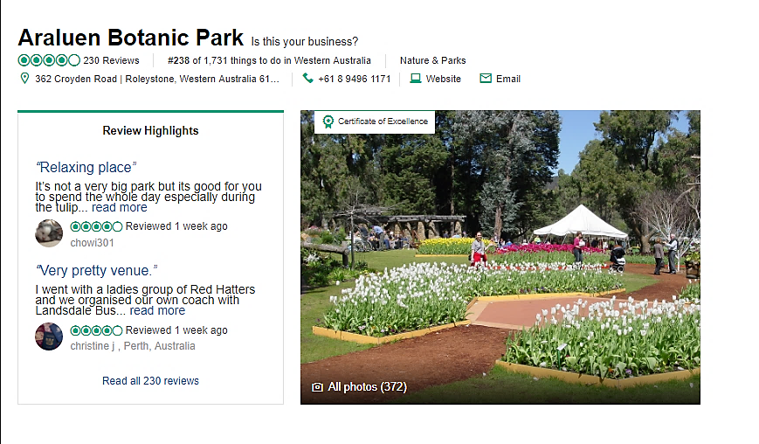
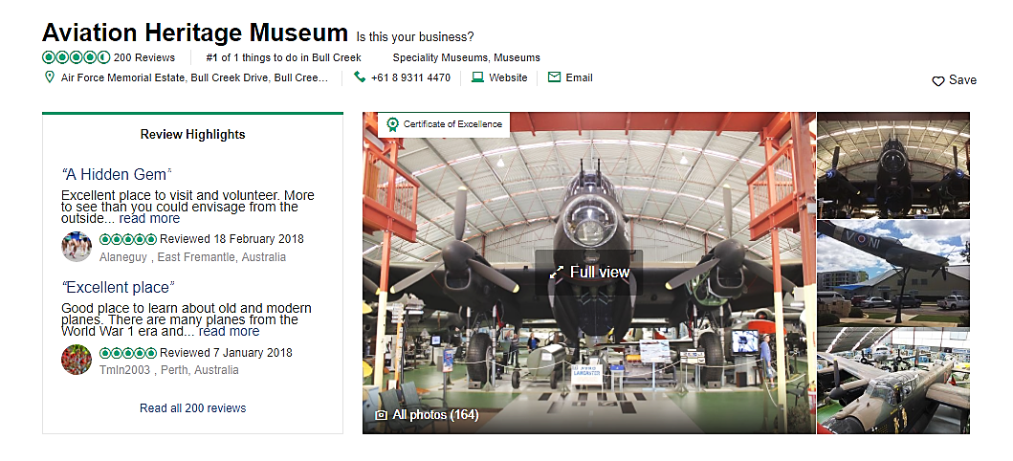
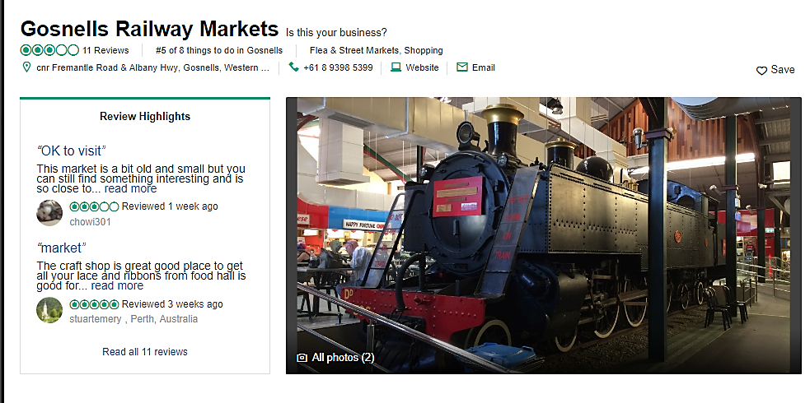
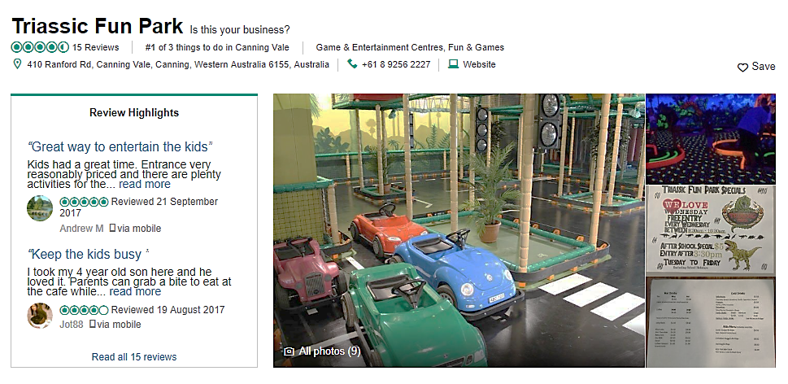
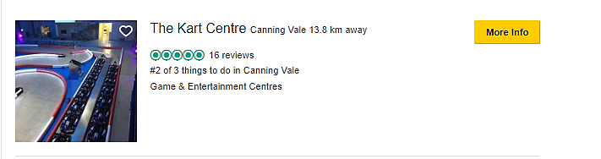
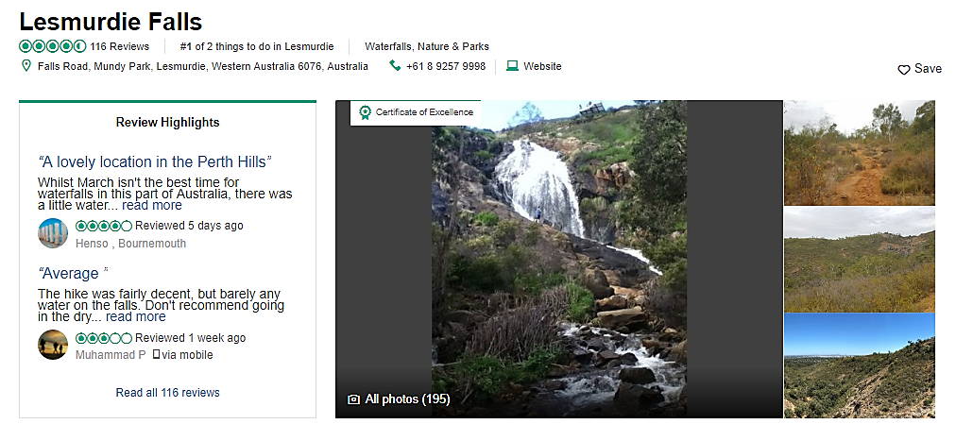

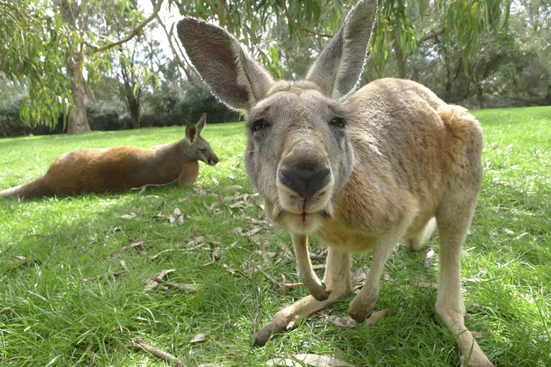
Ten Reasons To Love….Whiteman Park
Who doesn’t love a trip to Whiteman Park? With its wide, open spaces and natural bushland, activities for families and wildlife wandering around, it’s long been a favourite space for Perth families. If you’ve never been to Whiteman Park, it should definitely be on your to-do list, especially if you have children. Here’s ten reasons to love Whiteman Park.
1. Free entry and free facilities!
Entry to Whiteman Park is free! This means you can wander the grounds during opening hours, enjoy a picnic or spot some wildlife wandering around. Here are just some of the free facilities.
Free use of the multi-sport court, which caters for basketball and tennis, plus use of the cricket oval – can also borrow bats and balls from the Visitors Information Centre.
Picnic shelters and BBQ facilities.
Mini water playground and children’s playground – see below for more details.
Orienteering – get out into the bush and explore! Whiteman Park has two permanent orienteering courses, a short course centred around the village area and an overall course that covers the village and mussel pool and areas in between. The Village Course Maps are available from the Whiteman Park Visitor Information Centre, or you can download it here.

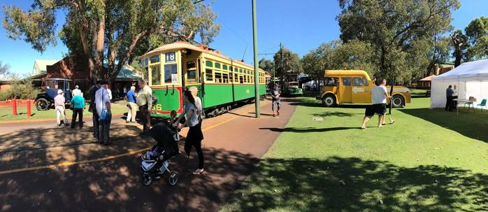
Image: Whiteman Park Facebook page

Perth Family Photography Sessions
Do you need an updated family photo?
7 Reasons To Join A Mums Group
Having the support and friendship of other mums who are living the same experience is important for the well-being of every mum. Here are 7 reasons to join a real-world mums group:
2. Children’s Forest
The Children’s Forest is a place for all kids to enjoy, explore and learn about WA’s native bush. It’s free to enter – look for the giant marching ants, colourful birds, peeking possums, a life size Wedge-Tailed Eagle’s nest made of steel and the Forest’s ‘guardians’, the Boy of the Bush and his sister Fern. You can read more about the Children’s Forest here.
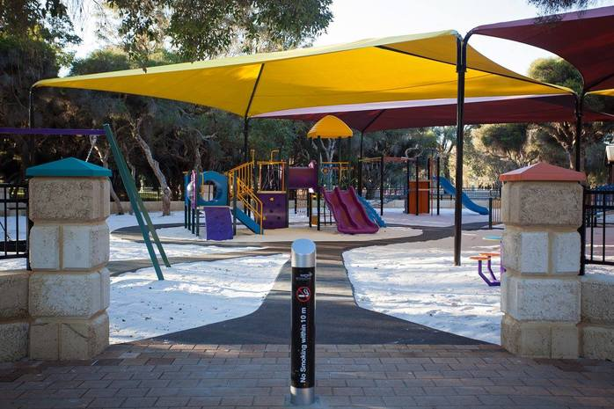
Image: Whiteman Park Facebook page
3. Pedal Play
Want a unique way to explore the Whiteman Park Village? Try pedal go-karting! Pedal Play has a wide range of go-karts available for hire and you can use the kart as an individual or as a family. With 14 kilometres of shared path available, there is lots to see and explore. The single junior go-karts are suitable for ages four and over, and the larger and two-seater go-karts with single or dual pedals are suitable for older children and adults. They even have a BERG Gran Tour four-seater, family go-kart. Hire is available all day Saturday and Sunday and every day on public holidays, plus 10am to 4pm on Tuesdays during winter. Hire fees start from $20.
7 Reasons To Join A Mums Group
Having the support and friendship of other mums who are living the same experience is important for the well-being of every mum. Here are 7 reasons to join a real-world mums group:
Perth Family Photography Sessions
Do you need an updated family photo?
4. Shops, Art Gallery and Village Café
If you are seeking a truly unique gift, check out the Whiteman Park Village Shops. You’ll find:
The Handcraft Centre – sells a range of locally made crafts for sale every day including homemade produce, souvenirs, hand-painted glasswork, woodcraft and homemade jams and pickles.
The Print Shop – along with producing high-quality work using traditional machinery and methods, the Print Shop stocks a range of novelty items, printed souvenirs and stationery, as well as a wide range of postcards featuring Whiteman Park.
The Lolly Stop – stocks a huge range of local and international lollies, sweets, chocolates, fudge, lollipops, ice creams and cold drinks, plus some novelty gifts.
Village Art Gallery – the Gallery features original paintings, prints and commissions and is home to a collective of accredited and award-winning artists. You can take a look at the award-winning pieces on display, talk to the artists and purchase a unique piece of art to take home.
Village Café – the Village Cafe has dine in and takeaway options for breakfast and lunch, plus snacks and hot drinks. The Village Café can also organise catering options, ranging from Aussie BBQ packs you can cook yourself on park barbeques, to hot sit-down meals and carveries.
5. Mini Water playground and playground
Open every day from 10am to 5pm from October to end of the April School Holidays, the Mini water playground is the place to cool down. This 30cm-deep paddling pool has water sprouts and shade shelters. Don’t forget your bathers and swim nappies!
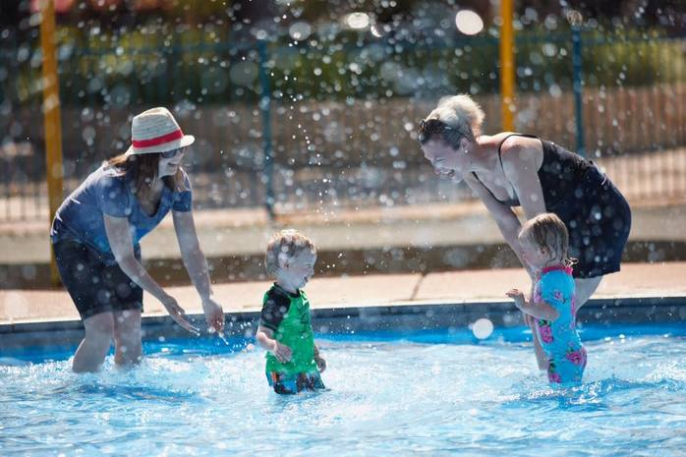
Image: Whiteman Park Facebook page
6. Caversham Wildlife Park
Caversham Wildlife Park is home to a whole heap of native wildlife that includes koalas, wallabies, possums, Tasmanian devils and wombats, and there are even opportunities to get close to the animals! You can feed the kangaroos or have your picture taken with the koalas, or take part in one of the many interactive shows running at the park. Entry fees apply.
7. Heritage Tram Rides and Train Rides
Whiteman Park is the only place in Western Australia where you can ride on a genuine vintage electric tram and provides a regular service through the picnic areas and farmland. It operates between the Mussel Pool and the Village at half hourly intervals, plus additional times on weekends, public holidays and school holidays. Fees apply.
You can also take a ride on the train – the Bennett Brook Railway operates steam and diesel trains over 6 kilometres through the Whiteman Park woodlands. Services are half hourly from the Village Junction Station and hourly from Mussel Pool on weekends and public holidays. During the week, take a scenic trip around the bushland loop, departing from the Village Junction Station on the hour on operating days. Fees apply.
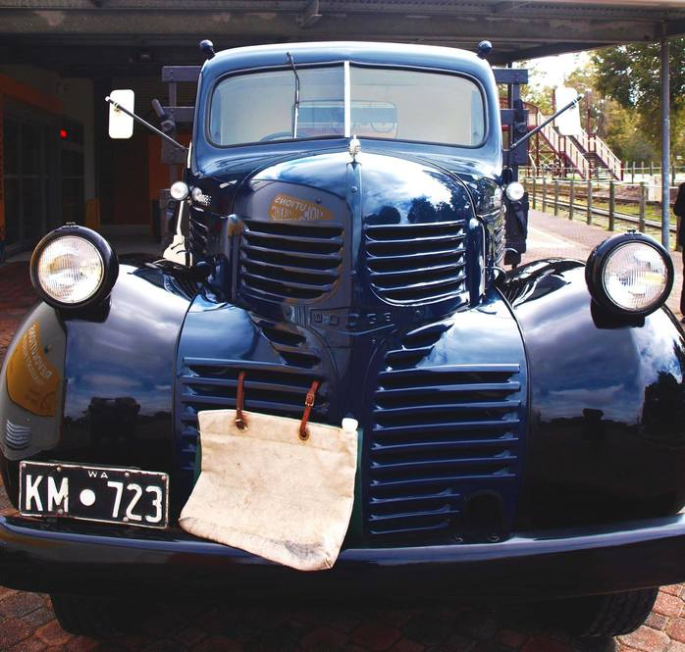
Image: Whiteman Park Facebook page
8. Transport Heritage Museums
Whiteman Park is home to a number of museums, as listed below:
Tractor Museum of WA – entry fees apply
Motor Museum of WA – entry fees apply
Revolutions Transport Museum – entry fees apply
Plus, you can hop aboard the Whiteman Explorer, a beautifully restored, vintage bus providing free tours of Whiteman Park.
9. Dog park
Dogs on a leash are welcome in Whiteman Park, but in the 2.5 hectacre dog park, they are free to run and jump as they please! The dog park is completely fenced off and also contains an obstacle course designed especially in colours that the dogs can see! There is also lots of shade, multiple water points and over 500m of walk path within the enclosure. Small dogs under 10kg are also catered for, with a smaller, separate enclosure just for them. The park is open from 8.30am to 6.00pm daily, and is free to use, although donations to help support the ongoing maintenance of the facility, as well as RSPCA WA, are welcome.
10. Events throughout the year
Whiteman Park has a number of events taking place during the year, including school holiday fun, Nocturnal Woylie Walks, Pottery Workshops, plus Ashley and Friends in May and September – these special train friends resemble Thomas the Tank Engine and his friends! You can read more here.
Whiteman Park is a public space that all Perth families can enjoy. Pack a picnic and enjoy exploring the park and getting out in the fresh air all year round.
Essential information
Whiteman Park
Address: Entry via Lord Street or Beechboro Road, Whiteman
Phone: 9209 6000
Opening hours: Open daily 8:30am to 6pm (Christmas Day 9am to 5pm – no attractions open)
Cost of entry: Free entry, although some attractions do incur a fee
Website https://www.whitemanpark.com.au
#Swan Valley & Perth Hills
#School Holidays
#Outdoor Activities
#Parks and Playgrounds

Amusements

Trees Adventure
WA’s First Tree Ropes Course! Trees Adventure is an exhilarating 2 Hour experience with courses landing from 2m low easy courses up to 25m high insane ones! Come and enjoy a day out amidst the breathtaking Peel Region only 45min from Mandurah in Dwellingup. With over 80 challenges and 20 Read more [...] No Reviews Favorite Pinpoint

- WA’s First Tree Ropes Course! Trees Adventure is an exhilarating 2 Hour experience with courses landing from 2m low easy courses up to 25m high insane ones! Come and enjoy a day out amidst the breathtaking Peel Region only 45min from Mandurah in Dwellingup. With over 80 challenges and 20 flying foxes, there is an adventure for the whole family!
Participants will be provided safety equipment and training.
  - Lower Courses for 4-7yrs
  - Higher Courses for 8+
  - Adult supervision is required.
  - Prices from $25.
  - Bookings are essential!
For online bookings and more details visit treesadventure.com.au.
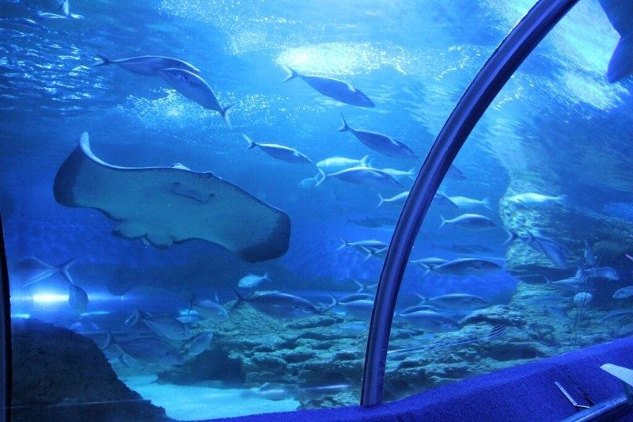
AQWA The Aquarium of Western Australia
AQWA -The Aquarium of Western Australia celebrates 30 years this April as one of Perth’s most iconic tourist destinations and home to hundreds of species of marine life from the coastline of Western Australia. With more than 7,080,093 people surging through AQWA’s gates over the 30 years, Perth’s leading tourist Read more [...]
No Reviews Favorite Pinpoint

AQWA The Aquarium of Western Australia
HomeThings to DoAttractionsAQWA The Aquarium of Western Australia
AQWA -The Aquarium of Western Australia celebrates 30 years this April as one of Perth’s most iconic tourist destinations and home to hundreds of species of marine life from the coastline of Western Australia.
With more than 7,080,093 people surging through AQWA’s gates over the 30 years, Perth’s leading tourist attraction continuously amazes visitors with an incredible underwater journey through the icy waters of coral reefs and colourful marine creatures.
To celebrate the big birthday AQWA will be hosting a week of programs and events during the school holidays from the 13th of April to the 20th of April. Every day from 11.30am – 2.30pm there will be FREE face painting, kid’s activities, roving performers and heaps more. Plus, all kids get a FREE slushy!

AQWA is Western Australia’s premier marine attraction featuring:
-Australia’s largest single aquarium and walk-through underwater tunnel
-Giant sharks, rays and turtles
-One of the largest living coral reefs in the world
-Beautiful temperate and tropical living coral displays
-Rare sea creatures, like leafy sea dragons
-DangerZone, featuring deadly marine life
-Interactive touch-pool
-A turtle rescue centre
-Dive and snorkel programs
-The AQWA Gift Shop and Fully Licensed Cafe
-Magnificent views of Hillarys Marina and the Indian ocean from the outdoor terraces
AQWA is located just 20 minutes north of the city at Hillarys Boat Harbour and is accessible by public transport. For up to date AQWA entry prices, see the website: http://www.aqwa.com.au/entry-prices/
Buggybuddys Deal

Free Coffee at AQWA

Treat the kids with a visit to AQWA, treat yourself with a FREE barista coffee in the AQWA Cafe. 1 standard espresso coffee (flat white, long black, latte, espresso, macchiato) per family/visit.
Expires on: 31/12/2018

Click to Open in Print View

Westfield Whitford City

Xtreme Ice Arena
We are Perth’s newest Ice Skating Arena. We offer Perth’s best selection of Ice Skating sports including General Skating, Figure Skating, Ice Hockey, Speed Skating and our Xtreme Bumper Cars on Ice! We can cater for all your birthday party needs with large dedicated party rooms for your guests with Read more [...]

The Maze, Home of Outback Splash
Hello Summer; The Outback Splash wet attractions are now open! The three-storey waterslide playground, The Plummet inflatable slide and the Octopus Bay kids splash zone. Play some mini golf, meet a koala or just enjoy a barbie. Outback Splash at The Maze; have ‘A full day of fun!’ Last season Read more [...]
2 Reviews Favorite Pinpoint

IKEA Perth
April School Holiday Activities Free Kids Activities There’s always plenty of fun for the kids at IKEA Perth! Kids’ Academy offers free kids activities and is held from 9am-11am every Tuesday, Wednesday and Thursday these April school holidays (except for ANZAC Day when the store is closed). Kids can also Read more [...]
No Reviews Favorite Pinpoint

Big Wave Surfing School
Secret Harbour. 14th – 29th April. Cost 2 day course $99, 4 day Weetbix surf groms course $189 (FREE Ripcurl pack) Family surfing lessons in Perth this school holidays. We are WA’s only family owned and operated surf school and we focus on creating bonding experiences for families. We provide a Read more [...]
No Reviews Favorite Pinpoint

Mindbuzz
A day of Minecraft fun and learning at Mindbuzz Camp. If you are 6-14 and love Minecraft then this is for you. We will learn, play and connect with others on multiple servers, learn new skills, Mindbuzz only server when you go home so the learning and fun never stops. Read more [...]
No Reviews Favorite Pinpoint

Maddington Central
No Reviews Favorite Pinpoint

Stockland Bullcreek
No Reviews Favorite Pinpoint

Cockburn Gateway Shopping City
April School Holidays Enter our Gateway to Space these April School Holidays and enjoy FREE astronomically awesome family activities 16 – 28 April: Intergalactic Adventures shows by Lunar Circus 16 – 22 April, 11am & 1pm daily (20min shows) Thunderbirds Craft Zone 23 – 28 April (excluding ANZAC Day), 11am Read more [...]
No Reviews Favorite Pinpoint
UWA Kids Holiday Program, University of Western Australia
SEND YOUR KIDS TO UWA UWA Kids Holiday Program, University of Western Australia Autumn Program: Mon 16 April – Fri 27 April The UWA Kids Holiday Programs are fun and exciting, multi-sport day camps for children aged 4–12 that run during the school holidays. View the Autumn activity schedule. With a focus Read more [...]
No Reviews Favorite Pinpoint

END YOUR KIDS TO UWA
UWA Kids Holiday Program, University of Western Australia
Autumn Program: Mon 16 April – Fri 27 April
The UWA Kids Holiday Programs are fun and exciting, multi-sport day camps for children aged 4–12 that run during the school holidays. View the Autumn activity schedule.
With a focus on participation and having a good time, this program is excellent for introducing kids to new sports in a friendly, non-competitive environment and for keeping them active and happy during the school holidays.
The program is run by an experienced team of enthusiastic and friendly leaders, trained in a variety of sports. Each holds a first aid qualification and a working with children check, so you know your little ones are in safe hands.
The UWA Kids Sports Holiday Program is a registered child care program and parents/guardians are eligible for the Child Care Benefit (CCB).
You spoke, they listened. UWA are excited to announce that you can now enrol your child/ren online!
Visit our website to find our more info and enrol today!

STEMmates
STEMmates is a local initiative that supports the renewed focus on Science, Technology, Engineering and Mathematics (STEM). With today’s economy and tomorrow’s innovations being powered by STEM, we believe that learning should not be confined to the classroom. STEMmates seeks to help kids engage with fundamental STEM concepts and principles Read more [...]
No Reviews Favorite Pinpoint
STEMmates is a local initiative that supports the renewed focus on Science, Technology, Engineering and Mathematics (STEM).
With today’s economy and tomorrow’s innovations being powered by STEM, we believe that learning should not be confined to the classroom.
STEMmates seeks to help kids engage with fundamental STEM concepts and principles outside the school setting through hands-on activity-based workshops that showcase:
> problem-solving;
> gathering and evaluating evidence; and
> making decisions.
These school Holidays, STEMmates are offering workshops in:
> Forensics
> Robotics
> Oceanography
> Electromagnetics
> Renewable Energies
And more!
For more information, visit stemmates.com.au/programs, email imagine@stemmates.com.au or call 1300 793 465.

HBF Arena
HBF Arena is a great venue for lap swimming and family friendly leisure swimming. Our facility features the following: Lap Pool Indoor 10 lane, 50m pool with a variable depth facility of 1.2m for 17m and 2.0m for 33m | heated to 26.5º | Permanent seating for over 600 | Sauna (18 Read more [...]
No Reviews Favorite Pinpoint
HBF Arena
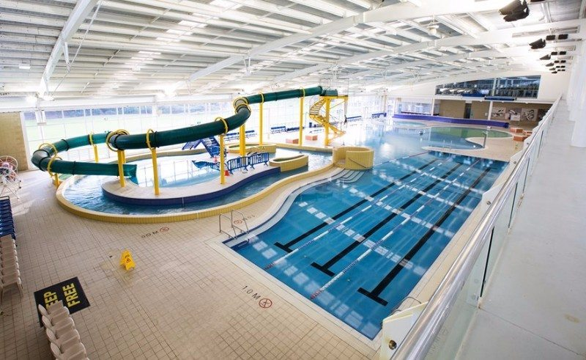
HBF Arena is a great venue for lap swimming and family friendly leisure swimming. Our facility features the following:
Lap Pool
Indoor 10 lane, 50m pool with a variable depth facility of 1.2m for 17m and 2.0m for 33m | heated to 26.5º | Permanent seating for over 600 | Sauna (18 +) | Aqua wheelchair available | Disabled change room with Hydraulic change bed and hoist | Disabled hoist for ease of entering the water for those requiring assistance
Family Pool
Indoor 3 lane, 25m teaching pool, heated to 29.5º | 400m² leisure pool integrated into same water body with depth ranging from 0m to 1.2m | Toddlers splash pool | Lazy river and other water features | 42m fully enclosed water slide ending in a splash pool (open weekends, public holidays and school holidays, hours are 11am-4pm) | Private parent change room | Outdoor play area with shade sail | Crèche, open 6 days
VACATION CARE
Vacation Care at HBF Arena is a great way to keep your kids active and entertained throughout the holidays. With both incursions and excursions your child will see all our venue has to offer and visit some of Perth’s best family friendly locations.
Last holidays the kids visited Swan Valley Adventure Centre to have a go at their flying fox, archery and team building activities. Took part in hands on learning with plants and animals at Landsdale Farm School. Saw The Boss Baby Movie at Currambine Cinemas.. and visited Perth Zoo for their Alice’s Adventure in Amazingland theatre show and A-MAZE-ing activities in the WILD Zone! Plus loads of fun incursions including Parkour, Velcro Wall & Bungie Slam Dunk inflatable and Sports Day.

The Maze, Home of Outback Splash
HomeThings to DoAttractionsThe Maze, Home of Outback Splash
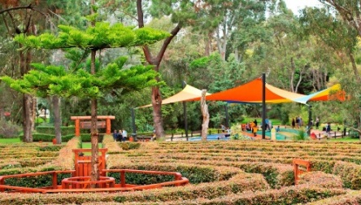
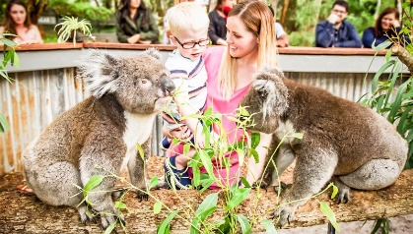
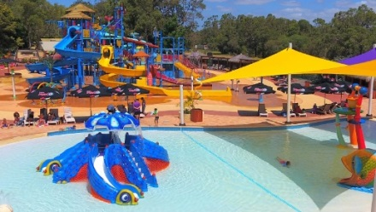

; The Outback Splash wet attractions are now open! The three-storeywaterslide playground, The Plummet inflatable slide and the Octopus Bay kids splash zone. Play some mini golf, meet a koala or just enjoy a barbie. Outback Splash at The Maze; have ‘A full day of fun!’
Last season the Park welcomed 2 brand new water attractions; The Plummet inflatable slide, standing over 10 meters high with a 7 metre drop, and the Octopus Bay kids splash zone featuring a 3-slide giant octopus and a miniature tipping bucket.
Not quite ready to get wet? Meet Australian animals up-close – including our brand new baby koala – explore one of the six challenging mazes – including Perth’s first hedge maze – or enjoy the giant jumping pillow, mini golf and nature-play children’s playground.
The Park is open from 10am to 5pm every day of the school holidays. Admission includes access to all park attractions and is $27.00 for children (4-15 years), $31 for students and $34.00 for adults.
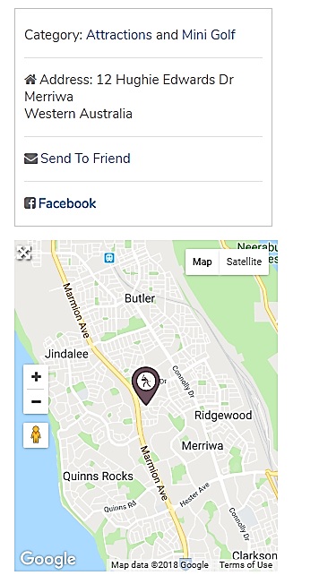
Tickets and Annual Passes are now available for purchase online. For more information visit themaze.com.au or facebook.com.au/outbacksplash
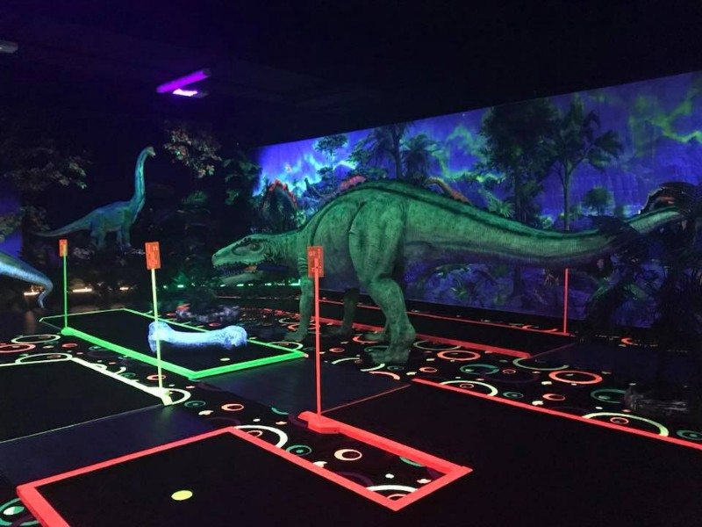

Chillisaurus Mini Golf
50 min 65.2 km
via Tonkin Hwy/State Route 4 and Mitchell Fwy/State Route 2

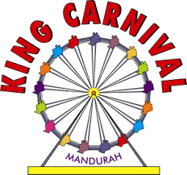

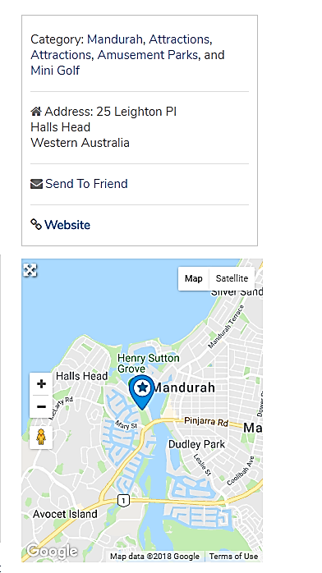
King Carnival
HomeThings to DoAmusement ParksKing Carnival
King Carnival is situated on the scenic and lovely Mandurah Estuary.
The Carnival is one of the oldest, historical amusement sites in the state of Western Australia.
Well appointed with a wide variety of rides and features.
A well-stocked amusement arcade provides hours of entertainment.
Food and drinks are available from the kiosk, which also provides golf clubs and golf balls for the excellent Adventure Mini Golf featured on site
Entry to King Carnival is always totally Free

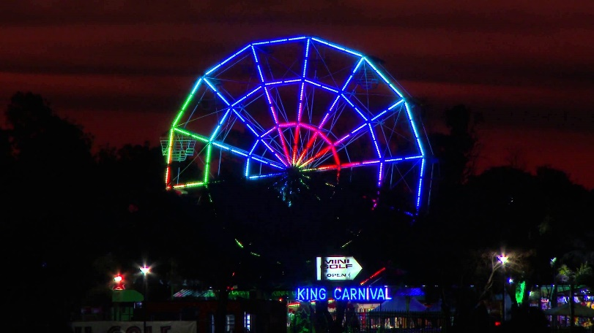

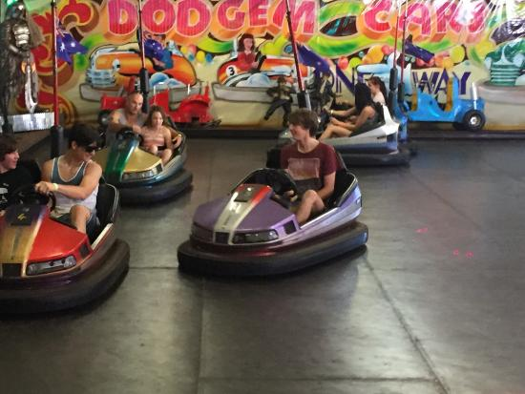
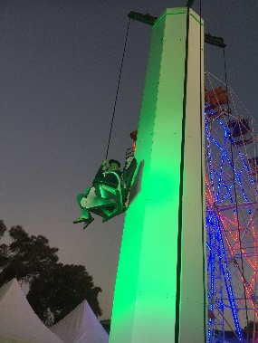
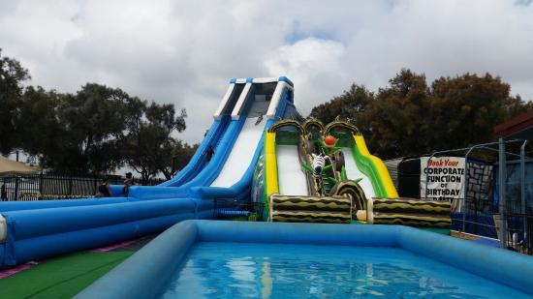

Prices
MINI GOLF ( 18 HOLES)
 | PRICES
ADULTS | $ 15
CHILDREN(UNDER 14) | $ 12
SENIORS | $ 12
FAMILY PASS ( 2 ADULTS, 2 CHILDREN UNDER 14) | $ 45
RIDES ( 1 TICKET COSTS $ 2.50 )
BUNGEE TRAMPOLINE | 4 TICKETS PER PERSON
CONVOY TRAIN | 2 TICKETS PER PERSON
FLYING HORSES | 2 TICKETS PER PERSON
VENTURER SIMULATOR | 3 TICKETS PER PERSON
TEA CUPS | 2 TICKETS PER PERSON
SUPER SKATE | 3 TICKETS PER PERSON
DODGEM CARS | 3 TICKETS PER PERSON
TILT A WHIRL | 3 TICKETS PER PERSON
PRO TRAMPS | 2 TICKETS PER PERSON
FERRIS WHEEL | 2 TICKETS PER PERSON
TOWER RIDE | 2 TICKETS PER PERSON
KIDDYS MIX | 2 TICKETS PER PERSON
PIRATE BOUNCY CASTLE | 2 TICKETS PER PERSON
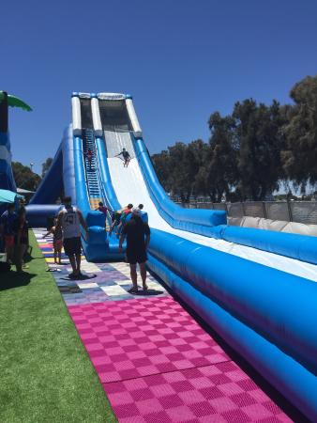
FAMILY SPECIAL 50 TICKETS FOR $100 ( SAVE $25 )

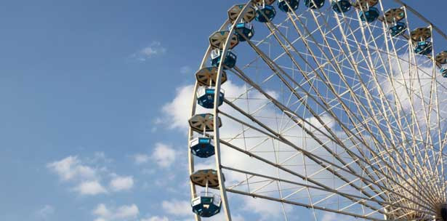

Museums

Gravity Discovery Centre

Directions FROM Kelmscott 1 h 8 min (87.6 km)
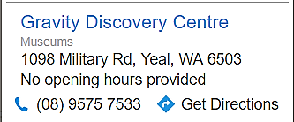
Western Australia 6111
Take Connell Ave to Tonkin Hwy/State Route 4 in Martin
8 min (5.7 km)
Take State Route 8, Mitchell Fwy/State Route 2and State Route 60 to Military Rd in Wilbinga
Continue on Military Rd to your destination in Yeal
18 min (15.3 km)
Gravity Discovery Centre
1098 Military Rd, Yeal WA 6503

The Gravity Discovery and Observatory April School Holiday Program.
April 16th to April 27th 2018
Monday, Wednesday and Friday – Rocket Making, (children to bring a 1.5 litre empty soft drink bottle)
Tuesday and Thursday Solar Kids
11:00 – 1.30 each day, normal entry fees apply

Kalamunda History Village
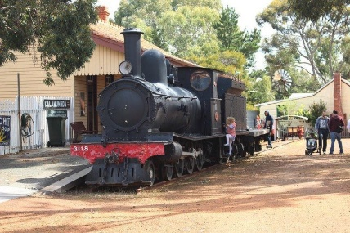
Category: Attractions and Museums
Address: Railway Road
Kalamunda
Western Australia
Time: Mon-Wed & Fri 10am-3pm; Saturday & Sunday 10am-4pm. Closed Thursdays.
Kalamunda History Village is on the site of the old Upper Darling Range Railway
Station built in the 1890s to service the Zig Zag line which transported timber from
Canning Mills to the main line at Midland Junction. It is the largest folk museum in
Western Australia depicting the unique hills life and industries that developed in the area.
The museum consists of:
Locomotive G118 – a "G" Class locomotive of the type used on the Kalamunda line, including the Zig Zag, during its 49 years of government ownership
Railway stations – the original railway station (1903-1927) and a second railway station (1927-1949)
School House (1905-1970) – the area's first State school building
Post Offices – the original Post Office (1901-1921) and the first official Post Office (1921-1972)
Chamber's House (1922) – which depicts a typical pre World War II boarding house
McCullagh Cottage (1895) – a settler's cottage
Carriage Shed – housing a range of older transportation vehicles
Orchard Shed – showing the development of the orchard industry in the district
Blacksmith – a display of the blacksmith's trade
Sawpit – as used by the pioneers of the timber industry
Dunny – an original, complete with newspaper
Whim – used in the early days of the timber industry for moving logs - on loan from the WA Museum
Kalamunda Community Memorial Building – featuring transport display and memorial wall

Aviation Heritage Museum
The Aviation Heritage Museum provides a unique museum experience of civilian and military aviation through its extraordinary aviation displays, helpful guides and special tours. The Museum’s talented volunteers have designed, donated and built a truly amazing array of aviation displays that include 30 aircraft and thousands of artefacts. From the
Aviation Heritage Museum
HomeThings to DoAttractionsAviation Heritage Museum

The Aviation Heritage Museum provides a unique museum experience of civilian and military aviation through its extraordinary aviation displays, helpful guides and special tours. The Museum’s talented volunteers have designed, donated and built a truly amazing array of aviation displays that include 30 aircraft and thousands of artefacts. From the helpful gift shop attendants to the meticulous restorers, the Museum’s hundreds of volunteers have truly built one of the most unique museums in the Southern Hemisphere or even the World.
The Royal Australian Air Force Association along with community assistance from sponsors, visitors, and friends of the Museum makes the Museum one of the top self funded Museums in Australia.
Adults (16 & Over ) $15.00 *** Children (4 to 16) $7.50 *** Family (2 Adults & up to 4 children) $35.00 Under 4 years are free *** Students & Concession Card Holders $10.00
Address: bull creek drive
Bull Creek
Western Australia
Time: Open 10.00am to 4.00pm every day, except Christmas Day, Boxing Day, New Years Day and Good Friday.
Phone: 99311 4470

Wanneroo Regional Museum
Opening Hours: Monday, Tuesday, Wednesday & Friday 10am – 4pm, Thursday 10am – 5pm, Saturday 12pm -4pm. Entry: FREE
No Reviews Favorite Pinpoint
WA Maritime Museum

WA Maritime Museum
April School Holidays Horrible Histories – Pirates: The Exhibition This school holidays | 9:30am-5pm | exhibition entry fees apply Pirates Ahoy! 14 – 29 April | 10am – 2pm | Free Pirate storytelling at 10:30am Cannon loading demonstration at 11am ANZAC Day 25 April 1pm-3pm The Lost Quays: Read more [...]
Category: Fremantle, Attractions, Attractions, Museums, School Holidays, and Attractions
April School Holidays
Horrible Histories – Pirates: The Exhibition
This school holidays | 9:30am-5pm | exhibition entry fees apply

Pirates Ahoy!
14 – 29 April | 10am – 2pm | Free
Pirate storytelling at 10:30am
Cannon loading demonstration at 11am
ANZAC Day 25 April 1pm-3pm

The Lost Quays: Sea Shanties workshop
Sun 15 Apr | 10:30am – 11:15am, 11:45am – 12:30pm, 1pm – 1:45pm | $5
Bookings essential, call 1300 134 081

Pirate combat workshops
Sat 21 – Sun 22 Apr | 10am – 2pm | Free

STEAMSub: sea, sand and skeletons: adventures in archaeology
16, 18, 23 & 24 April | 10am – 11.30am, & 12.00pm – 1:30pm | $10

Victoria Quay, Fremantle
Open 7 days a week, 9.30am – 5.00pm
Closed Christmas Day, Boxing Day and New Year’s Day
*WA Maritime Museum entry fees apply
museum.wa.gov.au/whats-on/school-holidays
1300 134 081

WA Shipwrecks Museum
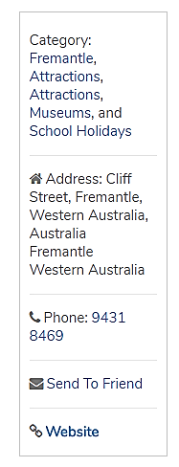
April School Holidays Tom Vickers and the Extraordinary Adventure of his Missing Sock 14 – 29 April | to book tickets visit sppt.asn.au or call 9335 5044 Cliff Street, Fremantle Closed Christmas Day, Boxing Day and New Year’s Day museum.wa.gov.au/whats-on/school-holidays 1300 134 081

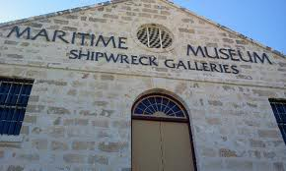
April School Holidays
Tom Vickers and the Extraordinary Adventure of his Missing Sock
14 – 29 April | to book tickets visit sppt.asn.au or call 9335 5044

Cliff Street, Fremantle
Closed Christmas Day, Boxing Day and New Year’s Day
museum.wa.gov.au/whats-on/school-holidays
1300 134 081

The Nostalgia Box
HomeThings to DoMuseumsThe Nostalgia Box
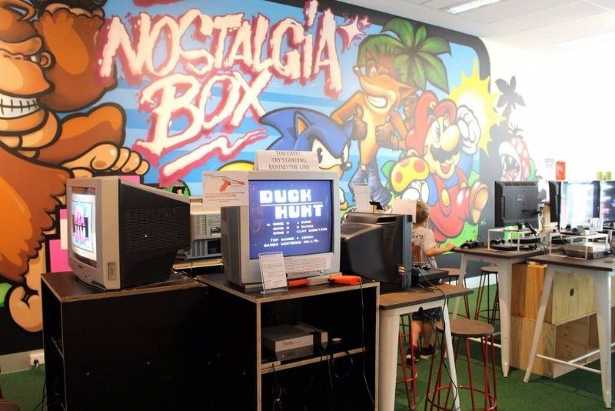
Address: 16 Aberdeen St
Perth
Western Australia
Send To Friend

Revolutions Transport Museum
April School Holidays Wheels of Fortune DATE:Saturday, 14 April 2018 – Sunday, 29 April 2018 TIME:All Day PRICE:$1.00 per child LOCATION: Revolutions Transport Museum Calling all super-sleuths and sharp-eyed detectives! A mysterious object has rolled into Revolutions Transport Museum these school holidays. Spin our ‘Wheel of Fortune’ to go on a Read more [...]

Gravity Discovery Centre
The Gravity Discovery and Observatory April School Holiday Program. April 16th to April 27th 2018 Monday, Wednesday and Friday – Rocket Making, (children to bring a 1.5 litre empty soft drink bottle) Tuesday and Thursday Solar Kids 11:00 – 1.30 each day, normal entry fees apply
No Reviews Favorite Pinpoint

State Library of WA
April School Holidays Discovery challenge 13 – 29 April | 10am – 2pm | Free TERM TIME LIBRARY ACTIVITIES Baby Rhyme Time For ages 0 – 2 years Every Tuesday at 10.30amStory Time For ages 2-5 years Every Wednesday at 10.30am Gather around the book totem and enjoy some wonderful Read more [...]
Scitech
Place Category: Attractions, Museums, Perth City, and Attractions
About
Scitech is an educational and engaging science centre conveniently located in the heart of Perth. As Western Australia’s leading science education institution, this unique centre offers interactive science experiences for people of all ages to enjoy.

Fremantle Prison

Place Category: Fremantle, Attractions, Attractions, and Museums
About
Address: 1 The Terrace
Fremantle
Western Australia
Send To Friend
Website

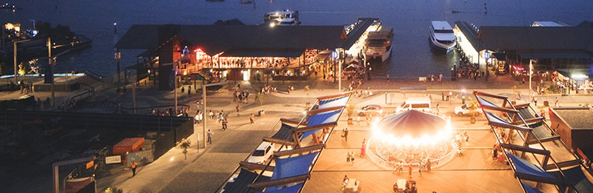
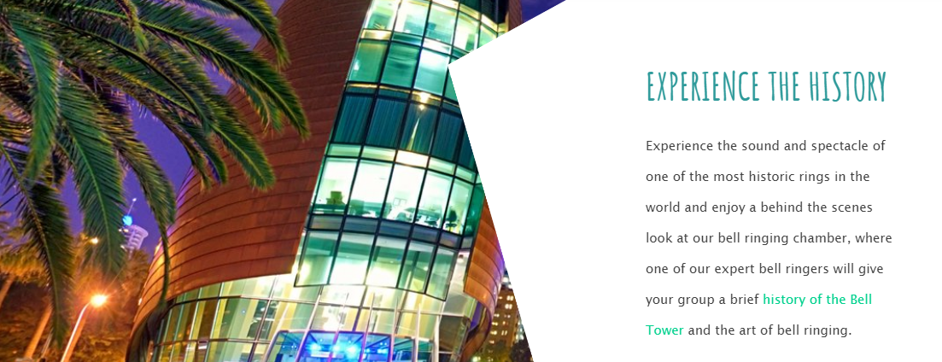
The Bell Tower
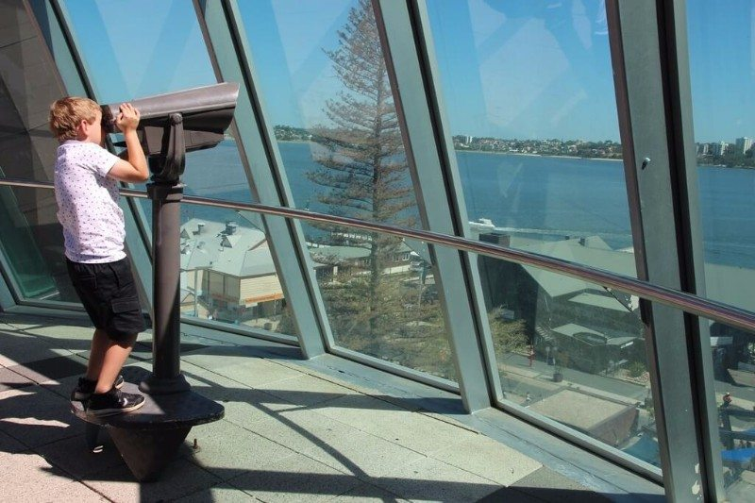

The Lost Treasure of Captain Black Jack - New Escape Room Experience
Home > Perth > Christmas | Family | Kids | School Holiday Activities | School Holidays | Indoor | Kids | Long Weekend | Adventure | Fun Things To Do | Fun for Children | Unusual Events | Unusual Things to do | Gifts | Party Ideas | Sales
Event: 13/03/2018 - 30/06/2018
The ultimate live game experience in Perth

Escape Hunt Perth has unveiled their latest hi-tech attraction, just in time for the school holidays - 'The Lost Treasure of Captain Black Jack' - a sensational family-friendly escape experience that's already been dubbed Escape Hunt's best adventure yet! Book now and discover it for yourself!
The escape room phenomenon is currently sweeping the world and Escape Hunt is one of the largest international escape room franchises with over 50 branches and 250 rooms in operation. The Bangkok venue even has its one game-building academy!
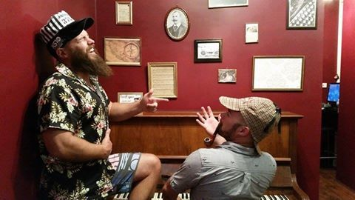
Escape Hunt Perth is home to the WA's best live role-playing escape room experiences and is conveniently located on Fremantle's busy cappuccino strip, across from The Monk Brewery, in the Piazza. Open 7 days a week from 9:30am until 9:30pm, Escape Room Perth is the ultimate interactive group activity for friends, families, corporate teams, social groups, tourists, online gamers and live pros.
Best of all, absolutely anyone can play from age 6 to 90 and there are no physical aspects involved - you just need to bring a sense of adventure!
At Escape Hunt Perth, you can choose from one of three immersive experiences: the mystery-thriller 'Poisoning in the Cafe', the action-packed 'Escape From the Mine' and the awe-inspiring 'The Lost Treasure of Captain Black Jack', which features several new innovations including clever gadgets, mind-boggling puzzles and challenges that require the use sight, sound, smell and touch.
In a team of 2 to 6 individuals, players must work together to find the clues and solve the puzzles and riddles before time runs out. If you need help, Escape Hunt's friendly and experienced gamemasters will be on hand and all to happy to offer some handy hints!
The one-hour games are played in one of five beautifully decorated and themed rooms and if you have a large group, you can form two teams and go head to head in two rooms! This takes the Escape Hunt experience to an exciting new level and makes it an ideal party idea for birthday celebrations, bucks nights, hens nights, Christmas parties, school excursions, family get-togethers and social clubs.
You can even plan the ultimate day or night out, as Escape Hunt is situated in the heart of the thriving Fremantle precinct! There are heaps of eateries to get a coffee, leisurely lunch or celebratory dinner at within a few steps of the premises and the dedicated staff can offer some great recommendations too!
Escape Hunt Perth also offers corporate training and many companies and staff have found it invaluable, as it is rare to find an enjoyable activity that also develops a sense of teambuilding.

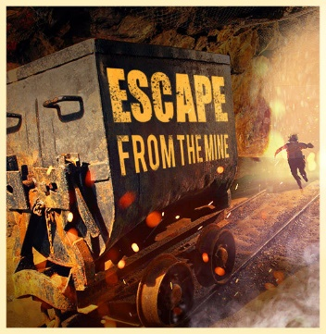

At the conclusion of the game you and your teamates can don period costumes and have a fun playful photo taken to remind you of the experience.
All players will also receive complimentary refreshments (either a can of drink or bottled mineral water) and the venue is fully air-conditioned - making it the perfect activity these school holidays!

To celebrate the opening of 'The Lost Treasure of Captain Black Jack', Escape Hunt Perth is generously offering 15% of all new bookings for 'The Lost Treasure of Captain Black Jack' experience. To take advantage of this exclusive offer, you will need to act fast! Simply use the code WN15 at the checkout or call 9336 6773 and mention the code over the phone. This offer is valid for all sessions until the 31st of December 2017.
If you are looking for a unique Christmas gift idea, consider purchasing a gift voucher.
Prices range from $36 to $42 per person - to make booking or to find out more, please visit perth.escapehunt.com
Escape Hunt Perth is just minutes away from the Fremantle train station and there is ample parking available at Queensgate car park and Henderson Street car park, which are both within walking distance.
To find out more and to book your Escape Hunt experience please visit perth.escapehunt.com or call 9336 6773.
Share: email facebook twitter
When: Open 9.30am until 9.30pm, 7 days a week
Website: https://perth.escapehunt.com
Where: U29A/36 South Terrace Fremantle 6160
Cost: $36-42

The Perth Mint
HomeThings to DoAttractionsThe Perth Mint

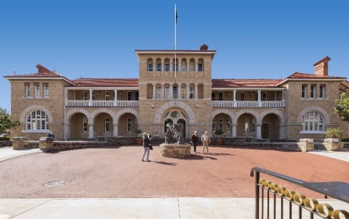
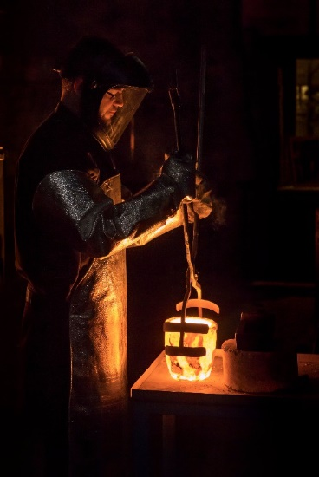

50 Free Things To Do in Perth's Family Fun Hot Spots This School Holidays
School holidays are always tough on the bank account, but there are so many free family friendly things to do in Perth to fill in the days and get the kids out of the house. All these events, parks and activities are free (or entry by donation). Don't forget to pack something to eat, drink and snack on to save you more and make a picnic part of the adventure. Enjoy!
Climbing Tree in the Swan Valley
1. Climb the awesome tree between Mash Brewery and Oasis Super Golf on West Swan Road.
2. Take a break from the wineries and enjoy a play at the huge St Leonards Estate Playground. Lots of fun for kids of all ages with rock climbing wall, fireman's pole, rope challenges, cubby houses connected by elevated ramps and more.
3. Sample free chocolates at Margaret River Chocolate Factory
4. Enjoy a picnic and explore Whiteman Park. Entry to the park is free and lots of the attractions are free too including the huge playground, and Children's Forest.
5. While you are at Whiteman Park pay a visit to the Revolutions Museum. They have fun activities included in your donation entry in the school holidays.
6. If it's between October and the end of the April holidays bring your bathers and keep cool in the Mini Water Playground at Whiteman Park.
7. Take on a family challenge and complete the Great Valley Rally. This is a great way to explore the Swan Valley and discover something new.
8. Get another chocolate fix at Whistlers Chocolate. Enjoy your free chocolate samples, check out the massive chocolate zoo display and let the kids run around in the huge backyard with sandpit, blackboard and nature based play.
9. Let the sampling continue at House of Honey. Taste honey and honey lollies, and try some of the honey body products too.
10. Another great playground to stretch the legs in between winery visits is Livvi's Place Playground Whiteman Edge. This massive playground is fully fenced, features adventure play and has been designed for all abilities and with features especially for those with those with autism spectrum disorders, physical, visual, hearing and mobility impairments.

Perth City
11. Dress up like a fire fighter and enjoy the interactive educational displays to learn more about emergency preparedness and response at the DFES Education and Heritage Centre, open Tues - Thurs (please note: The DFES Education and Heritage Centre is closed over Dec - Jan. Opens 6th February 2018)
Water Labyrinth in Forrest Place
12. Whenever you head into the city take some spare clothes, the kids won't be able to resist the Water Labyrinth in Forrest Place.
13. Catch a family flick in the Free Flicks for Kids series Saturday afternoons at the Northbridge Piazza(September to May). Find the Free Flicks for Kids movie schedule here.
14. Jump on a free Perth City CAT Bus and enjoy a ride around the city
15. Endulge in some free chocolate samples from the Margaret River Chocolate Factory on Murray Street
16. Splash at the free water playground, play and explore at Hyde Park North Perth. Have a close look in the lake and see if you can spot and oblong turtle or two. (Water Playground runs Nov - late March).
17. Climb to the top of the fort and look out over Elizabeth Quay at the Island Playground. Spare clothes recommended, as this playground includes water play.

Island Playground Elizabeth Quay
18. Head up to The Story Place a the WA State Library in the Perth Cultural Centre to read a book, or join in Rhyme or Story Time. Check out the pop up WA Museum Discovery Zone during the school holidays.
19. Ivey Watson Playground in Kings Park is a little kids play paradise. It's mostly fenced with lots of grassed area for picnicking (or Sticky Beaks Cafe is within the park if you want to treat yourself to a coffee and something to eat or grab an icecream for the kids).
20. For the bigger kids Synergy Parkland Kings Park is a super fun place to play, with prehistoric creatures throughout the park to learn about and climb on, Lycopod Island Playground and the Arthur Fairfall Playground, the kids will love exploring and playing for hours here.
21. Walk through the treetops along the Lotterywest Federation Walkway Kings Park.
22. Climb to the top of DNA Tower Kings Park and check out the amazing coastal and city views.
23. If it's adventure play you are after, head to Variety Place in Kings Park. Kids can climb through tunnels and up to the top of the fort or head to Rio Tinto Naturescape and check out the Stage 2 upgrade play features.

Variety Place Kings Park

Fremantle
24. Explore the shipwreck exhibits, dress up like a pirate, hold a cannon ball and more at the Shipwreck Galleries Fremantle. Entry is by donation.

Shipwreck Galleries Fremantle
25. Climb to the top of the climbing frame and play at the beautiful Esplanade Park alongside the Fremantle Fishing Boat Harbour.
26. Pack your skateboard or scooter and head to the Esplanade Youth Plaza and ride at one Perth's coolest skate parks. You can also play ping pong, swing on the funky monkey bars and take on the rock climbing wall in the hang out zone. Entry is free
27. Catch the free Fremantle CAT and explore Fremantle by bus
28. The Fremantle Roundhouse is Fremantle's oldest public building. It's been used as a jail and as accommodation for the Water Police. Now you can enter by donation and learn all about it's history. The cannon is fired at 1pm daily and you may even be able to trigger the shot.
29. Bathers Beach is a beautiful spot for a swim on a hot day and is also a nice walk through the Kidigo Art Precinct where you can often find works of art around the art house. You can walk up to The Fremantle Roundhouse along the Bathers Beach Foreshore walk path.
30. Take advantage of Fremantle free bike hire at The Fremantle Visitors Centre in Kings Square and E Bikes R Us at the E Shed on Victoria Quay and explore Fremantle on two wheels.

Hills / Eastern Perth
31. Picnic at the Construction Camp Hub Picnic Area looking up at the beautiful Mundaring Weir. Walk off your picnic lunch with a walk across the Spillway Bridge to check out the Old Pump Station and wander back across the top of the weir (please note access to the weir walkway is closed for maintenance until 23rd December 2017).
32. Play the day away at the Hills best playground and park, Sculpture Park.

Scultpure Park Mundaring
33. Enjoy a nature walk and check out the views from Lesmurdie Falls and the city or enjoy a bush walk at Ellis Brook Valley Martin
34. Wander through the dinosaurs and other creatures and characters in the gardens at The Bird and Fish Place Wattle Grove.
35. Play like a pirate and explore like an adventurer at Woodbridge Riverside Park. It's fully fenced and features a big wooden pirate ship, tunnels, flying fox and lots of nature based and adventure play.
36. Pack lunch or a snack and sit back and watch the planes take off and land at the Perth Airport Viewing Platform.
37. Pack your kayaks or canoes and head to Lake Leschenaultia Mundaring. Enjoy a day out of swimming, play at the playground and take in a nature and wildflower walk. Entry to Lake Leschenaultia is free, and a small fee can be paid to camp here also.
38. Keep the kids cool at Rainbow Waters Ellenbrook Water Playground. This runs during the warmer months of the year and features zero depth water play with cannons, sprays and tipping buckets.
39. Climb a volcano, ride the flying fox and dodge the water spouts in the jungle at the big, fully fenced Faulkner "Volcano" Park Belmont.
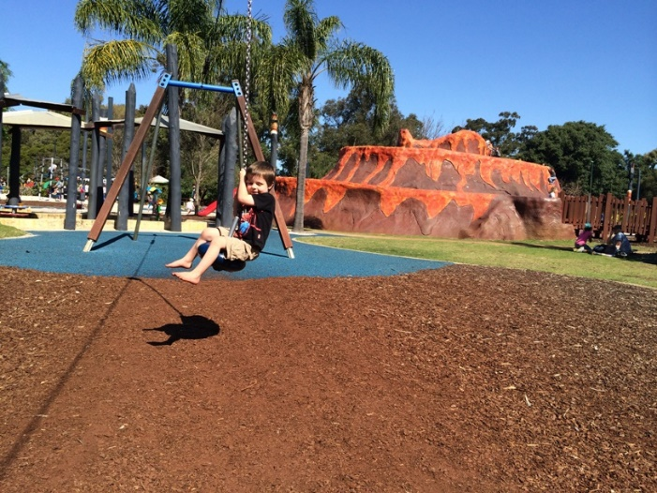Faulkner "Volcano" Park

South of the River
40. Give the kids an outdoor "tech" fix at the huge Robot Park Piara Waters.
41. Watch the planes and helicopters take off and land from the picnic area at Jandakot Aiport.
42. Do it all at the amazing Kwinana Adventure Park with water playground that runs all year round, trampolines, flying fox, tree walk and more.

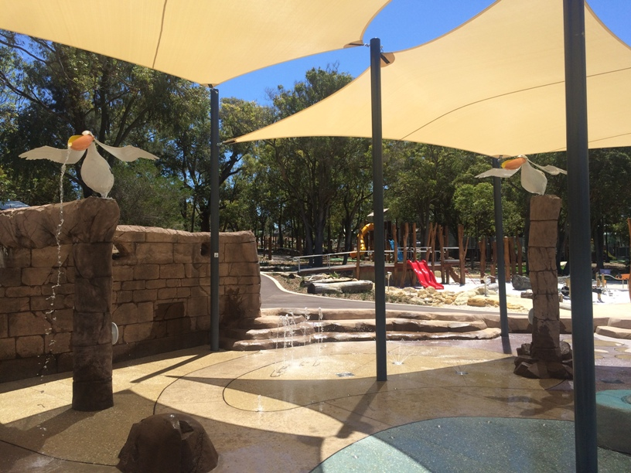
Kwinana Adventure Park
43. Climb to the top of the 7m tall jungle climb, bounce on the trampolines, ride at the skate park or on the bmx track at Wellard Adventure Playground.

North of the River
44. Swim out to the pontoon and slide into the calm waters of the Hillarys Boat Harbour all year round.

Hillarys Boat Harbour Pontoon

45. Climb to new heights at Eden Beach Foreshore Playground. The kids will be challenged by the 3 storey climb and slide down and long ropes challenge play equipment.
46. Head a little further north to Yanchep and climb and slide down the steps and slide built into the side of the cliff at Campground Playground.
47. Play at the two level Jungle Gym in the Karrinyup Shoppping Centre Food Court daily from 12-5pm.

Mandurah
48. Play and swim at Dolphin Quay. Swim out to the pontoon and slide into the calm waters, wander over the bridge to look out over Dolphin Quay and play at Keith Holmes Reserve.
49. Climb to the top of the 8m tall windmill, ride the giant pig slide and explore this huge farm theme adventure playground at Adventurescape Austin Lake, South Yunderup.
50. Explore the huge Quarry Adventure Park Meadow Spring. This is not just a park but a day of adventure at this park built within an old quarry with big climb up the cliff face and slide down.

Find events, playgrounds, cafes, attractions, deals and more nearest you and get a map to take you there while you are on the go with the Kids Around Perth App today!

Rock Climbing Centres

City Summit Rock Climbing Cente
Be amazed by Perth’s best indoor rock climbing centre, City Summit Rock Climbing Centre. We welcome absolute beginners with complimentary tuition. Indoor rock climbing is a great family day out or the perfect place to celebrate your child’s birthday. Check out our kids climbing courses, school holiday activities and healthy Read more [...]
No Reviews Favorite Pinpoint

Latitude
Trampolines | Climbing Walls | Skywalk | Parkour | Under 5’s Area Read the Buggybuddys Review
No Reviews Favorite Pinpoint

Clip n Climb
Location: Joondalup Read the Buggybuddys review
No Reviews Favorite Pinpoint

Joondalup Climbing Centre
No Reviews Favorite Pinpoint
What’s Near Me?

Perth has many Laser Tag venues suitable for kids and adults of all ages. We’ve compiled a list of our favourites which include pictures and reviews from local families.

Lazer Blaze
Lazer Blaze has three huge indoor Laser Tag Facilities in Malaga, Port Kennedy & Willetton. Catering for ages 7 and up it’s an activity the whole family can enjoy together. Be sure to wear your joggers/sneakers to join in the fun and we always suggest phoning ahead to make a Read more [...]
No Reviews Favorite Pinpoint
What’s Near Me?

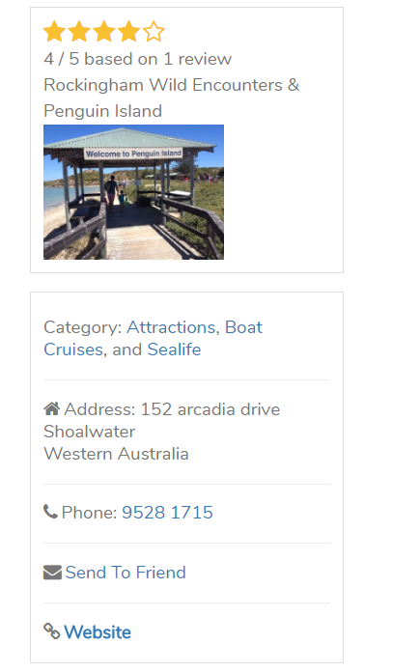
Rockingham Wild Encounters & Penguin Island
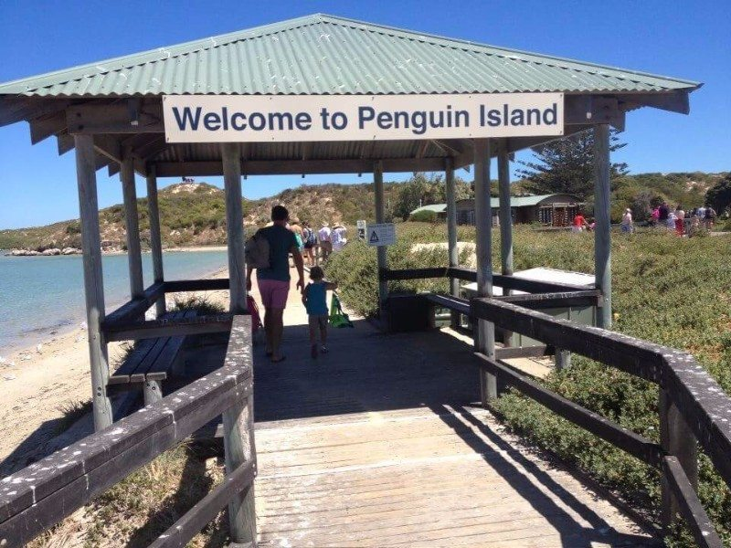
Category: Attractions, Boat Cruises, and Sealife
Address: 152 arcadia drive
Shoalwater
Western Australia
4 / 5 based on 1 review
Rockingham Wild Encounters & Penguin Island
Category: Attractions, Boat Cruises, and Sealife

Perth Garden Festival 2018 presented by Kleenheat is back this Autumn with an unmissable four-day, family-friendly extravaganza!
Expect more plants & nurseries, a spectacular range of landscape show gardens, many more exhibitors than previous years and a PIMMS Licensed Garden Bar to kick back and relax in!
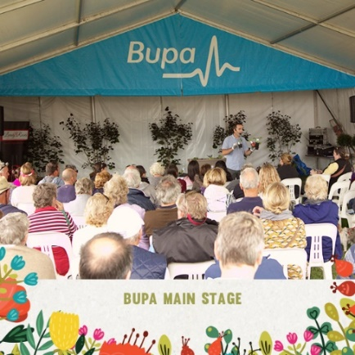
The Perth Garden Festival transforms McCallum Park into a gardener's paradise with spectacular landscape show gardens, a huge plant marketand incredible outdoor living products.

Autumn is the best time to revamp your garden and the Perth Garden Festival will be bursting with colour and inspirational ideas over four fabulous days.
If you are looking for some gardening advice, make sure to check out the daily seminar program on the Bupa Main Stage featuring Perth's best horticultural experts, including Sue McDougall from 6PR's Garden Talk and Sabrina Hahn from ABC Gardening.

Home cooks will also enjoy the Kleenheat Outdoor Kitchen featuring demonstrations by celebrity and local chefs Anna Gare, Vince Garreffa and Guy Jeffreys.

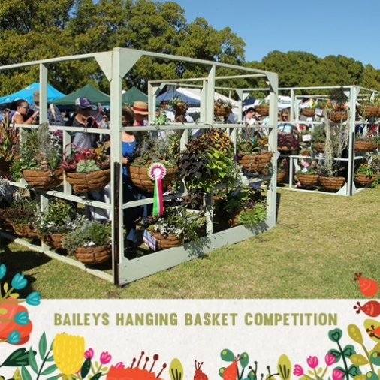
The kids enter free and can get their hands dirty in the School Education Area, which will be playing host to a variety of interactive workshops and activities thanks to Lotteryswest.
Take advantage of exclusive discounts and offers made available by many of the exhibitors at Perth Garden Festival 2018.

Over 30,000 people attended in 2017 so Beat the lines, Buy Your Tickets Online for a chance to WIN a $9k Outdoor Kitchen from Outdoor Alfresco Kitchens - https://tinyurl.com/pgf2018.

Prices start at $20 for General Admission, however, Kleenheat Members receive 50% off ticket purchases and Town of Victoria Park/City of South Perth Residents can take advantage of a 2 for 1 Special. BUPA members also receive an exclusive discount - Click here for all the details.
We hope to see you all there from Thursday the 12th of April to Sunday the 15th of April 2018.
For all the latest on the Perth Garden Festival, head to www.perthgardenfestival.com, www.facebook.com/perthgardenfestival, twitter.com/perthgardenfest andwww.instagram.com/perthgardenfestival

To Do

Smartphone Photography Course

Website: https://tinyurl.com/pgf2018
Where: McCallum Park, Victoria Park WA 6100
Cost: Adult $20, Kids Enter Free - Concession & Sponsor Member Discounts Apply

list an event 1 million Australian readers every month facebook
Bike in the Valley - FREE Event by Vanessa ★ (subscribe)
WeekendNotes Chief Editor / Chief Writer / PR & Communications.
Event: 29/04/2018
Gear up, cyclists - Bike in the Valley is back
This Autumn, The City of Swan is once again hosting their popular 'Bike in the Valley' family-friendly community cycling event through the beautiful Swan Valley.
Held on Sunday, 29 April 2018, the ride is suitable for all ages and fitness levels and will start and finish at Chardonnay Park, The Vines (corner of Barbera Lane and Vines Ave). Registration opens at 9am and the ride will commence at 10am.
Families can choose from 3 NEW routes: a short 8 km route, a medium 18 km route and a longer 30km route. All routes are well signed and supported by a 'sag wagon' which will follow the riders. Marshals will also man critical corners and crossings and Dr Bike will be there to make sure your bike is well set up.
The rides are mostly on bike paths and quieter back streets. Please note that there will be no road closures and all normal road rules apply, including the wearing of helmets.
After completing your chosen route, you can tuck into the fundraising sausage sizzle or bring your own gourmet picnic along.
This is a great activity for families, friends and workmates, so come along and enjoy a leisurely ride through the Valley on a balmy Autumn Sunday morning.
There will also be plenty of FREE parking on site.
For more information on this great FREE community event, please visit the City of Swan website.

list an event 1 million Australian readers every month facebook

Live at Locale - FREE Concert Event Series
Home > Perth > Community Events | Family | Free | Kids | School Holidays| Unusual Things to do | Unusual Events | Teenagers | Street Performers | Singles and Dating | School Holiday Activities | Pop Ups | Performing Arts | Music Venues | Misc | Fun Things To Do | Cultural Events | Concerts
Event: 08/04/2018 - 20/05/2018
FREE live music events on Sundays
large image
Live at Locale is a fresh new live music event series which kicks off at the revamped Locale Event Space this weekend.
Proudly presented by The City of Swan, Live at Locale plays host to an epic line-up of West Australian acts, including headliners Elli Schoen, The Tommyhawks, Lucy Peach and the Bambuseae Rhythm Section.
Each Sunday, between April 8 to May 20, from 3pm, you and your family and friends will have the unique opportunity to discover awesome local music acts. There will be a wide range of music genres showcased, from blues to indie, dance and hip-hop, ensuring there's something for everyone!
The Locale Event Space, located on the corner of Cale Street and The Crescent in Midland, recently underwent a major renovation and now houses an exciting pop-up food and drink space and artwork upcycled from the old Midland Railway Workshops.
Come down with your family and friends this Sunday and discover fabulous homegrown musicians and all that this unique public space has to offer! Entry is FREE.
For all the latest on the live music line-up each week, make sure to follow www.facebook.com/cityofswanevents
Hope to see you there!
Share: email facebook twitter
When: Sundays, April 8 - May 20
Website: www.facebook.com/events/157737991576991
Where: Locale Event Space, Cnr Cale St & The Crescent, Midland
Cost: FREE
Categories
If you to paint and get crafty, come join the Community Mural Fun Day at Victoria Park Central Shopping Centre on Saturday 14 April 2018.
This one day only event sees Victoria Park Central team up with renowned artist Paul Deej and the students from Ursula Frayne Catholic College, who have designed a mural.
From 11am, the local community is invited to help complete the 'paint by numbers 'mural, which is on a wall inside the shopping centre.
Plus there will be a range of free family entertainment to enjoy, including face painting, an animal farm, where you can cuddle a rabbit, guinea pig or chicken and pat a goat or sheep, and a Bricks 4 Kids Lego workshop.
This is sure to be a fun-filled day out for all Perth families!
For more information on the Community Mural Fun Day and what's on at Victoria Park Central these school holidays, please visit www.vicparkcentral.com.au and 'follow' www.facebook.com/victoriaparkcentral

Perth Homeless Support Group Go Kart Fundraiser
Event: 29/04/2018

Book now as places are limited

Spend a 'hands on, real time' electrifying adrenaline filled morning on the track.
large image
Perth Homeless Support Group (PHSG), will host an adrenaline filled morning of Go Kart Racing on Sunday, April 29, 2018 from 10:00am to 12:00pm.
During this time, PHSG have exclusive use of the venue at Kart World Belmont, to feed your racing aspirations. Moreover, the tickets includedriver briefing, helmet hire, 1 x 20 Lap Race and a sausage sizzle. Add a door prize, Champions Trophy and Runner-up medal, to finish off an exciting morning of fun.

The Perth Homeless Support Group Inc. (PHSG), takes a 'hands-on' approach to meet the homeless and those at risk of being homeless, by seeing their need and acting in a way that makes a difference to their situation. Please, 'like', 'follow' and 'share' their 'IMPORTANT OUTREACH EVENTS PAGE' and help support Perth's homeless.
The Sunday city walk helps the homeless
PHSG volunteers gather every Sunday, in the State Library Car Park, then assemble outside the State Library, followed by a walk through the Murray and Hay Street Malls, handing out Care Packs (food and toiletry), to the homeless of Perth.
Life is better with shoes that fit.
large image
If you can offer assistance or volunteer, you are most welcome to help support this small charity with a big heart. To keep in the loop, you can jointheir Facebook page and discover how you can help put your skills to work.
Do not miss the start
Places are limited, so do not miss the start, purchase your tickets here, at just $40 per person, and be part of an exciting time while you help the homeless.

Where: Kart World Belmont, 8 Cowcher Place, Belmont
Cost: $40 per person includes driver briefing, helmet hire and 1 x 20 Lap Race and a sausage sizzle
Categories
Western Australia

10 Free Things to do on a Rainy Day in Perth
Home > Perth > Family | Free | Fun for Children | Fun Things To Do | Kids | School Holiday Activities | Lists

by Sarah M (subscribe)
A freelance writer living in Perth, WA. My blog is coming soon. Watch this space!
Published May 3rd 2012
Winter is fast approaching and that means lots of rain. Luckily the weather in Perth is fairly moderate but when it does start to rain, especially for days on end, we will all be looking for something to do that doesn't cost a fortune or even better, is free. Where can you go? What can you do?
1. Go window shopping. Stroll through the arcades of Perth or any of the many large shopping centres in the surrounding areas. Shopping malls are warm and dry and window shopping is free - and the next time you need something, you will know exactly where to go to get it. Or you may just see something that you will fall in love with something and just have to have there and then.
2. Visit the Library. Check out a couple of good books or see what kind of activities are going on. There is always something going on at your local library for everyone to enjoy.
3. Browse the indoor or undercover markets. Stroll through the stalls of Fremantle Markets or one of the many other markets in the local areas.
4. Take a CAT bus ride and see the city. There are some wonderful places to visit around the city and you may be surprised at some of the beauty around the city.

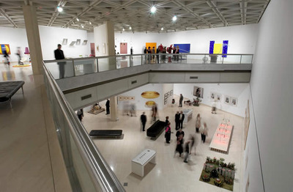
Art Gallery of Western Australia
5. The Art Gallery of Western Australia houses some beautiful art pieces including the State Art Collection which includes art pieces by prominent Western Australian, Australian and International artists.
Along with the long term displays, The Art Gallery of Western Australia exhibits different short term collections at different times of the year. This offers you the chance to experience unique collections of historic and contemporary art works all year round.
6. See something amazing at The Western Australian Museum - home to a vast collection of local and travelling exhibitions. Housing fascinating long term displays of birds, butterflies, mammals and marine life, the museum also has a Diamonds to Dinosaurs exhibition and a discovery centre. The museum also features magnificent short term travelling exhibitions at different times during the year.
7. Visit the Maritime Museum Shipwreck Gallery in Fremantle. This museum has plenty of interesting displays and exhibits full of artefacts and relics, enough to keep you occupied for a couple of hours.
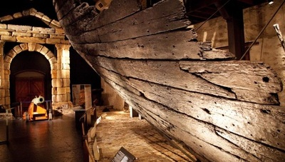
Maritime Museum Shipwreck Gallery
large image
8. Feel like some retail therapy? Harbour Town Shopping Centre is a fantastic two story shopping complex full of name brand outlets and loads of places to grab a bite to eat. They always have plenty of specials on offer and you can usually pick up some of your favourite brands at half price. Harbour Town is not completely under cover but you can easily duck from store to store without getting too wet, plus you can spend hours there without spending a penny.
9. Tour some old historical buildings. There are plenty of old cultural, historical buildings in Fremantle and Perth, plenty of new and interesting ones too. Visit the old Fremantle Prison, the Roundhouse, the Cathedral or the Swan Bell Tower.
10. Take a walk in the rain. If you're one of those people who like to walk in the rain, grab your coat and umbrella and go for a stroll. Plenty of lovely place to see in Perth and the nearby areas, even in the rain.
There are always lots of free and interesting activities available, these are just a few suggestions of what to do on a rainy day in Perth and I'm sure you can think of loads more.

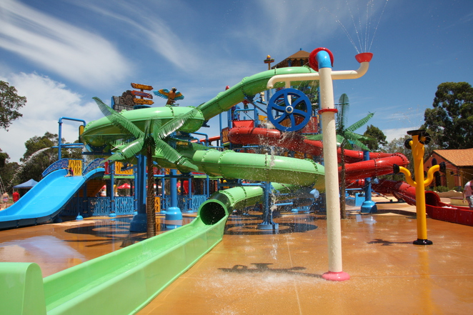
The Maize
The addition of the water slide park to the Maze has added a whole new dimension of fun to the park and definitely makes this a whole day attraction.
There's something for everyone here and the whole brood can fit on the large blue family slide and whizz down into the water. When we visited, there was a fabulous DJ creating a Summer soundtrack to chill out to in the water, and this created a real party atmosphere.
Around the water park there are numerous sun loungers (some shaded), and if you want to nab one of these, come early to avoid disappointment. If you're not lucky enough to bag a seat in the shade, you can bring your picnic rug, towels or beach tent to set up camp right next to the fun, on the adjacent grass areas.
There is plenty of room for everyone to spread out and relax on. Changing rooms are well appointed, clean and include showers too. For waterside refreshments there's a snack kiosk and the adjacent Cafe Iguana for more substantial meals. Whilst suited to all ages within your family, there's no real 'splash pool' for any babies within your party.
We had a 6 month old with us when we visited and he was happy enough to play in the jets on the ground, and even came down a slide with us, but if you've got younger kids than this, you might want to set up in the shaded area if the waterpark isn't their thing.
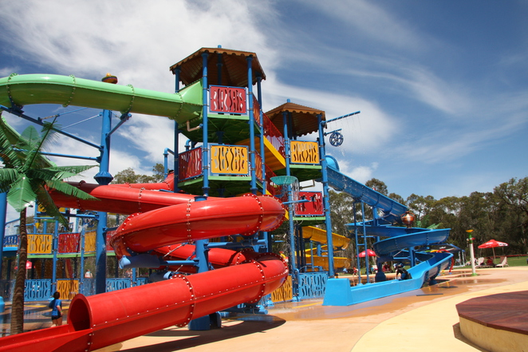
Plenty of slides to choose from
large image
Where:
Located approximately 45 minutes from Perth's CBD en-route to the heart of Bullsbrook and the beautiful Chittering valley. The address for your sat nav is 1635 Neaves Rd Bullsbrook and there is plenty of parking on site.
When:
10am to 5pm Wednesday to Friday
9am to 5pm Saturday & Sunday
Café Iguana 10am to 5pm Wednesday to Friday
9am to 5pm Saturday
8am to 5pm Sundays*
breakfast with the Koalas 8am to 11am Sundays
Closed Monday and Tuesday except for school and public holidays. Closed Christmas Day and Boxing Day.
Cost:
Children under 4 are free.
Adults $33
Student & Concession $29
Seniors $20
Children (4-15 years) $24
Family (2 adults & 2 children) $105
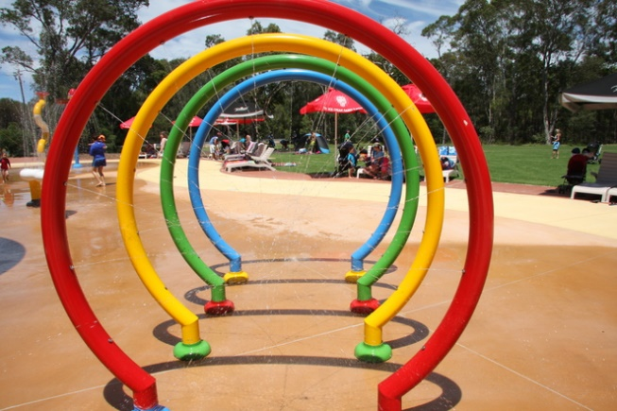
Little ones will love the walk through jets
large image
A season first for 2013 is the introduction of the season pass priced at $70 for an adult, $50 for a child (aged 4-15 yrs). Children aged 3 and under are free. Serniors are priced at $50. Season passes for 2013/14 are valid from 16 December 2013 through to the 26 September 2014. Pay once and come as many times as you like throughout this time. Season passes also make a great gift if you are interested in spoiling someone for a Christmas or birthday.

Season passes available now for a full Summer of outdoor fun
large image
What Else is There to do There?
The arrival of Outback Splash is fantastic news for Perth folk, but there's a tonne of things to do at the Maze if getting wet and wild isn't for you. Check out the below attractions so that you can plan to fit in a full day of fun in your next visit.
Mazes
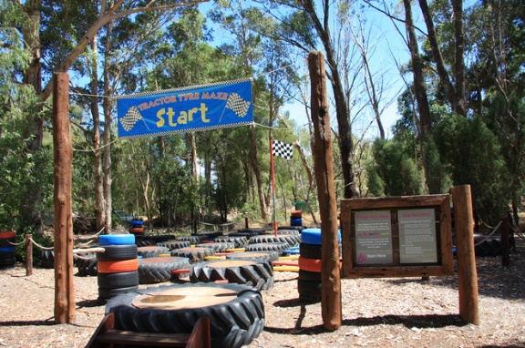
Tractor Maze
large image
With five different mazes to choose from, you can challenge your friends and family to endless quests to find the way out of the maze. Little ones will enjoy the bright colours and fun of the Tractor Tyre Maze, and all the family can get lost in the giant timber maze.
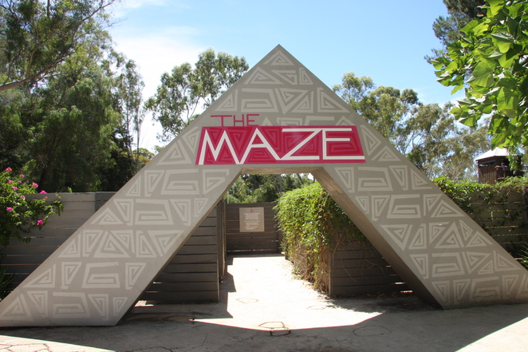
The timber maze
Koalas
Koalas are a big attraction at the Maze with daily koala talks in addition to a meet and greet session with the koalas at the Breakfast with Koalas on Sundays, where you can get up close and personal with these gorgeous furry creatures.
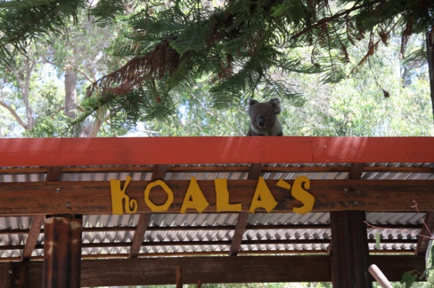
Check out the cheeky koalas
large image
Mini Golf
Included in your admission price is mini golf, and the course here is beautifully appointed within the cool shade of the front gardens of the Maze. It's a 9 hole course full of curves and turns to challenge you to get your ball in the hole.
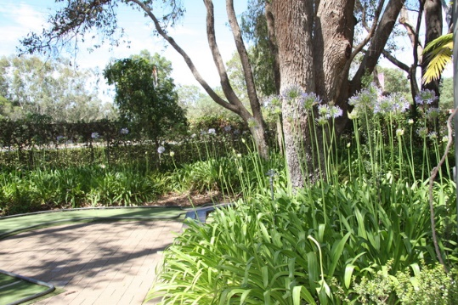
Mini golf in a picture perfect setting
Animals
In addition to the fluffy koalas that The Maze has become famous for, you can also meet emus kangaroos and a whole host of birds on your trip around this family attraction. In the aviary look out for Henry and some of his winged friends who will surprise you when they talk back to you. Look out for camel riding opportunities too.
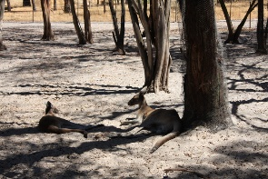
Chill with the kangaroos

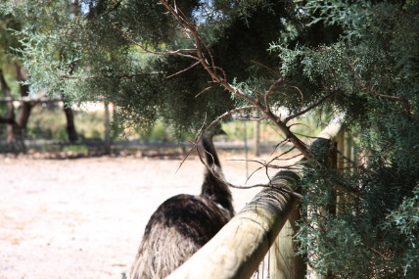
Emu spotting

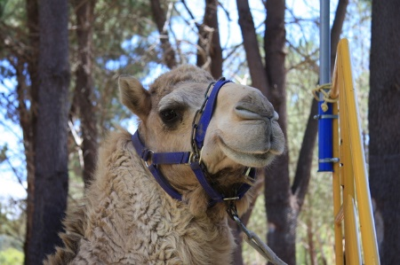
Alice is a camel...
Jumping Pillow
The jumping pillow, as the name suggests, is a giant inflated pillow that you can jump on. This is so much fun for kids (and big kids) and if you're worried about your little toddlers going on with the older kids, wait till specific toddler jumping times when they can jump to their hearts content without risk of getting bopped by the bigger kids.
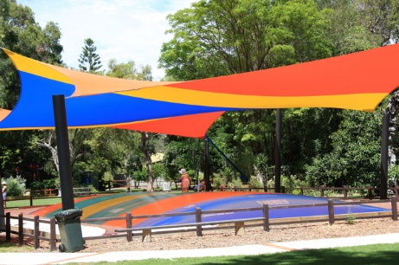
Jump for joy on the giant jumping pillow
Playground
The adventure playground is a well appointed wooden framed play area on a woodchip ground, for soft landings. Adjacent to a number of picnic benches and BBQs this is a great place for kids to explore whilst the parents get the food ready. Just away from the main timber frame, there is also a 4 person see-saw type structure that is heaps of bouncy fun.
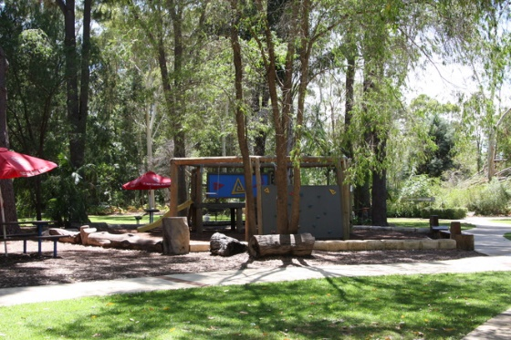
Kids adventure playground
large image
Chess
If you lost at mini golf, then never fear, just challenge your opponent to a game at the adjacent giant chess board. Grab your child size pawns and use your smarts to get you to check mate super fast.
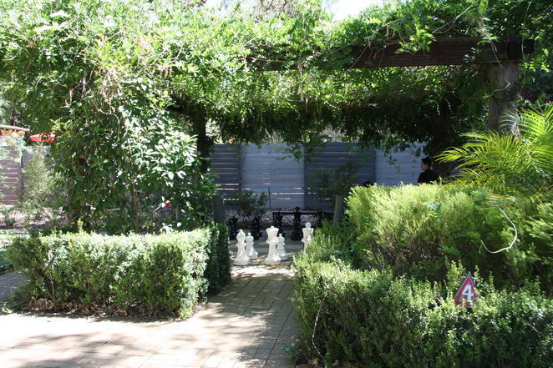
Game of chess, anyone?
large image
Click here for a map of all of the attractions on offer at the Maze.
When: 7 days a week, except for Christmas and Boxing Day
Phone: (08) 9571 1375
Website: www.themaze.com.au
Where: 1635 Neaves Rd Bullsbrook, WA 6084
Cost: Varies, approx $33 per adult
Categories
Bullsbrook (subscribe)
Escape the City(subscribe)
Family (subscribe)
Kids (subscribe)
School Holiday Activities(subscribe)
Swimming Pools(subscribe)
Western Australia(subscribe)
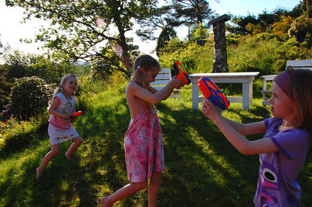

Of course, Perth is blessed with numerous fabulous beaches, stretching from Rockingham in the south to Yanchep in the far north. However, not all of us are fortunate enough to live with one close by. Similarly, while the ownership of back-yard swimming pools has skyrocketed over recent years, once again, not everyone can afford such a desirable luxury. Therefore, in order to keep our sanity in such a hot arid climate, it's essential that we know where the best spots in our local area are that we can get wet and wild, without it costing a small fortune. The following are some of Perth's top venues for exciting water-based fun that can be enjoyed by the whole family.
Maylands Waterland
Maylands Waterland is a personal favourite of mine, and I used to take my daughter there regularly when she was younger. Situated at 32 Clarkson Road, right next to the Swan River, it's a beautiful spot for the whole family to pleasantly while away a few hours in on a hot summer day. It consists of four child-friendly pools of various depths, all protected by sturdy shade sails. In addition there is a kiosk, several sheltered picnic areas and a variety of other play areas for when children tire of the water. In addition to standard admission charges, season passes and privilege card discounts are available.
Kalamunda Water Park

Food Night Safari Perth

A reincarnation of the popular Kalamunda Wet'n'Wild, the Kalamunda Water Park will keep the whole family cool and refreshed this summer. Situated on the corner of Canning and Collins Roads, the park features a variety of water-based attractions including a couple of awesome waterslides for thrill-seekers young and old, paddle pools for the littlies, and an Olympic pool for bigger people.
Image is from the YMCA Kalamunda Water Park website.
large image
Ellenbrook Rainbow Waters Park
Unlike most of the other water playgrounds in the Perth metropolitan area, the Ellenbrook Rainbow Water Park is absolutely free of charge. Completed in late 2009, it's the largest free water park in Perth, and boasts a wonderful assortment of exciting water features aimed at mainly younger children, including paddle pools, slides and fountains. It's located opposite the Ellenbrook Community Library on Main Street.
Hyde Park Water Playground
Located just 2 kilometres from Perth CBD in Highgate, Hyde Park has always been a cool spot to visit on a hot summer day. However, it's the presence of the water playground which makes the park a particularly attractive destination for children. Although there's been a water park here for decades, it's been recently refurbished after a hiatus of about three years. Parents will love the fact that this community centred water park is completely free of charge, while kids will simply be delighted that it's open again for 'business'.
The Great Escape
Situated at Hillarys Boat Harbour in the northern suburbs, the Great Escape is promoted as Perth's ultimate leisure park, boasting a dizzying variety of water-based fun, as well as drier forms of entertainment such as Jungle Mountain and rock-climbing. During the hot weather, the water slides naturally reign supreme and these include Wild Rapids, a 16 metre high ride that you take on a 'super tube', two Speed Twister slides, and the Hydro Tube. Since these rides can get pretty rowdy, especially at busy times, management emphasises that they're not suitable for littlies under three. Children between 3 and 6 can only use the Hydro Tube and must be accompanied by an adult.
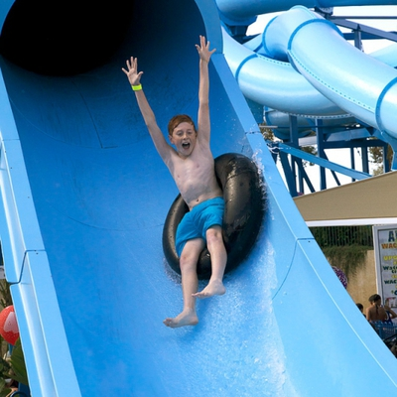
Image is from The Great Escape website.
large image
The Great Escape is a blast for people of all ages, and although it's not cheap entertainment, it's definitely a special treat for a hot day. For more information, including prices, check out the Great Escape website. If you think you'd like to go regularly, season passes are also available.
Adventure World
Although, like the Great Escape, Adventure World is certainly not 'just' a water park, no article about water playgrounds would be complete without at least a cursory mention of it, due to the many fun water-orientated activities which are available there. Very little children will enjoy a swim in the Lagoon and riding on the paddle boats, while the more boisterous will enthusiastically participate in water cannon fights on the bumper boats. For the die-hard daredevil, there are several waterslides to choose from, including the Tunnel of Terror, Rocky Mountain Rapids, Speed Slides and Water Mountain Mat Slides.
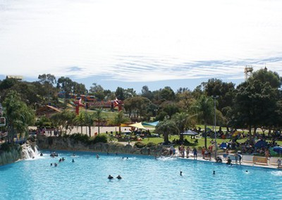
Image is from the Adventure World website.
large image
Adventure World is a great spot to head to for some refreshing water-based fun on a sweltering summer day. A season pass makes good sense for those who'd like to visit regularly. For more information, refer to the Adventure World website.
Water Labyrinth at Forrest Chase
An interactive sculpture by Danish artist Jeppe Hein, the newly-installed Water Labyrinth in the heart of Forrest Place offers a pleasant and watery diversion for hot, frazzled folk in the city, both young and old. To find out more, read here.
Local Pools
While purpose-build water playgrounds are often free of charge and leisure parks provide a bewildering assortment of high adrenalin water-based fun, don't rule out your local swimming pool this summer when the temperatures soar. A convenient distance to home, such destinations don't require a sweaty odyssey across the city, and most provide an adequate assortment of good, watery entertainment. While the waterslides (if they exist at all) may not be as high or scary as those at Adventure World, children really don't need all these fancy trappings to keep happy and entertained.
With water playgrounds like these popping up like mushrooms throughout the city, it looks as though we'll all be having a blast this summer. Playing with water was never so much fun.

The 'kinetic contraption' at Scitech... basically a giant game of Mousetrap
large image

A Sci-trekker membership which gives you unlimited entry for a whole year is the bargain basement price of $44 for adults and $28 for a junior (4-15 years). A family membership of two adults and up to six kids (yup, you read that right Brady Bunch) is only $127.
To put it in perspective, a Zoo Friends membership is $75 for adults*, $45 for kids and there is no discount for a family.
Please don't send hate mail, I love the zoo and I am a proud Zoo friend but for value-for-money, Scitech wins hands down.
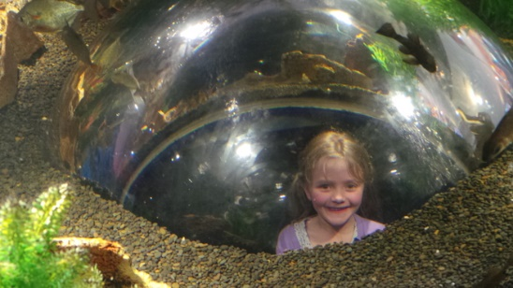
Feed your kids to the fish
large image
2. Parking
Recently City West has introduced boom gates in its undercover parking area and started charging parking fees of $5 for 2-3 hours and $15 for 3-4 hours. This is to discourage city workers and means more bays are freed up for Scitech and CityWest shoppers.
Don't want to spring for $15 parking? Fear not: take your parking ticket to the desk inside Scitech and they will validate it for you: that's eight hours of free parking. No messing around with coins or credit cards.
Free parking. All day. Undercover. Sorry, City of South Perth and Wilson Parking, but you simply can't compete with that.
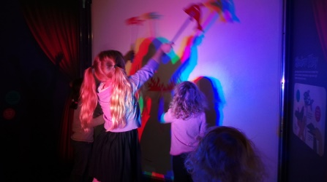
There's not much kids can't do at Scitech
large image
3. It's inside
We've all been caught at the zoo, a thousand miles from anywhere when it starts to rain. The walk back to the car is a long one with wet, whinging toddlers and mud all over your favourite new shoes. Scitech is blissfully indoors, and if you park in the undercover basement you never need to see the light of day. Eugh, sunshine.
That means no hat, no sunscreen, so umbrellas and no puddles. You can leave that extra bag at home.
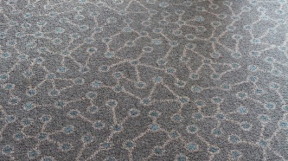
Even the carpet is science-y
large image
4. It's contained
All parents know that feeling when you turn around and you're missing one of the kids. The zoo is an impressive 41 acres, that's over 600 tennis courts.
Scitech, however, while apparently big enough to fit half of Perth during ToddlerWeek, is somewhat contained with only one main exit and entrance and no wild animals which eat small children**.
Discoverland is even more contained, as long as you park somewhere by the entrance, and even the most errant toddler can't escape.
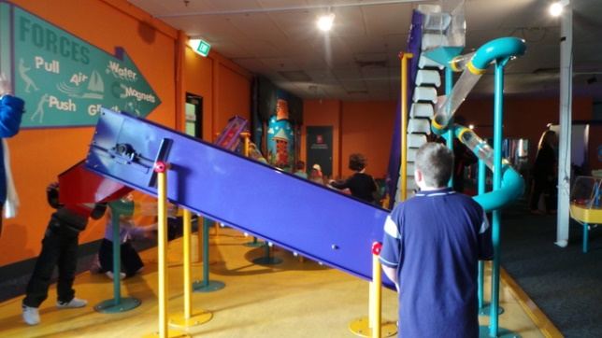
Everyone loves hearing their child bellow 'we need more balls' at the top of their lungs
large image
5. It's all-inclusive
It's the extras that get you. Well, it's the kids that harass you for the extras: $5 to feed the giraffes, a $4 ride on the Carousel, photos with the lions.
At Scitech, everything (except the gift shop) is included, including whatever special exhibit they have on at the time, plus all the puppet, theatre and Planetarium shows. That's 27 shows a day.
6. They have seats
One of the best things about Scitech is when your little Scitrekker is going mad building a wall or making sure the balls don't stop rolling, you can park yourself on a padded seat and simply enjoy the serenity (of hundreds of kids barking orders to each other).
Sure, the zoo might have lions roaring and the gentle bellow of elephants, but the benches at Scitech are padded. No contest.

If you're prone to motion sickness I would avoid the Planetarium
large image
7. You can catch the train
The City West train station is a short stroll to Scitech, and once you add a train ride to lasers and rolling bowling balls you have a complete day out for kids of all ages. It's true that trains don't compare to the awesomeness that is the Ferry which goes to South Perth, but the walk is much shorter.
8. You can have a nap
Have you been to the Planetarium? The seats recline a bit like first class on an airplane (so I have been told), and the shows go for 50 minutes. That's a decent cat-nap by any standards, and it's so dark in there, not even your own kids will know you've dropped off.
Those in the know, know that the seats in the centre of the room afford the best view (although they're further away from the doors in case of motion-sickness). Don't let your snoring give you away.
So those are my eight reasons why Scitech is better than the Zoo. Controversial? Perhaps. Superficial? Definitely.
*I am aware of the fact that the zoo has significant costs associated with it that Scitech doesn't. Like all those animals they have to feed and plants they have to water. That sort of thing.
Oh, and I'm pretty sure that there aren't too many wild animals at the zoo that will eat your small child. Then again…
Scitech is open every day of the year except Christmas Day and Boxing Day. Open from 10am to 5pm on weekends, school holidays and public holidays and from 9.30am to 4pm on weekdays during term.

Top Rainy Day Activities for Kids in Perth
Home > Perth > Swimming Pools | School Holiday Activities | Rainy Day | Fun Things To Do | Fun for Children | Family | Exhibitions | Cultural Events| Classical Music | Lists
by Helenonthesofa (subscribe)
Freelance writer, mum of two who loves living in sunny Perth.
Published June 11th 2012
So often when the rain comes beckoning in Perth, the desire to hibernate inside and stay cosy in our Ugg Boots takes over. However, we shouldn't forget that Perth plays host to an array of fantastic attractions based indoors, lending itself out as a perfect place to spend a rainy day this Winter time. If you're struggling for inspiration for rainy day activities with kids in tow; struggle no more. Read on.
Indoor Swimming Pools
Perth residents have access to some fantastic aquatic and leisure facilities. Recent years have seen some great movement in turning the humble indoor pool centre into something of an indoor water playground. A notable addition on the aquatic scene in the Northern Suburbs is Wanneroo Aquamotion presenting a little more than the average pool for big and little kids alike. Closer to Perth, Belmont's Oasis Aquatic centre offers a lovely space for water action with a large beach entry pool filled with water attractions. The bigger kids might also enjoy the waterslide at Joondalup's Venues West Arena.
Cinema
The Movie Masters Group of Grand and Ace Cinemas offer some great family viewing options, including a Bubs Club session to parents on a Wednesday, offering discounted tickets to parents with under school age children; under 5's are free. These sessions take place in dimmed lighting to allow for easier visibility of your little ones, and to help parents with feeding or nappy change demands.
For the bigger kids, there are some great early morning film screenings on weekends, should your outdoor plans be spoilt by rain. Sign your kids up to their Kids Movie Club and for $12 a year you can get kids' movie tickets for $9, any movie, any day.
Indoor playgrounds
Are indoor playcentres breeding? There seems to have been a huge increase in the number of indoor centres in the last few years, each providing their own different flavour of activities and playground apparatus for kids of mixed ages.
My top choice for a mixed age indoor centre is The Beach House in Osborne Park which is a non-profit business supporting Christian City Church Beachway who run a variety of worthy programs. The Centre provides some great jungle gym type equipment for the big kids, yet doesn't forget the tiny toddler demographic and provides for them in a nicely enclosed play area complete with ball pit and a host of mini vehicles and tiny climbing structures.
Some of the indoor centres are now also deepening their offering by offering some organised activities in addition to their play ground, notably Chipmunks in Hillarys who now offer a free storytime session on a Monday and craft time on a Tuesday. Should your kid's birthday fall in the Winter months, these play centres are a great venue choice; with many offering party packages.
Music
The West Australian Symphony Orchestra (WASO) are again offering a great musical treat for families this year throughout May, with their cushion concert programme. Ideally suited to the 2-7 age range, the cushion concert series showcases the musical talents of a 15 piece ensemble where kids are encouraged to go and try out the instruments after the music stops. Prices are $12 per participant and under 1's are free. Tickets are still available for Perth and Joondalup but book soon as places seem to be getting snapped up quickly.
Museums
Sticking with the cultural theme, a rainy day is a great time to top up on your family's education programe. Perth's musems offer a diverse range of activities providing scope for many days out and entertainment for your family. A highlight for me is Scitech, Perth's science museum located close to the City West train station, which provides numerous hands-on, interactive displays for all ages. I have been to Scitech with a mixed age group of children, and even those as young as 14 months were able to find some entertainment.
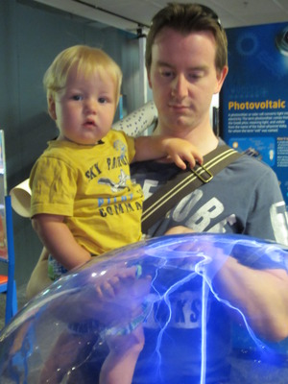
Lots of visual stimulation for big and little kids
large image
A great way to combine a mixed weather day and a bit of culture is to visit the beautiful Whiteman Park where you can spend the sunny hours enjoying the delights of nature and when it rains you can duck into one of their museums. Whiteman Park houses the Motor Museum of WA, Revolutions Transport Museum as well as the Tractor Museum of WA. So if you've got any little guys (or gals) interested in cars, transport or tractors you'll definitely want to check these out. Entry to Whiteman Park is free, but a gold coin donation is encouraged for the Tractor and Transport Museum and a small fee ($10 for adults) is payable for the Motor Museum.
Skating
One for the big kids, and certainly a great way to expend some energy when the weather outside isn't too inviting. Cockburn Ice Arena has a really good selection of public session times, some with a DJ to accompany your skating prowess. Prices start from $10 for kids under 4 and spectators are free.
Pottery
I've been really happy to see a few of the pottery cafes popping up in Perth. These craft havens provide a space to take your kids (week days and weekends) and get them tapping into their creative spirit by painting up a storm onto a piece of pottery which you can then have glazed for that professional look. Whilst the kids are busy getting covered in non toxic paint, you can sit back and grab a coffee.
I've particularly enjoyed taking my son to Cafe Ceramica in Perth's far north and together we've made lots of handprinted gifts for grandparents as well as Father's Day gifts and Christmas presents. I've found Cafe Ceramica to be particularly well appointed in terms of selection of potteries as well as their collection of paints and stencils. Couple this with knowledgable and helpful staff, and this makes this pottery cafe a real winner. Did I also mention that there is a play pen area for tiny tots too? Prices for ceramics start at around $10.
In addition to this, don't forget that with showers never lasting too long in Perth, it's also a great excuse, especially with little ones, to don your gum boots and your plastic mac and get out and splash in the puddles and go hunting for rainbows. Sometimes the best things in life are free.

Smartphone Photography Class

Sit down with your teens and ask what they're special interests are, and if there's anything new that they'd like to learn or get involved in. The following paragraphs provide a few suggestions which you may find helpful. With your encouragement, they might plant the seeds for a hobby or career your teenager will enjoy throughout his or her life.
Writing and Art Competitions
If your teenager is a quiet, self-motivated kind of person who is a talented writer or artist, perhaps they may be interested in entering some of the many competitions which are held around Australia each year. With a few weeks free, school holidays are the perfect time to work on a special creative project.
School holidays can be a great time to get creative.
large image
Some popular local competitions include the Shaun Tan Award for Young Artists and the Tim Winton Award for Young Writers. This website also includes some upcoming competitions for young writers.
Learn to cook
With cooking shows such as Master Chef and My Kitchen Rules enjoying immense popularity, perhaps your teenager has been experiencing an unprecedented urge to contribute towards your family meals. If so, he or she should definitely be encouraged, and there is no better time for them to begin than during school holidays. If you haven't got a good supply of cooking books at home, take your teen down to the local library to select a few which are of interest and help them to purchase the necessary ingredients. While older teens will probably be alright working independently, younger ones may need some guidance. Before they begin, emphasise that cooking also involves cleaning up after themselves.

Cooking is a great hobby for teenagers to take up.
large image
Learn a new sport
Many teenagers have a tendency to loaf around during the holidays, often accompanied by complaints of being bored. A great way to combat this kind of adolescent indolence is to get them into classes for some kind of sport they find cool or interesting. While team sports are often attractive for younger children, teens may find sports such as diving, surfing, horse-riding, rock-climbing, yoga or sailing more appealing. For something a bit different, circus skills are also becoming increasingly popular, and the WA Circus School in Fremantle holds school holiday courses for kids of all ages. These activities are generally not cheap, but they will inspire your teen to move off their back-side and get active.
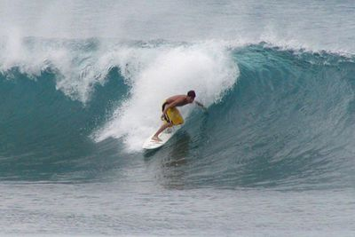
Surfing is a popular sport for teens. This image is from Wikimedia Commons (by Stan Shebs).
large image
Calling All Science Enthusiasts
Scitech has some extremely cool activities organised every school holiday. As well as catering to young children, they also have workshops aimed at 'seniors' ten to fourteen years old which feature topics such as robotics, electronics and growing microscopic crystals.To learn more, check out this website.
Learn photography
Photography is a wonderful hobby which is popular with people of all ages, even fussy teens. These days, with the great variety of good quality, easy-to-use and affordable digital cameras available, even total novices can came up with some amazing images. In addition, there are heaps of great online programs available such as Be Funky where they can manipulate their images, creating effects that were once only possible for professional photographers.
If your teenager is especially enthusiastic and talented, perhaps encourage them to enter one of the many competitions which are always being held, locally and interstate.
Get Crafty
If your teenagers are creative, work in cooperation with them to make up a arts and crafts kit for our home. The contents of this will depend on what media they like to work in. A visit to the library may also provide ideas for their projects. Beading, card-making, sewing, knitting, drawing and crochet are easy crafts to do at home, and there is plenty of help available from library books and on-line.
There are also some awesome creative courses around Perth, so if you can afford it, book your teens into some of those. Older, more mature teenagers may feel comfortable attending adult classes while younger ones will probably want to be with kids their own age. Fremantle Art Centreand the Tresillian Community Centre in Nedlands often hold very good courses specifically for teenagers during the school holidays.
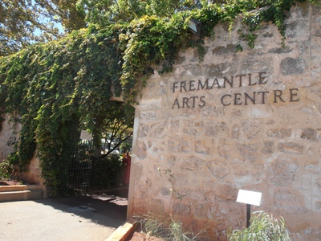
Fremantle Art Centre often holds courses for teenagers.
large image
Volunteer
Volunteering is a great way to give back to our local community, and it's important that young people are aware of its importance. Here in Perth there are many opportunities to volunteer, and the following are a few suggestions. Oxfam, also known as Community Aid Abroad, operates three fair trade shops around Perth and they're always looking out for volunteers. Working here, your child will learn about human rights, fair trade and the struggle for existence which many people in developing countries experience.
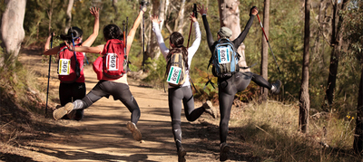

Image is from the Oxfam Australia website.
If your teen is an animal lover or enjoys nature-based activities, perhaps they can volunteer at the RSPCA, the People and Animal Welfare Society or at one of Perth's wildlife rescue centres. For young people with an interest in sustainable living and organic growing, community gardens such as City Farm in East Perth, Subiaco's Earthwise Community Centre and Fremantle's FERN could be the place to go. Young science enthusiasts (over sixteen years old) may also enjoy volunteering at Scitech, while the Perth Royal Show is a fun spot to help out at during the October school holidays.
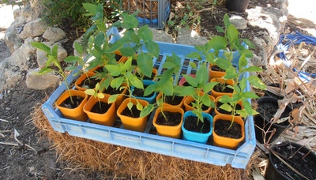
Your teenager might want to volunteer at one of Perth's community gardens.
large image
Sail Into The Sunset
Based in Fremantle, the Leeuwin Ocean Adventure Foundation offers Youth Explorer Voyages throughout the year for young people aged fourteen and over. The Leeuwin is a magnificent three-masted barquentine, approximately 55 metres in length with over 810 square metres of sail. Operating under the principle of 'challenge by choice', participants are expected to get involved in every aspect of life on-board, including sailing, steering, navigating, cleaning and even climbing the mast. Check out the Leeuwin website for more information, but keep in mind, school holiday voyages get booked out very quickly.
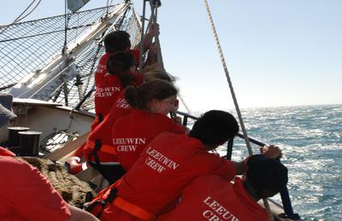
This image is from the Leeuwin Ocean Adventures.website.
large image
Duke of Edinburgh Award
Bright, active and community-minded teenagers may find the Duke of Edinburgh Award program appealing. Aimed at young people fourteen to twenty five years of age, participants are required to select and complete an activity in a specified time period for each of the four criteria: volunteering (community service), physical (sport, dance or fitness), skills (creative, practical or social interests) and an expedition. There are three progressive levels, bronze and gold, with the requirements becoming increasingly demanding as the participant works through them.
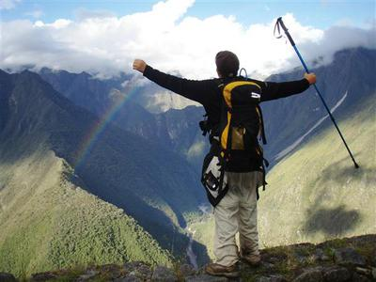
This image is from the Duke of Edinburgh Award website.
large image
Established in 1956 in England, the Duke of Edinburgh Award program is still popular in Australia and many schools encourage their pupils to get involved. However, it's also possible to participate independently, although your children might feel more inspired if they do it with a group of their friends, especially for the expedition, which involves working in a team. Although some people consider it a bit old-fashioned, I personally think it's great and it will look fabulous on your teen's resume. For more information, take a look at the Duke of Edinburgh Award website.
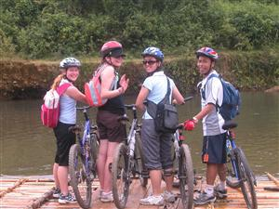
This image is from the Duke of Edinburgh Award website

Outward Bound
Outward Bound Australia is a unique organisation which focuses on personal and leadership development through outdoor adventure activities. As well as holding expeditions for adults, during most school holidays they offer programs in wilderness areas around Western Australia for young people aged fifteen to seventeen. Participants have the choice of two different expeditions: one in which they can take part independently and the other in which they are accompanied by a parent or care-giver. These unique programs give teens the chance to not only experience some of our magnificent Western Australian wilderness areas, but also to cultivate qualities such as self-reliance and resourcefulness, while working as part of a team. Activities include hiking, rafting and rock-climbing.
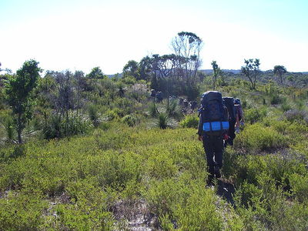
This image is from Wikimedia Commons (by Hughesdarren).
large image
Outward Bound also offers a specialised six-day program which supports the expedition segment of the Duke of Edinburgh Awards: something that can be a challenge for young people who are working towards them independently. Check out the Outward Bound website for more information about all these programs.
Canoeing adventures
Canoeing is a wonderful hobby for people of all ages, and exploring our local waterways is a great adventure. If you don't own your own canoe or kayak, it's possible to hire them at various places around the city. Beginners may be interested to paddle along the upper reaches of the Swan or Canning Rivers. Alternatively, Mandurah and the Peel region has some very scenic and sheltered waterways. The Canning River Eco Education Centre at the corner of Kent Street and Queen's Park Road in Wilson has maps of canoe trails along the upper reaches of the Canning River, while the Mandurah Visitors Centre at 75 Mandurah Terrace provides several maps of canoe trails around the Peel region.
Cycling adventures
Another possibility for active and adventurous teens is to embark on a cycling adventure. While older teenagers may be mature and competent enough to travel alone, this could be a wonderful family trip if your children are younger. Here in Perth, there are cycle paths everywhere, so your adventure could simply be a long day trip, or you extend it to include one or more nights. One suggestion for an overnight trip is to cycle from Perth to Rockingham, a route which mainly follows the Kwinana Freeway and the Mandurah railway line. This might be ideal for novices, as you can simply catch the train if the physical exertion gets to be too much. Click here for a copy of the Perth - Rockingham cycle map. If you're planning to stay overnight, be sure to book your accommodation well in advance.
Other options are the Munda Biddi Trail, WA's ultimate off-road cycling experience, which begins in Mundaring and will eventually continue all the way down to Albany. To accommodate long-distance cyclists, there are cabins along the route. However, it's probably a good idea to pack your own tent and camping equipment as the trail can get pretty busy at peak times.
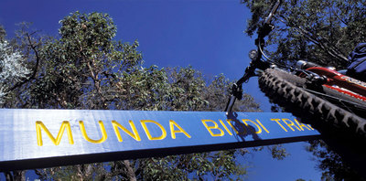
This image is from the Munda Biddi Trail website.
large image
If your teenager is mature and competent to ride on major roads, travelling anywhere is possible. With a properly equipped bike and light-weight, good quality camping eqipment, a family cycling and camping holiday is a cheap and exciting way to explore Western Australia.
Bushwalking
Over the last decade or so, the Australian lifestyle has become increasingly sedentary. A great way to combat this and the health issues which it implies, is to get out regularly into the great outdoors. Bushwalking is a terrific activity which can be enjoyed by people of all ages and fitness levels, and if outings are planned carefully, even extremely lazy teenagers can be inspired to participate.
While the Perth Hills are criss-crossed by innumerable walking trails of varying lengths, teens may also enjoy the challenge of a long-distance walk which involves camping out. The Bibbulmun Track is the most famous of Western Australia's long-distance walks, and stretches from Kalamunda in the north to Albany on the south coast, with plenty of well-maintained camping sites along the way. The Cape to Cape Trail, a five day walk starting near Dunsborough and ending in Augusta is also a great walk, with magnificent views over the ocean. If you're travelling up in the far north, the Piccaninny Gorge Walk in the Purnululu National Park near Kununurra is also strongly recommended for experienced, fit and well-equipped walkers. For more information, contact the Purnululu National Park Visitors Centre on 08 9168 4200.
This image is from the Bibbulmun Track website.
large image
To find out more about bushwalking in WA, check out the Top Trails website.
Family camping trip
In my opinion, the best kind of holiday is a family camping trip. Covering a vast area spanning from the tropical north to the temperate south, Western Australia has more than fifty national parks, as well as innumerable nature reserves and sanctuaries, many which provide camping facilities. Personal favourites are Karajini National Park in the Pilbara region and the Cape Range National Park near Exmouth, which provide stunning scenery and walking trails as well as top camping sites. Check out the DEC Campsites website for more information about camping in Western Australia's national parks. While the camping facilities at many national parks are quite rustic (many are just simple bush camps), there are also many well-equipped caravan parks in tourist centres around the state and these may be more suitable for families who want to travel on a budget but still like a few creature comforts.
Western Australia is also a paradise for four-wheel drive enthusiasts, and tracks such as the Canning Stock Route and the Gunbarrel Highway have a legendary status around the country. Many involve traversing extremely rugged country, so if your teen is an adrenaline junkie, then this may be their kind of adventure.

